
OPC Unified Architecture
Specification
Part 5: Information Model
Release Candidate1.01.13
May 28, 2008

Specification Type | Industry Standard Specification
Title: | OPC Unified Architecture  Information Model | Date: | May 28, 2008
Version: | Release Candidate 1.01.13 | Software | MS-Word
 |  | Source: | 0000.doc
Author: | OPC Foundation | Status: | Release Candidate

CONTENTS
Page
1 Scope 1
2 Reference documents 1
3 Terms, definitions, and conventions 1
3.1 OPC UA Part 1 terms 1
3.2 OPC UA Part 2 terms 2
3.3 OPC UA Part 3 terms 2
3.4 OPC UA Part 4 terms 2
3.5 OPC UA Information Model terms 2
3.5.1 ClientUserId 2
3.6 Abbreviations and symbols 2
3.7 Conventions for Node descriptions 3
4 NodeIds and BrowseNames 5
4.1 NodeIds 5
4.2 BrowseNames 5
5 Common Attributes 6
5.1 General 6
5.2 Objects 6
5.3 Variables 6
5.4 VariableTypes 7
6 Standard ObjectTypes 8
6.1 General 8
6.2 BaseObjectType 8
6.3 ObjectTypes for the Server Object 9
6.3.1 ServerType 9
6.3.2 ServerCapabilitiesType 10
6.3.3 ServerDiagnosticsType 11
6.3.4 SessionsDiagnosticsSummaryType 12
6.3.5 SessionDiagnosticsObjectType 13
6.3.6 VendorServerInfoType 13
6.3.7 ServerRedundancyType 14
6.3.8 TransparentRedundancyType 14
6.3.9 NonTransparentRedundancyType 15
6.4 ObjectTypes used as EventTypes 15
6.4.1 General 15
6.4.2 BaseEventType 16
6.4.3 AuditEventType 18
6.4.4 AuditSecurityEventType 19
6.4.5 AuditChannelEventType 19
6.4.6 AuditOpenSecureChannelEventType 20
6.4.7 AuditSessionEventType 20
6.4.8 AuditCreateSessionEventType 21
6.4.9 AuditUrlMismatchEventType 22
6.4.10 AuditActivateSessionEventType 22
6.4.11 AuditCancelEventType 23
6.4.12 AuditCertificateEventType 23
6.4.13 AuditCertificateDataMismatchEventType 24
6.4.14 AuditCertificateExpiredEventType 24
6.4.15 AuditCertificateInvalidEventType 24
6.4.16 AuditCertificateUntrustedEventType 25
6.4.17 AuditCertificateRevokedEventType 25
6.4.18 AuditCertificateMismatchEventType 25
6.4.19 AuditNodeManagementEventType 26
6.4.20 AuditAddNodesEventType 26
6.4.21 AuditDeleteNodesEventType 27
6.4.22 AuditAddReferencesEventType 27
6.4.23 AuditDeleteReferencesEventType 28
6.4.24 AuditUpdateEventType 28
6.4.25 AuditWriteUpdateEventType 29
6.4.26 AuditHistoryUpdateEventType 29
6.4.27 AuditUpdateMethodEventType 30
6.4.28 SystemEventType 30
6.4.29 DeviceFailureEventType 30
6.4.30 BaseModelChangeEventType 31
6.4.31 GeneralModelChangeEventType 31
6.4.32 SemanticChangeEventType 31
6.5 ModellingRuleType 32
6.6 FolderType 32
6.7 DataTypeEncodingType 32
6.8 DataTypeSystemType 33
7 Standard VariableTypes 34
7.1 General 34
7.2 BaseVariableType 34
7.3 PropertyType 34
7.4 BaseDataVariableType 34
7.5 ServerVendorCapabilityType 35
7.6 DataTypeDictionaryType 35
7.7 DataTypeDescriptionType 36
7.8 ServerStatusType 36
7.9 BuildInfoType 36
7.10 ServerDiagnosticsSummaryType 37
7.11 SamplingRateDiagnosticsArrayType 37
7.12 SamplingRateDiagnosticsType 38
7.13 SubscriptionDiagnosticsArrayType 38
7.14 SubscriptionDiagnosticsType 39
7.15 SessionDiagnosticsArrayType 39
7.16 SessionDiagnosticsVariableType 40
7.17 SessionSecurityDiagnosticsArrayType 42
7.18 SessionSecurityDiagnosticsType 42
8 Standard Objects and their Variables 43
8.1 General 43
8.2 Objects used to organise the AddressSpace structure 43
8.2.1 Overview 43
8.2.2 Root 43
8.2.3 Views 44
8.2.4 Objects 44
8.2.5 Types 45
8.2.6 ObjectTypes 46
8.2.7 VariableTypes 47
8.2.8 ReferenceTypes 48
8.2.9 DataTypes 48
8.2.10 OPC Binary 50
8.2.11 XML Schema 50
8.3 Server Object and its containing Objects 50
8.3.1 General 50
8.3.2 Server Object 52
8.4 ModellingRule Objects 52
8.4.1 ExposesItsArray 52
8.4.2 Mandatory 52
8.4.3 Optional 53
9 Standard Methods 53
10 Standard Views 53
11 Standard ReferenceTypes 53
11.1 References 53
11.2 HierarchicalReferences 53
11.3 NonHierarchicalReferences 54
11.4 HasChild 54
11.5 Aggregates 54
11.6 Organizes 55
11.7 HasComponent 55
11.8 HasOrderedComponent 55
11.9 HasProperty 55
11.10 HasSubtype 56
11.11 HasModellingRule 56
11.12 HasTypeDefinition 56
11.13 HasEncoding 57
11.14 HasDescription 57
11.15 HasEventSource 57
11.16 HasNotifier 57
11.17 GeneratesEvent 58
12 Standard DataTypes 58
12.1 Overview 58
12.2 DataTypes defined in Part 3 59
12.3 DataTypes defined in Part 4 62
12.4 BuildInfo 64
12.5 RedundancySupport 64
12.6 ServerState 65
12.7 RedundantServerDataType 65
12.8 SamplingRateDiagnosticsDataType 66
12.9 ServerDiagnosticsSummaryDataType 66
12.10 ServerStatusDataType 67
12.11 SessionDiagnosticsDataType 67
12.12 SessionSecurityDiagnosticsDataType 69
12.13 ServiceCounterDataType 69
12.14 StatusResult 70
12.15 SubscriptionDiagnosticsDataType 70
12.16 ModelChangeStructureDataType 71
12.17 SemanticChangeStructureDataType 72
Appendix A (informative): Design decisions when modelling the server information 73
A.1 Overview 73
A.2 ServerType and Server Object 73
A.3 Typed complex Objects beneath the Server Object 73
A.4 Properties vs. DataVariables 73
A.5 Complex Variables using complex DataTypes 74
A.6 Complex Variables having an array 74
A.7 Redundant information 74
A.8 Usage of the BaseDataVariableType 75
A.9 Subtyping 75
A.10 Extensibility mechanism 75
Appendix B (normative): StateMachines 76
B.1 Scope 76
B.2 Examples of finite state machines 76
B.2.1 Simple state machine 76
B.2.2 State machine containing substates 77
B.3 Definition of state machine 77
B.4 Representation of state machines in the AddressSpace 78
B.4.1 Overview 78
B.4.2 StateMachineType 79
B.4.3 StateVariableType 80
B.4.4 TransitionVariableType 81
B.4.5 FiniteStateMachineType 81
B.4.6 FiniteStateVariableType 82
B.4.7 FiniteTransitionVariableType 83
B.4.8 StateType 83
B.4.9 InitialStateType 84
B.4.10 TransitionType 85
B.4.11 FromState 85
B.4.12 ToState 85
B.4.13 HasCause 86
B.4.14 HasEffect 86
B.4.15 HasSubStateMachine 87
B.4.16 TransitionEventType 87
B.4.17 AuditUpdateStateEventType 88
B.4.18 Special Restrictions on subtyping StateMachines 88
B.4.19 Specific StatusCodes for StateMachines 88
B.5 Examples of StateMachines in the AddressSpace 89
B.5.1 StateMachineType using inheritance 89
B.5.2 StateMachineType with a sub-machine using inheritance 90
B.5.3 StateMachineType using containment 92
B.5.4 Example of a StateMachine having Transitions to SubStateMachines 92

FIGURES
Figure 1 – Standard AddressSpace Structure 43
Figure 2 – Views Organization 44
Figure 3 – Objects Organization 45
Figure 4 – ObjectTypes Organization 46
Figure 5 – VariableTypes Organization 47
Figure 6 – ReferenceType Definitions 48
Figure 7 – DataTypes Organization 49
Figure 8 – Excerpt of Diagnostic Information of the Server 51
Figure 9 – Example of a simple state machine 76
Figure 10 – Example of a state machine having a sub-machine 77
Figure 11 – The StateMachine Information Model 79
Figure 12 – Example of an initial State in a sub-machine 84
Figure 13 – Example of a StateMachineType using inheritance 89
Figure 14 – Example of a StateMachineType with a SubStateMachine using inheritance 90
Figure 15 – Example of a StateMachineType using containment 92
Figure 16 – Example of a state machine with transitions from sub-states 93
Figure 17 – Example of a StateMachineType having Transitions to SubStateMachines 94

TABLES
Table 1 – Examples of DataTypes 3
Table 2 – Type Definition Table 4
Table 3 – Common Node Attributes 6
Table 4 – Common Object Attributes 6
Table 5 – Common Variable Attributes 6
Table 6 – Common VariableType Attributes 7
Table 7 – BaseObjectType Definition 8
Table 8 – ServerType Definition 9
Table 9 – ServerCapabilitiesType Definition 10
Table 10 – ServerDiagnosticsType Definition 11
Table 11 – SessionsDiagnosticsSummaryType Definition 12
Table 12 – SessionDiagnosticsObjectType Definition 13
Table 13 – VendorServerInfoType Definition 13
Table 14 – ServerRedundancyType Definition 14
Table 15 – TransparentRedundancyType Definition 14
Table 16 – NonTransparentRedundancyType Definition 15
Table 17 – BaseEventType Definition 16
Table 18 – AuditEventType Definition 18
Table 19 – AuditSecurityEventType Definition 19
Table 20 – AuditChannelEventType Definition 19
Table 21 – AuditOpenSecureChannelEventType Definition 20
Table 22 – AuditSessionEventType Definition 20
Table 23 – AuditCreateSessionEventType Definition 21
Table 24 – AuditUrlMismatchEventType Definition 22
Table 25 – AuditActivateSessionEventType Definition 22
Table 26 – AuditCancelEventType Definition 23
Table 27 – AuditCertificateEventType Definition 23
Table 28 – AuditCertificateDataMismatchEventType Definition 24
Table 29 – AuditCertificateExpiredEventType Definition 24
Table 30 – AuditCertificateInvalidEventType Definition 24
Table 31 – AuditCertificateUntrustedEventType Definition 25
Table 32 – AuditCertificateRevokedEventType Definition 25
Table 33 – AuditCertificateMismatchEventType Definition 25
Table 34 – AuditNodeManagementEventType Definition 26
Table 35 – AuditAddNodesEventType Definition 26
Table 36 – AuditDeleteNodesEventType Definition 27
Table 37 – AuditAddReferencesEventType Definition 27
Table 38 – AuditDeleteReferencesEventType Definition 28
Table 39 – AuditUpdateEventType Definition 28
Table 40 – AuditWriteUpdateEventType Definition 29
Table 41 – AuditHistoryUpdateEventType Definition 29
Table 42 – AuditUpdateMethodEventType Definition 30
Table 43 – SystemEventType Definition 30
Table 44 – DeviceFailureEventType Definition 30
Table 45 – BaseModelChangeEventType Definition 31
Table 46 – GeneralModelChangeEventType Definition 31
Table 47 – SemanticChangeEventType Definition 31
Table 48 – ModellingRuleType Definition 32
Table 49 – FolderType Definition 32
Table 50 – DataTypeEncodingType Definition 32
Table 51 – DataTypeSystemType Definition 33
Table 52 – BaseVariableType Definition 34
Table 53 – PropertyType Definition 34
Table 54 – BaseDataVariableType Definition 35
Table 55 – ServerVendorCapabilityType Definition 35
Table 56 – DataTypeDictionaryType Definition 35
Table 57 – DataTypeDescriptionType Definition 36
Table 58 – ServerStatusType Definition 36
Table 59 – BuildInfoType Definition 36
Table 60 – ServerDiagnosticsSummaryType Definition 37
Table 61 – SamplingRateDiagnosticsArrayType Definition 37
Table 62 – SamplingRateDiagnosticsType Definition 38
Table 63 – SubscriptionDiagnosticsArrayType Definition 38
Table 64 – SubscriptionDiagnosticsType Definition 39
Table 65 – SessionDiagnosticsArrayType Definition 39
Table 66 – SessionDiagnosticsVariableType Definition 40
Table 67 – SessionSecurityDiagnosticsArrayType Definition 42
Table 68 – SessionSecurityDiagnosticsType Definition 42
Table 69 – Root Definition 43
Table 70 – Views Definition 44
Table 71 – Objects Definition 45
Table 72 – Types Definition 45
Table 73 – ObjectTypes Definition 46
Table 74 – VariableTypes Definition 47
Table 75 – ReferenceTypes Definition 48
Table 76 – DataTypes Definition 49
Table 77 – OPC Binary Definition 50
Table 78 – XML Schema Definition 50
Table 79 – Server Definition 52
Table 80 – ExposesItsArray Definition 52
Table 81 – Mandatory Definition 52
Table 82 – Optional Definition 53
Table 83 – References ReferenceType 53
Table 84 – HierarchicalReferences ReferenceType 53
Table 85 – NonHierarchicalReferences ReferenceType 54
Table 86 – HasChild ReferenceType 54
Table 87 – Aggregates ReferenceType 54
Table 88 – Organizes ReferenceType 55
Table 89 – HasComponent ReferenceType 55
Table 90 – HasOrderedComponent ReferenceType 55
Table 91 – HasProperty ReferenceType 56
Table 92 – HasSubtype ReferenceType 56
Table 93 – HasModellingRule ReferenceType 56
Table 94 – HasTypeDefinition ReferenceType 56
Table 95 – HasEncoding ReferenceType 57
Table 96 – HasDescription ReferenceType 57
Table 97 – HasEventSource ReferenceType 57
Table 98 – HasNotifier ReferenceType 57
Table 99 – GeneratesEvent ReferenceType 58
Table 100 – Part 3 DataType Definitions 59
Table 101 – BaseDataType Definition 60
Table 102 – Structure Definition 60
Table 103 – Enumeration Definition 61
Table 104 – ByteString Definition 61
Table 105 – Number Definition 61
Table 106 – Double Definition 61
Table 107 – Integer Definition 61
Table 108 – DateTime Definition 62
Table 109 – String Definition 62
Table 110 – UInteger Definition 62
Table 111 – Image Definition 62
Table 112 – Part 4 DataType Definitions 63
Table 113 – UserIdentityToken Definition 63
Table 114 – BuildInfo Structure 64
Table 115 – BuildInfo Definition 64
Table 116 – RedundancySupport Values 64
Table 117 – RedundancySupport Definition 64
Table 118 – ServerState Values 65
Table 119 – ServerState Definition 65
Table 120 – RedundantServerDataType Structure 65
Table 121 – RedundantServerDataType Definition 65
Table 122 – SamplingRateDiagnosticsDataType Structure 66
Table 123 – SamplingRateDiagnosticsDataType Definition 66
Table 124 – ServerDiagnosticsSummaryDataType Structure 66
Table 125 – ServerDiagnosticsSummaryDataType Definition 67
Table 126 – ServerStatusDataType Structure 67
Table 127 – ServerStatusDataType Definition 67
Table 128 – SessionDiagnosticsDataType Structure 67
Table 129 – SessionDiagnosticsDataType Definition 69
Table 130 – SessionSecurityDiagnosticsDataType Structure 69
Table 131 – SessionSecurityDiagnosticsDataType Definition 69
Table 132 – ServiceCounterDataType Structure 69
Table 133 – ServiceCounterDataType Definition 69
Table 134 – StatusResult Structure 70
Table 135 – StatusResult Definition 70
Table 136 – SubscriptionDiagnosticsDataType Structure 70
Table 137 – SubscriptionDiagnosticsDataType Definition 71
Table 138 – ModelChangeStructureDataType Structure 71
Table 139 – ModelChangeStructureDataType Definition 71
Table 140 – SemanticChangeStructureDataType Structure 72
Table 141 – SemanticChangeStructureDataType Definition 72
Table 142 – StateMachineType Definition 80
Table 143 – StateVariableType Definition 80
Table 144 – TransitionVariableType Definition 81
Table 145 – FiniteStateMachineType Definition 82
Table 146 – FiniteStateVariableType Definition 83
Table 147 – FiniteTransitionVariableType Definition 83
Table 148 – StateType Definition 84
Table 149 – InitialStateType Definition 85
Table 150 – TransitionType Definition 85
Table 151 – FromState ReferenceType 85
Table 152 – ToState ReferenceType 86
Table 153 – HasCause ReferenceType 86
Table 154 – HasEffect ReferenceType 87
Table 155 – HasSubStateMachine ReferenceType 87
Table 156 - TransitionEventType 87
Table 157 - AuditUpdateStateEventType 88
Table 158 – Specific StatusCodes for StateMachines 89

OPC Foundation
____________

UNIFIED ARCHITECTURE –
FOREWORD
This specification is the specification for developers of OPC UA applications. The specification is a result of an analysis and design process to develop a standard interface to facilitate the development of applications by multiple vendors that shall inter-operate seamlessly together.
Copyright © 2006, OPC Foundation, Inc.
AGREEMENT OF USE
COPYRIGHT RESTRICTIONS
Any unauthorized use of this specification may violate copyright laws, trademark laws, and communications regulations and statutes. This document contains information which is protected by copyright. All Rights Reserved. No part of this work covered by copyright herein may be reproduced or used in any form or by any means--graphic, electronic, or mechanical, including photocopying, recording, taping, or information storage and retrieval systems--without permission of the copyright owner.
OPC Foundation members and non-members are prohibited from copying and redistributing this specification. All copies must be obtained on an individual basis, directly from the OPC Foundation Web site
http://www.opcfoundation.org.
PATENTS
The attention of adopters is directed to the possibility that compliance with or adoption of OPC specifications may require use of an invention covered by patent rights. OPC shall not be responsible for identifying patents for which a license may be required by any OPC specification, or for conducting legal inquiries into the legal validity or scope of those patents that are brought to its attention. OPC specifications are prospective and advisory only. Prospective users are responsible for protecting themselves against liability for infringement of patents.
WARRANTY AND LIABILITY DISCLAIMERS
WHILE THIS PUBLICATION IS BELIEVED TO BE ACCURATE, IT IS PROVIDED "AS IS" AND MAY CONTAIN ERRORS OR MISPRINTS. THE OPC FOUDATION MAKES NO WARRANTY OF ANY KIND, EXPRESSED OR IMPLIED, WITH REGARD TO THIS PUBLICATION, INCLUDING BUT NOT LIMITED TO ANY WARRANTY OF TITLE OR OWNERSHIP, IMPLIED WARRANTY OF MERCHANTABILITY OR WARRANTY OF FITNESS FOR A PARTICULAR PURPOSE OR USE. IN NO EVENT SHALL THE OPC FOUNDATION BE LIABLE FOR ERRORS CONTAINED HEREIN OR FOR DIRECT, INDIRECT, INCIDENTAL, SPECIAL, CONSEQUENTIAL, RELIANCE OR COVER DAMAGES, INCLUDING LOSS OF PROFITS, REVENUE, DATA OR USE, INCURRED BY ANY USER OR ANY THIRD PARTY IN CONNECTION WITH THE FURNISHING, PERFORMANCE, OR USE OF THIS MATERIAL, EVEN IF ADVISED OF THE POSSIBILITY OF SUCH DAMAGES.
The entire risk as to the quality and performance of software developed using this specification is borne by you.
RESTRICTED RIGHTS LEGEND
This Specification is provided with Restricted Rights. Use, duplication or disclosure by the U.S. government is subject to restrictions as set forth in (a) this Agreement pursuant to DFARs 227.7202-3(a); (b) subparagraph (c)(1)(i) of the Rights in Technical Data and Computer Software at DFARs 252.227-7013; or (c) the Commercial Computer Software Restricted Rights at FAR 52.227-19 subdivision (c)(1) and (2), as applicable. Contractor / manufacturer are the OPC Foundation,. 16101 N. 82nd Street, Suite 3B, Scottsdale, AZ, 85260-1830
COMPLIANCE
The OPC Foundation shall at all times be the sole entity that may authorize developers, suppliers and sellers of hardware and software to use certification marks, trademarks or other special designations to indicate compliance with these materials. Products developed using this specification may claim compliance or conformance with this specification if and only if the software satisfactorily meets the certification requirements set by the OPC Foundation. Products that do not meet these requirements may claim only that the product was based on this specification and must not claim compliance or conformance with this specification.
Trademarks
Most computer and software brand names have trademarks or registered trademarks. The individual trademarks have not been listed here.
GENERAL PROVISIONS
Should any provision of this Agreement be held to be void, invalid, unenforceable or illegal by a court, the validity and enforceability of the other provisions shall not be affected thereby.
This Agreement shall be governed by and construed under the laws of the State of Minnesota, excluding its choice or law rules.
This Agreement embodies the entire understanding between the parties with respect to, and supersedes any prior understanding or agreement (oral or written) relating to, this specification.
ISSUE REPORTING
The OPC Foundation strives to maintain the highest quality standards for its published specifications, hence they undergo constant review and refinement. Readers are encouraged to report any issues and view any existing errata here:
http://www.opcfoundation.org/errata

Scope
This specification defines the Information Model of the OPC Unified Architecture. The Information Model describes standardised Nodes of a server’s AddressSpace. These Nodes are standardised types as well as standardised instances used for diagnostics or as entry points to server specific Nodes. Thus, the Information Model defines the AddressSpace of an empty OPC UA server. However, it is not expected that all servers will provide all of these Nodes.

Reference documents
Part 1: OPC UA Specification: Part 1 – Concepts, Version 1.0 or later
http://www.opcfoundation.org/UA/Part1/
Part 2: OPC UA Specification: Part 2 – Security Model, Version 1.0 or later
http://www.opcfoundation.org/UA/Part2/
Part 3: OPC UA Specification: Part 3 – Address Space Model, Version 1.0 or later
http://www.opcfoundation.org/UA/Part3/
Part 4: OPC UA Specification: Part 4 – Services, Version 1.0 or later
http://www.opcfoundation.org/UA/Part4/
Part 6: OPC UA Specification: Part 6 – Mapping, Version 1.0 or later
http://www.opcfoundation.org/UA/Part6/
Part 7: OPC UA Specification: Part 7 – Profiles, Version 1.0 or later
http://www.opcfoundation.org/UA/Part7/
Part 9: OPC UA Specification: Part 9 – Alarms and Conditions, Version 1.0 or later
http://www.opcfoundation.org/UA/Part9/
Part 10: OPC UA Specification: Part 10 – Programs, Version 1.0 or later
http://www.opcfoundation.org/UA/Part10/
Part 11: OPC UA Specification: Part 11 – Historical Access, Version 1.0 or later
http://www.opcfoundation.org/UA/Part11/

Terms, definitions, and conventions

OPC UA Part 1 terms
The following terms defined in Part 1 apply.
- AddressSpace
- Attribute
- Event
- Information Model
- Method
- MonitoredItem
- Node
- NodeClass
- Notification
- Object
- ObjectType
- Profile
- Reference
- ReferenceType
- Service
- Service Set
- Subscription
- Variable
- View

OPC UA Part 2 terms
There are no Part 2 terms used in this part.

OPC UA Part 3 terms
The following terms defined in Part 3 apply.
- DataVariable
- EventType
- Hierarchical Reference
- InstanceDeclaration
- ModellingRule
- Property
- SourceNode
- TargetNode
- TypeDefinitionNode
- VariableType

OPC UA Part 4 terms
There are no Part 4 terms used in this part.

OPC UA Information Model terms

ClientUserId
A String that identifies the user of the client requesting an action.
NOTE: The ClientUserId is obtained directly or indirectly from the UserIdentityToken passed by the Client in the ActivateSession Service call. See 6.4.3 for details.

Abbreviations and symbols
UA Unified Architecture
XML Extensible Markup Language

Conventions for Node descriptions
Node definitions are specified using tables (See Table 1)...
Attributes are defined by providing the Attribute name and a value, or a description of the value.
References are defined by providing the ReferenceType name, the BrowseName of the TargetNode and its NodeClass.
- If the TargetNode is a component of the Node being defined in the table the Attributes of the composed Node are defined in the same row of the table. That implies that the referenced Node has a HasModelParent Reference with the Node defined in the Table as TargetNode (see Part 3 for the definition of ModelParents).
- The DataType is only specified for Variables; “[<number>]” indicates a single-dimensional array, for multi-dimensional arrays the expression is repeated for each dimension (e.g. [2][3] for a two-dimensional array). For all arrays the ArrayDimensions is set as identified by <number> values. If no <number> is set, the corresponding dimension is set to 0, indicating an unknown size. If no number is provided at all the ArrayDimensions can be omitted. If no brackets are provided, it identifies a scalar DataType and the ValueRank is set to the corresponding value (see Part 3). In addition, ArrayDimensions is set to null or is omitted. If it can be Any or ScalarOrOneDimension, the value is put into “{<value>}”, so either “{Any}” or “{ScalarOrOneDimension}” and the ValueRank is set to the corresponding value (see Part 3) and the ArrayDimensions is set to null or is omitted. In Table 1 examples are given.
Table 1 – Examples of DataTypes
Notation | DataType | ValueRank | ArrayDimensions | Description
Int32 | Int32 | -1 | omitted or NULL | A scalar Int32
Int32[] | Int32 | 1 | omitted or {0} | Single-dimensional array of Int32 with an unknown size
Int32[][] | Int32 | 2 | omitted or {0,0} | Two-dimensional array of Int32 with unknown sizes for both dimensions
Int32[3][] | Int32 | 2 | {3,0} | Two-dimensional array of Int32 with a size of 3 for the first dimension and an unknown size for the second dimension
Int32[5][3] | Int32 | 2 | {5,3} | Two-dimensional array of Int32 with a size of 5 for the first dimension and a size of 3 for the second dimension
Int32{Any} | Int32 | -2 | omitted or NULL | An Int32 where it is unknown if it is scalar or array with any number of dimensions
Int32{ScalarOrOneDimension} | Int32 | -3 | omitted or NULL | An Int32 where it is either a single-dimensional array or a scalar

- The TypeDefinition is specified for Objects and Variables.
- The TypeDefinition column specifies a symbolic name for a NodeId, i.e. the specified Node points with a HasTypeDefinition Reference to the corresponding Node.
- The ModellingRule of the referenced component is provided by specifying the symbolic name of the rule in the ModellingRule column. In the AddressSpace, the Node shall use a HasModellingRule Reference to point to the corresponding ModellingRule Object.
If the NodeId of a DataType is provided, the symbolic name of the Node representing the DataType shall be used.
Nodes of all other NodeClasses cannot be defined in the same table; therefore only the used ReferenceType, their NodeClass and their BrowseName are specified. A reference to another of this document points to their definition.
Table 2 illustrates the table. If no components are provided, the DataType, TypeDefinition and ModellingRule columns may be omitted and only a Comment column is introduced to point to the Node definition.
Table 2 – Type Definition Table
Attribute | Value
Attribute name | Attribute value. If it is an optional Attribute that is not set “--“ will be used.
References |  | NodeClass | BrowseName | DataType | TypeDefinition | ModellingRule
ReferenceType name |  | NodeClass of the TargetNode. | BrowseName of the target Node. If the Reference is to be instantiated by the server, then the value of the target Node’s BrowseName is “--“. | Attributes of the referenced Node, only applicable for Variables and Objects. |  | Referenced ModellingRule of the referenced Object.
Notes –
- Notes referencing footnotes of the table content.

Components of Nodes can be complex, i.e. containing components by themselves. The TypeDefinition, NodeClass, DataType and ModellingRule can be derived from the type definitions, and the symbolic name can be created as defined in 4.1. Therefore those containing components are not explicitly specified; they are implicitly specified by the type definitions.

NodeIds and BrowseNames

NodeIds
The NodeIds of all Nodes described in this document are only symbolic names. Part 6 defines the actual NodeIds.
The symbolic name of each Node defined in this document is its BrowseName, or, when it is part of another Node, the BrowseName of the other Node, a “.”, and the BrowseName of itself. In this case “part of” means that the whole has a HasProperty or HasComponent Reference to its part. Since all Nodes not being part of another Node have a unique name in this document, the symbolic name is unique. For example, the ServerType defined in 6.3.1 has the symbolic name “ServerType”. One of its InstanceDeclarations would be identified as “ServerType.ServerCapabilities”. Since this Object is complex, another InstanceDeclaration of the ServerType is “ServerType.ServerCapabilities.MinSupportedSampleRate”. The Server Object defined in 8.3.2 is based on the ServerType and has the symbolic name “Server”. Therefore, the instance based on the InstanceDeclaration described above has the symbolic name “Server.ServerCapabilities.MinSupportedSampleRate”.
The NamespaceIndex for all NodeIds defined in this specification is 0. The namespace for this NamespaceIndex is specified in Part 3.
Note: This specification does not only define concrete Nodes, but also requires that some Nodes have to be generated, for example one for each Session running on the server. The NodeIds of those Nodes are server-specific, including the Namespace. But the NamespaceIndex of those Nodes cannot be the NamespaceIndex 0, because they are not defined by the OPC Foundation but generated by the Server.

BrowseNames
The text part of the BrowseNames for all Nodes defined in this part is specified in the tables defining the Nodes. The NamespaceIndex for all BrowseNames defined in this part is 0.

Common Attributes

General
For all Nodes specified in this part, the Attributes named in Table 3 shall be set as specified in the table.
Table 3 – Common Node Attributes
Attribute | Value
DisplayName | The DisplayName is a LocalizedText. Each server shall provide the DisplayName identical to the BrowseName of the Node for the LocaleId “en”. Whether the server provides translated names for other LocaleIds is vendor specific.
Description | Optionally a vendor specific description is provided
NodeClass | Shall reflect the NodeClass of the Node
NodeId | The NodeId is described by BrowseNames as defined in 4.1 and defined in Part 6
WriteMask | Optionally the WriteMask Attribute can be provided. If the WriteMask Attribute is provided, it shall set all Attributes to not writeable that are not said to be vendor-specific. For example, the Description Attribute may be set to writeable since a Server may provide a server-specific description for the Node. The NodeId shall not be writeable, because it is defined for each Node in this specification.
UserWriteMask | Optionally the UserWriteMask Attribute can be provided. The same rules as for the WriteMask Attribute apply.

Objects
For all Objects specified in this part, the Attributes named in Table 4 shall be set as specified in the table.
Table 4 – Common Object Attributes
Attribute | Value
EventNotifier | Whether the Node can be used to subscribe to Events or not is vendor specific

Variables
For all Variables specified in this part, the Attributes named in Table 5 shall be set as specified in the table.
Table 5 – Common Variable Attributes
Attribute | Value
MinimumSamplingInterval | Optionally, a vendor-specific minimum sampling interval is provided
AccessLevel | The access level for Variables used for type definitions is vendor-specific, for all other Variables defined in this part, the access level shall allow a current read; other settings are vendor specific.
UserAccessLevel | The value for the UserAccessLevel Attribute is vendor-specific. It is assumed that all Variables can be accessed by at least one user.
Value | For Variables used as InstanceDeclarations, the value is vendor-specific; otherwise it shall represent the value described in the text.
ArrayDimensions | If the ValueRank does not identify an array of a specific dimension (i.e. ValueRank <= 0) the ArrayDimensions can either be set to null or the Attribute is missing. This behaviour is vendor-specific.  If the ValueRank specifies an array of a specific dimension (i.e. ValueRank > 0) then the ArrayDimensions Attribute shall be specified in the table defining the Variable.

VariableTypes
For all VariableTypes specified in this part, the Attributes named in Table 6 shall be set as specified in the table.
Table 6 – Common VariableType Attributes
Attributes | Value
Value | Optionally a vendor-specific default value can be provided
ArrayDimensions | If the ValueRank does not identify an array of a specific dimension (i.e. ValueRank <= 0) the ArrayDimensions can either be set to null or the Attribute is missing. This behaviour is vendor-specific.  If the ValueRank specifies an array of a specific dimension (i.e. ValueRank > 0) then the ArrayDimensions Attribute shall be specified in the table defining the VariableType.

Standard ObjectTypes

General
Typically, the components of an ObjectType are fixed and can be extended by subtyping. However, since each Object of an ObjectType can be extended with additional components, This specification allows extending the standard ObjectTypes defined in this document with additional components. Thereby, it is possible to express the additional information in the type definition that would already be contained in each Object. Some ObjectTypes already provide entry points for server specific extensions. However, it is not allowed to restrict the components of the standard ObjectTypes defined in this Part. An example of extending the ObjectTypes is putting the standard Property NodeVersion defined in Part 3 into the BaseObjectType, stating that each Object of the server will provide a NodeVersion.

BaseObjectType
The BaseObjectType is used as type definition whenever there is an Object having no more concrete type definition available. Servers should avoid using this ObjectType and use a more specific type, if possible. This ObjectType is the base ObjectType and all other ObjectTypes shall either directly or indirectly inherit from it. However, it might not be possible for servers to provide all HasSubtype References from this ObjectType to its subtypes, and therefore it is not required to provide this information.
There are no References except for HasSubtype References specified for this ObjectType. It is formally defined in Table 7.
Table 7 – BaseObjectType Definition
Attribute | Value
BrowseName | BaseObjectType
IsAbstract | False
References |  | NodeClass | BrowseName | DataType | TypeDefinition | ModellingRule
HasSubtype |  | ObjectType | ServerType | Defined in 6.3.1
HasSubtype |  | ObjectType | ServerCapabilitiesType | Defined in 6.3.2
HasSubtype |  | ObjectType | ServerDiagnosticsType | Defined in 6.3.3
HasSubtype |  | ObjectType | SessionsDiagnosticsSummaryType | Defined in 6.3.4
HasSubtype |  | ObjectType | SessionDiagnosticsObjectType | Defined in 6.3.5
HasSubtype |  | ObjectType | VendorServerInfoType | Defined in 6.3.6
HasSubtype |  | ObjectType | ServerRedundancyType | Defined in 6.3.7
HasSubtype |  | ObjectType | BaseEventType | Defined in 6.4.2
HasSubtype |  | ObjectType | ModellingRuleType | Defined in 6.5
HasSubtype |  | ObjectType | FolderType | Defined in 6.6
HasSubtype |  | ObjectType | DataTypeEncodingType | Defined in 6.7
HasSubtype |  | ObjectType | DataTypeSystemType | Defined in 6.8

ObjectTypes for the Server Object

ServerType
This ObjectType defines the capabilities supported by the OPC UA server. It is formally defined in Table 8.
Table 8 – ServerType Definition
Attribute | Value
BrowseName | ServerType
IsAbstract | False
References |  | NodeClass | BrowseName | DataType | TypeDefinition | Modelling  Rule
Subtype of the BaseObjectType defined in 6.2
HasProperty |  | Variable | ServerArray | String[] | PropertyType | Mandatory
HasProperty |  | Variable | NamespaceArray | String[] | PropertyType | Mandatory
HasComponent |  | Variable | ServerStatus¹ | ServerStatusDataType | ServerStatusType | Mandatory
HasProperty |  | Variable | ServiceLevel | Byte | PropertyType | Mandatory
HasProperty |  | Variable | Auditing | Boolean | PropertyType | Mandatory
HasComponent |  | Object | ServerCapabilities¹ | - | ServerCapabilitiesType | Mandatory
HasComponent |  | Object | ServerDiagnostics¹ | - | ServerDiagnosticsType | Mandatory
HasComponent |  | Object | VendorServerInfo | - | VendorServerInfoType | Mandatory
HasComponent |  | Object | ServerRedundancy¹ | - | ServerRedundancyType | Mandatory
Notes –
- Containing Objects and Variables of these Objects and Variables are defined by their BrowseName defined in the corresponding TypeDefinitionNode. The NodeId is defined by the composed symbolic name described in 4.1.

ServerArray defines an array of server URIs. This Variable is also referred to as the server table. Each URI in this array represents a globally-unique logical name for a server within the scope of the network in which it is installed. Each OPC UA server instance has a single URI that is used in the server table of other OPC UA servers. Index 0 is reserved for the URI of the local server. Values above 0 are used to identify remote servers and are specific to a server. Part 4 describes discovery mechanism that can be used to resolve URIs into URLs.
The indexes into this table are referred to as server indexes or server names. They are used in OPC UA Services to identify TargetNodes of References that reside in remote servers. Clients may read the entire table or they may read individual entries in the table. The server shall not modify or delete entries of this table while any client has an open session to the server, because clients may cache this table. A server may add entries to the table even if clients are connected to the server.
NamespaceArray defines an array of namespace URIs. This Variable is also referred as namespace table. The indexes into this table are referred to as NamespaceIndexes. NamespaceIndexes are used in NodeIds in OPC UA Services, rather than the longer namespace URI. Index 0 is reserved for the OPC UA namespace, and index 1 is reserved for the local server. Clients may read the entire table or they may read individual entries in the table. The server shall not modify or delete entries of this table while any client has an open session to the server, because clients may cache this table. A server may add entries to the table even if clients are connected to the server. It is recommended that servers not change the indexes of this table but only add entries, because the client may cache NodeIds using the indexes. Nevertheless, it might not always be possible for servers to avoid changing indexes in this table. Clients that cache NamespaceIndexes of NodeIds should always check when starting a session to verify that the cached NamespaceIndexes have not changed.
ServerStatus contains elements that describe the status of the server. See 12.10 for a description of its elements.
ServiceLevel describes the ability of the server to provide its data to the client. The value range is from 0 to 255, where 0 indicates the worst and 255 indicates the best. The concrete values are vendor-specific. The intent is to provide the clients an indication of availability among redundant servers.
Auditing is a Boolean specifying if the server is currently generating audit events. It is set to TRUE if the server generates audit events, otherwise to false. The profiles defined in Part 7 specify what kind of audit events are generated by the server.
ServerCapabilities defines the capabilities supported by the OPC UA server. See 6.3.2 for its description.
ServerDiagnostics defines diagnostic information about the OPC UA server. See 6.3.3 for its description.
VendorServerInfo represents the browse entry point for vendor-defined server information. This Object is required to be present even if there are no vendor-defined Objects beneath it. See 6.3.6 for its description.
ServerRedundancy describes the redundancy capabilities provided by the server. This Object is required even if the server does not provide any redundancy support. If the server supports redundancy, then a subtype of ServerRedundancyType is used to describe its capabilities. Otherwise, it provides an Object of type ServerRedundancyType with an empty array of RedundancySupportArray. See 6.3.7 for the description of ServerRedundancyType.

ServerCapabilitiesType
This ObjectType defines the capabilities supported by the OPC UA server. It is formally defined in Table 9.
Table 9 – ServerCapabilitiesType Definition
Attribute | Value
BrowseName | ServerCapabilitiesType
IsAbstract | False
References |  | NodeClass | BrowseName | DataType | TypeDefinition | Modelling  Rule
Subtype of the BaseObjectType defined in 6.2
HasProperty |  | Variable | ServerProfileArray | String[] | PropertyType | Mandatory
HasProperty |  | Variable | LocaleIdArray | LocaleId[] | PropertyType | Mandatory
HasProperty |  | Variable | MinSupportedSampleRate | UInt32 | PropertyType | Mandatory
HasProperty |  | Variable | MaxBrowseContinuationPoints | UInt16 | PropertyType | Mandatory
HasProperty |  | Variable | MaxQueryContinuationPoints | UInt16 | PropertyType | Mandatory
HasProperty |  | Variable | MaxHistoryContinuationPoints | UInt16 | PropertyType | Mandatory
HasProperty |  | Variable | SupportsAuditing | Boolean | PropertyType | Mandatory
HasComponent |  | Object | ModellingRules |  | FolderType | Mandatory
HasComponent |  | Variable | Vendor specific Variables of a subtype of the ServerVendorCapabilityType defined in 7.5 |  |  | --

ServerProfileArray defines the conformance profile of the server. See Part 7 for the definitions of server profiles.
LocaleIdArray is an array of LocaleIds that are known to be supported by the server. The server might not be aware of all LocaleIds that it supports because it may provide access to underlying servers, systems or devices that do not report the LocaleIds that they support.
MinSupportedSampleRate defines the minimum supported sample rate, including 0, which is supported by the server.
MaxBrowseContinuationPoints is an integer specifying the maximum number of parallel continuation points of the Browse Service that the server can support per session. The value specifies the maximum the server can support under normal circumstances, so there is no guarantee the server can always support the maximum. The client should not open more Browse calls with open continuation points than exposed in this Variable. The value 0 indicates that the server does not restrict the number of parallel continuation points the client should use.
MaxQueryContinuationPoints is an integer specifying the maximum number of parallel continuation points of the QueryFirst Services that the server can support per session. The value specifies the maximum the server can support under normal circumstances, so there is no guarantee the server can always support the maximum. The client should not open more QueryFirst calls with open continuation points than exposed in this Variable. The value 0 indicates that the server does not restrict the number of parallel continuation points the client should use.
MaxHistoryContinuationPoints is an integer specifying the maximum number of parallel continuation points of the ReadHistory Services that the server can support per session. The value specifies the maximum the server can support under normal circumstances, so there is no guarantee the server can always support the maximum. The client should not open more ReadHistory calls with open continuation points than exposed in this Variable. The value 0 indicates that the server does not restrict the number of parallel continuation points the client should use.
SupportsAuditing is a Boolean specifying if the server is capable of generating audit events. It is set to TRUE if the server can generate audit events, otherwise to false. It does not specify if the server is currently generating audit events. This information is captured in the Auditing Variable of the Server Object.
ModellingRules is an entry point to browse to all ModellingRules supported by the server. All ModellingRules supported by the Server should be able to be browsed starting from this Object.
The remaining components of the ServerCapabilitiesType define the server-specific capabilities of the server. Each is defined using a HasComponent Reference whose target is an instance of a vendor-defined subclass of the abstract ServerVendorCapabilityType (see 7.5). Each subtype of this type defines a specific server capability. The NodeIds for these Variables and their VariableTypes are server-defined.

ServerDiagnosticsType
This ObjectType defines diagnostic information about the OPC UA server. This ObjectType is formally defined in Table 10.
Table 10 – ServerDiagnosticsType Definition
Attribute | Value
BrowseName | ServerDiagnosticsType
IsAbstract | False
References |  | NodeClass | BrowseName | DataType / TypeDefinition | ModellingRule
Subtype of the BaseObjectType defined in 6.2
HasComponent |  | Variable | ServerDiagnosticsSummary | ServerDiagnosticsSummaryDataType  ServerDiagnosticsSummaryType | Mandatory
HasComponent |  | Variable | SamplingRateDiagnosticsArray | SamplingRateDiagnosticsDataType[]  SamplingRateDiagnosticsArrayType | Mandatory
HasComponent |  | Variable | SubscriptionDiagnosticsArray | SubscriptionDiagnosticsDataType[]  SubscriptionDiagnosticsArrayType | Mandatory
HasComponent |  | Object | SessionsDiagnosticsSummary | --  SessionsDiagnosticsSummaryType | Mandatory
HasProperty |  | Variable | EnabledFlag | Boolean  PropertyType | Mandatory

ServerDiagnosticsSummary contains diagnostic summary information for the server, as defined in 12.9.
SamplingRateDiagnosticsArray is an array of diagnostic information per sampling rate as defined in 12.8. There is one entry for each sampling rate currently used by the server. Its TypeDefinitionNode is the VariableType SamplingRateDiagnosticsArrayType, providing a Variable for each entry in the array, as defined in 7.11.
SubscriptionDiagnosticsArray is an array of Subscription diagnostic information per subscription, as defined in 12.15. There is one entry for each Notification channel actually established in the server. Its TypeDefinitionNode is the VariableType SubscriptionDiagnosticsArrayType, providing a Variable for each entry in the array as defined in 7.13. Those Variables are also used as Variables referenced by other Variables.
SessionsDiagnosticsSummary contains diagnostic information per session, as defined in 6.3.4.
EnabledFlag identifies whether or not diagnostic information is collected by the server. It can also be used by a client to enable or disable the collection of diagnostic information of the server. The following settings of the Boolean value apply: TRUE indicates that the server collects diagnostic information, and setting the value to TRUE leads to resetting and enabling the collection. FALSE indicates that no statistic information is collected, and setting the value to FALSE disables the collection without resetting the statistic values.

SessionsDiagnosticsSummaryType
This ObjectType defines diagnostic information about the sessions of the OPC UA server. This ObjectType is formally defined in Table 11.
Table 11 – SessionsDiagnosticsSummaryType Definition
Attribute | Value
BrowseName | SessionsDiagnosticsSummaryType
IsAbstract | False
References |  | NodeClass | BrowseName | DataType / TypeDefinition | ModellingRule
Subtype of the BaseObjectType defined in 6.2
HasComponent |  | Variable | SessionDiagnosticsArray | SessionDiagnosticsDataType[]  SessionDiagnosticsArrayType | Mandatory
HasComponent |  | Variable | SessionSecurityDiagnosticsArray | SessionSecurityDiagnosticsDataType[]  SessionSecurityDiagnosticsArrayType | Mandatory
HasComponent |  | Object | For each session of the server one Object has to be provided | --  SessionDiagnosticsObjectType | --

SessionDiagnosticsArray provides an array with an entry for each session in the server having general diagnostic information about a session.
SessionSecurityDiagnosticsArray provides an array with an entry for each active session in the server having security-related diagnostic information about a session. Since this information is security-related, it should not be made accessible to all users, but only to authorised users.
For each session of the server, this Object also provides an Object representing the session. It has the ClientName of the session as BrowseName and is of the ObjectType SessionDiagnosticsObjectType, as defined in 6.3.5.

SessionDiagnosticsObjectType
This ObjectType defines diagnostic information about a session of the OPC UA server. This ObjectType is formally defined in Table 12.
Table 12 – SessionDiagnosticsObjectType Definition
Attribute | Value
BrowseName | SessionDiagnosticsObjectType
IsAbstract | False
References |  | NodeClass | BrowseName | DataType / TypeDefinition | Modelling  Rule
Subtype of the BaseObjectType defined in 6.2
HasComponent |  | Variable | SessionDiagnostics | SessionDiagnosticsDataType  SessionDiagnosticsVariableType | Mandatory
HasComponent |  | Variable | SessionSecurityDiagnostics | SessionSecurityDiagnosticsDataType  SessionSecurityDiagnosticsType | Mandatory
HasComponent |  | Variable | SubscriptionDiagnosticsArray | SubscriptionDiagnosticsDataType[]  SubscriptionDiagnosticsArrayType | Mandatory

SessionDiagnostics contains general diagnostic information about the session.
the SessionSecurityDiagnostics Variable contains security-related diagnostic information. Because the information of the second Variable is security-related, it should not be made accessible to all users, but only to authorised users.
SubscriptionDiagnosticsArray is an array of Subscription diagnostic information per opened subscription, as defined in 12.15. Its TypeDefinitionNode is the VariableType SubscriptionDiagnosticsArrayType providing a Variable for each entry in the array, as defined in 7.13.

VendorServerInfoType
This ObjectType defines a placeholder Object for vendor-specific information about the OPC UA server. This ObjectType defines an empty ObjectType that has no components. It shall be subtyped by vendors to define their vendor-specific information. This ObjectType is formally defined in Table 13.
Table 13 – VendorServerInfoType Definition
Attribute | Value
BrowseName | VendorServerInfoType
IsAbstract | False
References |  | NodeClass | BrowseName | DataType | TypeDefinition | ModellingRule
Subtype of the BaseObjectType defined in 6.2

ServerRedundancyType
This ObjectType defines the redundancy capabilities supported by the OPC UA server. It is formally defined in Table 14.
Table 14 – ServerRedundancyType Definition
Attribute | Value
BrowseName | ServerRedundancyType
IsAbstract | False
References |  | NodeClass | BrowseName | DataType | TypeDefinition | Modelling  Rule
Subtype of the BaseObjectType defined in 6.2
HasProperty |  | Variable | RedundancySupport | RedundancySupport | PropertyType | Mandatory
HasSubtype |  | ObjectType | TransparentRedundancyType | Defined in 6.3.8
HasSubtype |  | ObjectType | NonTransparentRedundancyType | Defined in 6.3.9

RedundancySupport indicates what redundancy is supported by the server. Its values are defined in 12.5.

TransparentRedundancyType
This ObjectType is a subtype of ServerRedundancyType and is used to identify the capabilities of the OPC UA server for server-controlled redundancy with a transparent switchover for the client. It is formally defined in Table 15.
Table 15 – TransparentRedundancyType Definition
Attribute | Value
BrowseName | TransparentRedundancyType
IsAbstract | False
References |  | Node  Class | BrowseName | DataType | TypeDefinition | ModellingRule
Subtype of the ServerRedundancyType defined in 6.3.7, i.e. inheriting the InstanceDeclarations of that Node.
HasProperty |  | Variable | CurrentServerId | String | PropertyType | Mandatory
HasProperty |  | Variable | RedundantServerArray | RedundantServerDataType[] | PropertyType | Mandatory

RedundancySupport is inherited from the ServerRedundancyType.
Although, in a transparent switchover scenario, all redundant servers serve under the same URI to the client, it may be required to track the exact data source on the client. Therefore, CurrentServerId contains an identifier of the currently-used server in the redundant set. This server is valid only inside a session; if a client opens several sessions, different servers of the redundant set of servers may serve it in different sessions. The value of the CurrentServerId may change due to failover or load balancing, so a client that needs to track its data source shall subscribe to this Variable.
As diagnostic information, the RedundantServerArray contains an array of available servers in the redundant set; including their service levels (see 12.7). This array may change during a session.

NonTransparentRedundancyType
This ObjectType is a subtype of ServerRedundancyType and is used to identify the capabilities of the OPC UA server for non-transparent redundancy. It is formally defined in Table 16.
Table 16 – NonTransparentRedundancyType Definition
Attribute | Value
BrowseName | NonTransparentRedundancyType
IsAbstract | False
References |  | NodeClass | BrowseName | DataType | TypeDefinition | ModellingRule
Subtype of the ServerRedundancyType defined in 6.3.7, i.e. inheriting the InstanceDeclarations of that Node.
HasProperty |  | Variable | ServerUriArray | String[] | PropertyType | Mandatory

ServerUriArray is an array with the URI of all redundant servers of the OPC UA server. See Part 1 for the definition of redundancy in this specification. Since, in a non-transparent redundancy environment, the client is responsible to subscribe to the redundant servers, it might or might not open a session to one or more redundant servers of this array.
The redundancy support provided by the server is defined in the RedundancySupport (defined in the supertype). The client is allowed to access the redundant sever only as described there, however, ”hot” switchover implies the support of “warm” switchover and “warm” switchover implies the support of “cold” switchover.
If the server supports only a “cold” switchover, the ServiceLevel Variable of the Server Object should be considered to identify the primary server. In this scenario, only the primary server may be able to access the underlying system, because the underlying system may support access only from a single server. In this case, all other servers will be identified with a ServiceLevel of zero.

ObjectTypes used as EventTypes

General
This specification defines standard EventTypes. They are represented in the AddressSpace as ObjectTypes. The EventTypes are already defined in Part 3. The following subsections specify their representation in the AddressSpace.

BaseEventType
This EventType is defined in Part 3. Its representation in the AddressSpace is formally defined in Table 17.
Table 17 – BaseEventType Definition
Attribute | Value
BrowseName | BaseEventType
IsAbstract | True
References |  | NodeClass | BrowseName | DataType | TypeDefinition | ModellingRule
Subtype of the BaseObjectType defined in 6.2
HasSubtype |  | ObjectType | AuditEventType | Defined in 6.4.3
HasSubtype |  | ObjectType | SystemEventType | Defined in 6.4.28
HasSubtype |  | ObjectType | BaseModelChangeEventType | Defined in 6.4.30
HasSubtype |  | ObjectType | SemanticChangeEventType | Defined in 6.4.32
HasProperty |  | Variable | EventId | ByteString | PropertyType | Mandatory
HasProperty |  | Variable | EventType | NodeId | PropertyType | Mandatory
HasProperty |  | Variable | SourceNode | NodeId | PropertyType | Mandatory
HasProperty |  | Variable | SourceName | String | PropertyType | Mandatory
HasProperty |  | Variable | Time | UtcTime | PropertyType | Mandatory
HasProperty |  | Variable | ReceiveTime | UtcTime | PropertyType | Mandatory
HasProperty |  | Variable | TimeZone | Int32 | PropertyType | Mandatory
HasProperty |  | Variable | DaylightSavingTime | Boolean | PropertyType | Mandatory
HasProperty |  | Variable | Message | LocalizedText | PropertyType | Mandatory
HasProperty |  | Variable | Severity | UInt16 | PropertyType | Mandatory

EventId is generated by the server to uniquely identify a particular Event Notification. The server is responsible to ensure that each Event has its unique EventId. It may do this, for example, by putting GUIDs into the ByteString. Clients can use the EventId to assist in minimizing or eliminating gaps and overlaps that may occur during a redundancy failover.
EventType describes the specific type of Event.
SourceNode identifies the Node that the Event originated from. If the Event is not specific to a Node the NodeId is set to null. Some subtypes of this BaseEventType may define additional rules for SourceNode.
SourceName provides a description of the source of the Event. This could be the DisplayName of the Event source – if the Event is specific to a Node – or some server-specific notation.
Time provides the time the Event occurred. This value is set as close to the event generator as possible. It often comes from the underlying system or device. Once set, intermediate OPC UA Servers shall not alter the value.
ReceiveTime provides the time the OPC UA Server received the Event from the underlying device of another Server. ReceiveTime is analogous to ServerTimestamp defined in Part 4, i.e. in the case where the OPC UA Server gets an Event from another OPC UA Server, each Server applies its own ReceiveTime. That implies that a Client may get the same Event – having the same EventId – from different Servers having different values of the ReceiveTime.
TimeZone specifies the time difference (in minutes) between the Time Property and the standard time at the location in which the event was issued. TimeZone shall not be dependent on Standard/Daylight savings time at the originating location, because this would add ambiguities.
DaylightSavingTime indicates whether the daylight saving time was applied at the location in which the event was issued.
TRUE indicates that it was applied and therefore 60 min. shall be added to TimeZone in order to get the correct time with regard to daylight saving time.
FALSE indicates that daylight saving time was not applied and TimeZone represents the correct value with respect to daylight saving time.
Message provides a human-readable and localizable text description of the Event. The server may return any appropriate text to describe the Event. A null string is not a valid value; if the server does not have a description, it shall return the string part of the BrowseName of the Node associated with the Event.
Severity is an indication of the urgency of the Event. This is also commonly called “priority”. Values will range from 1 to 1000, with 1 being the lowest severity and 1000 being the highest. Typically, a severity of 1 would indicate an Event which is informational in nature, while a value of 1000 would indicate an Event of catastrophic nature, which could potentially result in severe financial loss or loss of life.
It is expected that very few server implementations will support 1000 distinct severity levels. Therefore, server developers are responsible for distributing their severity levels across the 1 – 1000 range in such a manner that clients can assume a linear distribution. For example, a client wishing to present five severity levels to a user should be able to do the following mapping:
Client Severity | OPC Severity
HIGH | 801 – 1000
MEDIUM HIGH | 601 – 800
MEDIUM | 401 – 600
MEDIUM LOW | 201 – 400
LOW | 1 – 200

In many cases a strict linear mapping of underlying source severities to the OPC Severity range is not appropriate. The server developer will instead intelligently map the underlying source severities to the 1 – 1000 OPC Severity range in some other fashion. In particular, it is recommended that server developers map Events of high urgency into the OPC severity range of 667 – 1000, Events of medium urgency into the OPC severity range of 334 – 666 and Events of low urgency into OPC severities of 1 – 333.
For example, if a source supports 16 severity levels that are clustered such that severities 0 – 2 are considered to be LOW, 3 – 7 are MEDIUM and 8 – 15 are HIGH, then an appropriate mapping might be as follows:
OPC Range | Source Severity | OPC Severity
HIGH (667 – 1000) | 15 | 1000
HIGH (667 – 1000) | 14 | 955
HIGH (667 – 1000) | 13 | 910
HIGH (667 – 1000) | 12 | 865
HIGH (667 – 1000) | 11 | 820
HIGH (667 – 1000) | 10 | 775
HIGH (667 – 1000) | 9 | 730
HIGH (667 – 1000) | 8 | 685
MEDIUM (334 – 666) | 7 | 650
MEDIUM (334 – 666) | 6 | 575
MEDIUM (334 – 666) | 5 | 500
MEDIUM (334 – 666) | 4 | 425
MEDIUM (334 – 666) | 3 | 350
LOW (1 – 333) | 2 | 300
LOW (1 – 333) | 1 | 150
LOW (1 – 333) | 0 | 1

Some servers might not support any Events which are catastrophic in nature, so they may choose to map all of their severities into a subset of the 1 – 1000 range (for example, 1 – 666). Other servers might not support any Events which are merely informational, so they may choose to map all of their severities into a different subset of the 1 – 1000 range (for example, 334 – 1000).
The purpose of this approach is to allow clients to use severity values from multiple servers from different vendors in a consistent manner. Additional discussions of severity can be found in Part 9.

AuditEventType
This EventType is defined in Part 3. Its representation in the AddressSpace is formally defined in Table 18.
Table 18 – AuditEventType Definition
Attribute | Value
BrowseName | AuditEventType
IsAbstract | True
References |  | NodeClass | BrowseName | DataType | TypeDefinition | ModellingRule
Subtype of the BaseEventType defined in 6.4.2, i.e. inheriting the InstanceDeclarations of that Node.
HasSubtype |  | ObjectType | AuditSecurityEventType | Defined in 6.4.4
HasSubtype |  | ObjectType | AuditNodeManagementEventType | Defined in 6.4.19
HasSubtype |  | ObjectType | AuditUpdateEventType | Defined in 6.4.24
HasSubtype |  | ObjectType | AuditUpdateMethodEventType | Defined in 6.4.27
HasProperty |  | Variable | ActionTimeStamp | UtcTime | PropertyType | Mandatory
HasProperty |  | Variable | Status | Boolean | PropertyType | Mandatory
HasProperty |  | Variable | ServerId | String | PropertyType | Mandatory
HasProperty |  | Variable | ClientAuditEntryId | String | PropertyType | Mandatory
HasProperty |  | Variable | ClientUserId | String | PropertyType | Mandatory

This EventType inherits all Properties of the BaseEventType. Their semantic is defined in 6.4.2.
ActionTimeStamp identifies the time the user initiated the action that resulted in the AuditEvent being generated. It differs from the Time Property because this is the time the server generated the AuditEvent documenting the action.
Status identifies whether the requested action could be performed (set Status to TRUE) or not (set Status to FALSE).
ServerId uniquely identifies the server generating the Event. It identifies the server uniquely even in a server-controlled transparent redundancy scenario where several servers may use the same URI.
ClientAuditEntryId contains the human-readable AuditEntryId defined in Part 3.
The ClientUserId identifies the user of the client requesting an action. The ClientUserId can be obtained from the UserIdentityToken passed in the ActivateSession call. This token can contain the information in multiple formats depending on the type of User Identity that is passed to the service. If the UserIdentityToken that was passed was defined as a UserName, then the structure contains an explicit string that is the user. If the passed UserIdentityToken was defined as X509v3, then the CertificateData byte string contains an element that is the user string which can be extracted from the subject key in this structure. If the passed UserIdentityToken was defined as WSS, then the user string can be extracted from the WS-Security XML token. If an AnonymousIdentityToken was used, the value is null.

AuditSecurityEventType
This EventType is defined in Part 3. Its representation in the AddressSpace is formally defined in Table 19.
Table 19 – AuditSecurityEventType Definition
Attribute | Value
BrowseName | AuditSecurityEventType
IsAbstract | True
References |  | NodeClass | BrowseName | DataType | TypeDefinition | ModellingRule
Subtype of the AuditEventType defined in 6.4.3, i.e. inheriting the InstanceDeclarations of that Node.
HasSubtype |  | ObjectType | AuditChannelEventType | Defined in 6.4.5
HasSubtype |  | ObjectType | AuditSessionEventType | Defined in 6.4.7
HasSubtype |  | ObjectType | AuditCertificateEventType | Defined in 6.4.12

This EventType inherits all Properties of the AuditEventType. Their semantic is defined in 6.4.3. There are no additional Properties defined for this EventType.

AuditChannelEventType
This EventType is defined in Part 3. Its representation in the AddressSpace is formally defined in Table 20.
Table 20 – AuditChannelEventType Definition
Attribute | Value
BrowseName | AuditChannelEventType
IsAbstract | True
References |  | NodeClass | BrowseName | DataType | TypeDefinition | ModellingRule
Subtype of the AuditSecurityEventType defined in 6.4.4, i.e. inheriting the InstanceDeclarations of that Node.
HasSubtype |  | ObjectType | AuditOpenSecureChannelEventType | Defined in 6.4.6
HasProperty |  | Variable | SecureChannelId | String | PropertyType | Mandatory

This EventType inherits all Properties of the AuditSecurityEventType. Their semantic is defined in 6.4.4. There are no additional Properties defined for this EventType. The SourceNode for Events of this type should be assigned to the Server Object. The SourceName for Events of this type should be “SecureChannel/” and the Service that generates the Event (e.g. SecureChannel/OpenSecureChannel or SecureChannel/CloseSecureChannel). If the ClientUserId is not available for a CloseSecureChannel call, then this parameter shall be set to ‘System/CloseSecureChannel’.
The SecureChannelId shall uniquely identify the SecureChannel. The application shall use the same identifier in all AuditEvents related to the Session Service Set (AuditSessionEventType and its subtypes) and the SecureChannel Service Set (AuditChannelEventType and its subtypes).

AuditOpenSecureChannelEventType
This EventType is defined in Part 3. Its representation in the AddressSpace is formally defined in Table 21.
Table 21 – AuditOpenSecureChannelEventType Definition
Attribute | Value
BrowseName | AuditOpenSecureChannelEventType
IsAbstract | True
References |  | NodeClass | BrowseName | DataType | TypeDefinition | Modelling  Rule
Subtype of the AuditChannelEventType defined in 6.4.5, i.e. inheriting the InstanceDeclarations of that Node.
HasProperty |  | Variable | ClientCertificate | ByteString | PropertyType | Mandatory
HasProperty |  | Variable | ClientCertificateThumbprint | String | PropertyType | Mandatory
HasProperty |  | Variable | RequestType | SecurityTokenRequestType | PropertyType | Mandatory
HasProperty |  | Variable | SecurityPolicyUri | String | PropertyType | Mandatory
HasProperty |  | Variable | SecurityMode | MessageSecurityMode | PropertyType | Mandatory
HasProperty |  | Variable | RequestedLifetime | Duration | PropertyType | Mandatory

This EventType inherits all Properties of the AuditChannelEventType. Their semantic is defined in 6.4.5. The SourceName for Events of this type should be “SecureChannel/OpenSecureChannel”. The ClientUserId is not available for this call, thus this parameter shall be set to ‘System/OpenSecureChannel’
The additional Properties defined for this EventType reflect parameters of the Service call that triggers the Event.
ClientCertificate is the clientCertificate parameter of the OpenSecureChannel Service call.
ClientCertificateThumbprint is a thumbprint of the ClientCertificate.
RequestType is the requestType parameter of the OpenSecureChannel Service call.
SecurityPolicyUri is the securityPolicyUri parameter of the OpenSecureChannel Service call.
SecurityMode is the securityMode parameter of the OpenSecureChannel Service call.
RequestedLifetime is the requestedLifetime parameter of the OpenSecureChannel Service call.

AuditSessionEventType
This EventType is defined in Part 3. Its representation in the AddressSpace is formally defined in Table 22.
Table 22 – AuditSessionEventType Definition
Attribute | Value
BrowseName | AuditSessionEventType
IsAbstract | True
References |  | NodeClass | BrowseName | DataType | TypeDefinition | ModellingRule
Subtype of the AuditEventType defined in 6.4.4, i.e. inheriting the InstanceDeclarations of that Node.
HasSubtype |  | ObjectType | AuditCreateSessionEventType | Defined in 6.4.8
HasSubtype |  | ObjectType | AuditActivateSessionEventType | Defined in 6.4.10
HasSubtype |  | ObjectType | AuditCancelEventType | Defined in 6.4.11
HasProperty |  | Variable | SessionId | NodeId | PropertyType | Mandatory

This EventType inherits all Properties of the AuditEventType. Their semantic is defined in 6.4.4. There are no additional Properties defined for this EventType.
If the Event is generated by a TransferSubscriptions Service call, the SourceNode should be assigned to the SessionDiagnostics Object that represents the session. The SourceName for Events of this type should be “Session/TransferSubscriptions”.
Otherwise, the SourceNode for Events of this type should be assigned to the Server Object. The SourceName for Events of this type should be “Session/” and the Service that generates the Event (e.g. CreateSession, ActivateSession or CloseSession).
The SessionId should contain the SessionId of the session that the Service call was issued on In the CreateSession Service this shall be set to the newly created SessionId. If no session context exists (e.g. for a failed CreateSession Service call) the SessionId is set to NULL.

AuditCreateSessionEventType
This EventType is defined in Part 3. Its representation in the AddressSpace is formally defined in Table 23.
Table 23 – AuditCreateSessionEventType Definition
Attribute | Value
BrowseName | AuditCreateSessionEventType
IsAbstract | True
References |  | NodeClass | BrowseName | DataType | TypeDefinition | ModellingRule
Subtype of the AuditSessionEventType defined in 6.4.7, i.e. inheriting the InstanceDeclarations of that Node.
HasSubtype |  | ObjectType | AuditUrlMismatchEventType | Defined in 6.4.9
HasProperty |  | Variable | SecureChannelId | String | PropertyType | Mandatory
HasProperty |  | Variable | ClientCertificate | ByteString | PropertyType | Mandatory
HasProperty |  | Variable | ClientCertificateThumbprint | String | PropertyType | Mandatory
HasProperty |  | Variable | RevisedSessionTimeout | Duration | PropertyType | Mandatory

This EventType inherits all Properties of the AuditSessionEventType. Their semantic is defined in 6.4.7. The SourceName for Events of this type should be “Session/CreateSession”. The ClientUserId is not available for this call thus this parameter shall be set to the ‘System/CreateSession’.
The additional Properties defined for this EventType reflect parameters of the Service call that triggers the Event.
SecureChannelId shall uniquely identify the SecureChannel. The application shall use the same identifier in all AuditEvents related to the Session Service Set (AuditSessionEventType and its subtypes) and the SecureChannel Service Set (AuditChannelEventType and its subtypes).
ClientCertificate is the clientCertificate parameter of the CreateSession Service call.
ClientCertificateThumbprint is a thumbprint of the ClientCertificate.
RevisedSessionTimeout is the returned revisedSessionTimeout parameter of the CreateSession Service call.

AuditUrlMismatchEventType
This EventType is defined in Part 3. Its representation in the AddressSpace is formally defined in Table 23.
Table 24 – AuditUrlMismatchEventType Definition
Attribute | Value
BrowseName | AuditUrlMismatchEventType
IsAbstract | True
References |  | NodeClass | BrowseName | DataType | TypeDefinition | ModellingRule
Subtype of the AuditCreateSessionEventType defined in 6.4.8, i.e. inheriting the InstanceDeclarations of that Node.
HasProperty |  | Variable | EndpointUrl | String | PropertyType | Mandatory

This EventType inherits all Properties of the AuditSessionEventType. Their semantic is defined in 6.4.8.
The additional Properties defined for this EventType reflect parameters of the Service call that triggers the Event.
EndpointUrl is the endpointUrl parameter of the CreateSession Service call.

AuditActivateSessionEventType
This EventType is defined in Part 3. Its representation in the AddressSpace is formally defined in Table 25.
Table 25 – AuditActivateSessionEventType Definition
Attribute | Value
BrowseName | AuditActivateSessionEventType
IsAbstract | True
References |  | NodeClass | BrowseName | DataType | TypeDefinition | ModellingRule
Subtype of the AuditSessionEventType defined in 6.4.7, i.e. inheriting the InstanceDeclarations of that Node.
HasProperty |  | Variable | ClientSoftwareCertificates | SignedSoftwareCertificate[] | PropertyType | Mandatory
HasProperty |  | Variable | UserIdentityToken | UserIdentityToken | PropertyType | Mandatory

This EventType inherits all Properties of the AuditSessionEventType. Their semantic is defined in 6.4.7. The SourceName for Events of this type should be “Session/ActivateSession”.
The additional Properties defined for this EventType reflect parameters of the Service call that triggers the Event.
ClientSoftwareCertificates is the clientSoftwareCertificates parameter of the ActivateSession Service call.
UserIdentityToken reflects the userIdentityToken parameter of the ActivateSession Service call. For Username/Password tokens the password should NOT be included.

AuditCancelEventType
This EventType is defined in Part 3. Its representation in the AddressSpace is formally defined in Table 26.
Table 26 – AuditCancelEventType Definition
Attribute | Value
BrowseName | AuditCancelEventType
IsAbstract | True
References |  | NodeClass | BrowseName | DataType | TypeDefinition | ModellingRule
Subtype of the AuditSessionEventType defined in 6.4.7, i.e. inheriting the InstanceDeclarations of that Node.
HasProperty |  | Variable | RequestHandle | UInt32 | PropertyType | Mandatory

This EventType inherits all Properties of the AuditSessionEventType. Their semantic is defined in 6.4.7. The SourceName for Events of this type should be “Session/Cancel”.
The additional Properties defined for this EventType reflect parameters of the Service call that triggers the Event.
RequestHandle is the requestHandle parameter of the Cancel Service call.

AuditCertificateEventType
This EventType is defined in Part 3. Its representation in the AddressSpace is formally defined in Table 27.
Table 27 – AuditCertificateEventType Definition
Attribute | Value
BrowseName | AuditCertificateEventType
IsAbstract | True
References |  | NodeClass | BrowseName | DataType | TypeDefinition | ModellingRule
Subtype of the AuditSecurityEventType defined in 6.4.7, i.e. inheriting the InstanceDeclarations of that Node.
HasSubtype |  | ObjectType | AuditCertificateDataMismatchEventType | Defined in 6.4.13
HasSubtype |  | ObjectType | AuditCertificateExpiredEventType | Defined in 6.4.14
HasSubtype |  | ObjectType | AuditCertificateInvalidEventType | Defined in 6.4.15
HasSubtype |  | ObjectType | AuditCertificateUntrustedEventType | Defined in 6.4.16
HasSubtype |  | ObjectType | AuditCertificateRevokedEventType | Defined in 6.4.17
HasSubtype |  | ObjectType | AuditCertificateMismatchEventType | Defined in 6.4.18
HasProperty |  | Variable | Certificate | ByteString | PropertyType | Mandatory

This EventType inherits all Properties of the AuditSecurityEventType. Their semantic is defined in 6.4.4. The SourceName for Events of this type should be “Security/Certificate”.
Certificate is the certificate that encountered a validation issue. Additional subtypes of this EventType will be defined representing the individual validation errors. This certificate can be matched to the service that passed it (Session or SecureChannel Service Set) since the AuditEvents for these Services also included the Certificate.

AuditCertificateDataMismatchEventType
This EventType is defined in Part 3. Its representation in the AddressSpace is formally defined in Table 28.
Table 28 – AuditCertificateDataMismatchEventType Definition
Attribute | Value
BrowseName | AuditCertificateDataMismatchEventType
IsAbstract | True
References |  | NodeClass | BrowseName | DataType | TypeDefinition | ModellingRule
Subtype of the AuditCertificateEventType defined in 6.4.12, i.e. inheriting the InstanceDeclarations of that Node.
HasProperty |  | Variable | InvalidHostname | String | PropertyType | Mandatory
HasProperty |  | Variable | InvalidUri | String | PropertyType | Mandatory

This EventType inherits all Properties of the AuditCertificateEventType. Their semantic is defined in 6.4.12. The SourceName for Events of this type should be “Security/Certificate”.
InvalidHostname is the string that represents the host name passed in as part of the URL that is found to be invalid. If the host name was not invalid it can be NULL.
InvalidUri is the URI that was passed in and found to not match what is contained in the certificate. If the URI was not invalid it can be NULL.
Either the InvalidHostname or InvalidUri shall be provided.

AuditCertificateExpiredEventType
This EventType is defined in Part 3. Its representation in the AddressSpace is formally defined in Table 29.
Table 29 – AuditCertificateExpiredEventType Definition
Attribute | Value
BrowseName | AuditCertificateExpiredEventType
IsAbstract | True
References |  | NodeClass | BrowseName | DataType | TypeDefinition | ModellingRule
Subtype of the AuditCertificateEventType defined in 6.4.12, i.e. inheriting the InstanceDeclarations of that Node.

This EventType inherits all Properties of the AuditCertificateEventType. Their semantic is defined in 6.4.12. The SourceName for Events of this type should be “Security/Certificate”. The Message Variable shall include a description of why the certificate was expired (i.e. time before start or time after end). There are no additional Properties defined for this EventType.

AuditCertificateInvalidEventType
This EventType is defined in Part 3. Its representation in the AddressSpace is formally defined in Table 30.
Table 30 – AuditCertificateInvalidEventType Definition
Attribute | Value
BrowseName | AuditCertificateInvalidEventType
IsAbstract | True
References |  | NodeClass | BrowseName | DataType | TypeDefinition | ModellingRule
Subtype of the AuditCertificateEventType defined in 6.4.12, i.e. inheriting the InstanceDeclarations of that Node.

This EventType inherits all Properties of the AuditCertificateEventType. Their semantic is defined in 6.4.12. The SourceName for Events of this type should be “Security/Certificate”. The Message shall include a description of why the certificate is invalid. There are no additional Properties defined for this EventType.

AuditCertificateUntrustedEventType
This EventType is defined in Part 3. Its representation in the AddressSpace is formally defined in Table 31.
Table 31 – AuditCertificateUntrustedEventType Definition
Attribute | Value
BrowseName | AuditCertificateUntrustedEventType
IsAbstract | True
References |  | NodeClass | BrowseName | DataType | TypeDefinition | ModellingRule
Subtype of the AuditCertificateEventType defined in 6.4.12, i.e. inheriting the InstanceDeclarations of that Node.

This EventType inherits all Properties of the AuditCertificateEventType. Their semantic is defined in 6.4.12. The SourceName for Events of this type should be “Security/Certificate”. The Message Variable shall include a description of why the certificate is not trusted. If a trust chain is involved then the certificate that failed in the trust chain should be described. There are no additional Properties defined for this EventType.

AuditCertificateRevokedEventType
This EventType is defined in Part 3. Its representation in the AddressSpace is formally defined in Table 32.
Table 32 – AuditCertificateRevokedEventType Definition
Attribute | Value
BrowseName | AuditCertificateRevokedEventType
IsAbstract | True
References |  | NodeClass | BrowseName | DataType | TypeDefinition | ModellingRule
Subtype of the AuditCertificateEventType defined in 6.4.12, i.e. inheriting the InstanceDeclarations of that Node.

This EventType inherits all Properties of the AuditCertificateEventType. Their semantic is defined in 6.4.12. The SourceName for Events of this type should be “Security/Certificate”. The Message Variable shall include a description of why the certificate is revoked (was the revocation list unavailable or was the certificate on the list). There are no additional Properties defined for this EventType.

AuditCertificateMismatchEventType
This EventType is defined in Part 3. Its representation in the AddressSpace is formally defined in Table 33.
Table 33 – AuditCertificateMismatchEventType Definition
Attribute | Value
BrowseName | AuditCertificateMismatchEventType
IsAbstract | True
References |  | NodeClass | BrowseName | DataType | TypeDefinition | ModellingRule
Subtype of the AuditCertificateEventType defined in 6.4.12, i.e. inheriting the InstanceDeclarations of that Node.

This EventType inherits all Properties of the AuditCertificateEventType. Their semantic is defined in 6.4.12. The SourceName for Events of this type should be “Security/Certificate”. The Message Variable shall include a description of the certificated misuse. There are no additional Properties defined for this EventType.

AuditNodeManagementEventType
This EventType is defined in Part 3. Its representation in the AddressSpace is formally defined in Table 34.
Table 34 – AuditNodeManagementEventType Definition
Attribute | Value
BrowseName | AuditNodeManagementEventType
IsAbstract | True
References |  | NodeClass | BrowseName | DataType | TypeDefinition | ModellingRule
Subtype of the AuditEventType defined in 6.4.3, i.e. inheriting the InstanceDeclarations of that Node.
HasSubtype |  | ObjectType | AuditAddNodesEventType
HasSubtype |  | ObjectType | AuditDeleteNodesEventType
HasSubtype |  | ObjectType | AuditAddReferencesEventType
HasSubtype |  | ObjectType | AuditDeleteReferencesEventType

This EventType inherits all Properties of the AuditEventType. Their semantic is defined in 6.4.3. There are no additional Properties defined for this EventType. The SourceNode for Events of this type should be assigned to the Server Object. The SourceName for Events of this type should be “NodeManagement/” and the Service that generates the Event (e.g. AddNodes, AddReferences, DeleteNodes, DeleteReferences).

AuditAddNodesEventType
This EventType is defined in Part 3. Its representation in the AddressSpace is formally defined in Table 35.
Table 35 – AuditAddNodesEventType Definition
Attribute | Value
BrowseName | AuditAddNodesEventType
IsAbstract | True
References |  | NodeClass | BrowseName | DataType | TypeDefinition | ModellingRule
Subtype of the AuditNodeManagementEventType defined in 6.4.19, i.e. inheriting the InstanceDeclarations of that Node.
HasProperty |  | Variable | NodesToAdd | AddNodesItem[] | PropertyType | Mandatory

This EventType inherits all Properties of the AuditNodeManagementEventType. Their semantic is defined in 6.4.19. The SourceName for Events of this type should be “NodeManagement/AddNodes”.
The additional Properties defined for this EventType reflect parameters of the Service call that triggers the Event.
NodesToAdd is the NodesToAdd parameter of the AddNodes Service call.

AuditDeleteNodesEventType
This EventType is defined in Part 3. Its representation in the AddressSpace is formally defined in Table 36.
Table 36 – AuditDeleteNodesEventType Definition
Attribute | Value
BrowseName | AuditDeleteNodesEventType
IsAbstract | True
References |  | NodeClass | BrowseName | DataType | TypeDefinition | ModellingRule
Subtype of the AuditNodeManagementEventType defined in 6.4.19, i.e. inheriting the InstanceDeclarations of that Node.
HasProperty |  | Variable | NodesToDelete | DeleteNodesItem[] | PropertyType | Mandatory

This EventType inherits all Properties of the AuditNodeManagementEventType. Their semantic is defined in 6.4.19. The SourceName for Events of this type should be “NodeManagement/DeleteNodes”.
The additional Properties defined for this EventType reflect parameters of the Service call that triggers the Event.
NodesToDelete is the nodesToDelete parameter of the DeleteNodes Service call.

AuditAddReferencesEventType
This EventType is defined in Part 3. Its representation in the AddressSpace is formally defined in Table 37.
Table 37 – AuditAddReferencesEventType Definition
Attribute | Value
BrowseName | AuditAddReferencesEventType
IsAbstract | True
References |  | NodeClass | BrowseName | DataType | TypeDefinition | ModellingRule
Subtype of the AuditNodeManagementEventType defined in 6.4.19, i.e. inheriting the InstanceDeclarations of that Node.
HasProperty |  | Variable | ReferencesToAdd | AddReferencesItem[] | PropertyType | Mandatory

This EventType inherits all Properties of the AuditNodeManagementEventType. Their semantic is defined in 6.4.19. The SourceName for Events of this type should be “NodeManagement/AddReferences”.
The additional Properties defined for this EventType reflect parameters of the Service call that triggers the Event.
ReferencesToAdd is the referencesToAdd parameter of the AddReferences Service call.

AuditDeleteReferencesEventType
This EventType is defined in Part 3. Its representation in the AddressSpace is formally defined in Table 38.
Table 38 – AuditDeleteReferencesEventType Definition
Attribute | Value
BrowseName | AuditDeleteReferencesEventType
IsAbstract | True
References |  | NodeClass | BrowseName | DataType | TypeDefinition | ModellingRule
Subtype of the AuditNodeManagementEventType defined in 6.4.19, i.e. inheriting the InstanceDeclarations of that Node.
HasProperty |  | Variable | ReferencesToDelete | DeleteReferencesItem[] | PropertyType | Mandatory

This EventType inherits all Properties of the AuditNodeManagementEventType. Their semantic is defined in 6.4.19. The SourceName for Events of this type should be “NodeManagement/DeleteReferences”.
The additional Properties defined for this EventType reflect parameters of the Service call that triggers the Event.
ReferencesToDelete is the referencesToDelete parameter of the DeleteReferences Service call.

AuditUpdateEventType
This EventType is defined in Part 3. Its representation in the AddressSpace is formally defined in Table 39.
Table 39 – AuditUpdateEventType Definition
Attribute | Value
BrowseName | AuditUpdateEventType
IsAbstract | True
References |  | NodeClass | BrowseName | DataType | TypeDefinition | ModellingRule
Subtype of the AuditEventType defined in 6.4.3, i.e. inheriting the InstanceDeclarations of that Node.
HasSubtype |  | ObjectType | AuditWriteUpdateEventType | Defined in 6.4.25
HasSubtype |  | ObjectType | AuditHistoryUpdateEventType | Defined in 6.4.26

This EventType inherits all Properties of the AuditEventType. Their semantic is defined in 6.4.3. The SourceNode for Events of this type should be assigned to the NodeId that was changed. The SourceName for Events of this type should be “Attribute/” and the Service that generated the event (e.g. Write, HistoryUpdate). Note that one Service call may generate several Events of this type, one per changed value.

AuditWriteUpdateEventType
This EventType is defined in Part 3. Its representation in the AddressSpace is formally defined in Table 40.
Table 40 – AuditWriteUpdateEventType Definition
Attribute | Value
BrowseName | AuditWriteUpdateEventType
IsAbstract | True
References |  | NodeClass | BrowseName | DataType | TypeDefinition | ModellingRule
Subtype of the AuditUpdateEventType defined in 6.4.24 , i.e. inheriting the InstanceDeclarations of that Node.
HasProperty |  | Variable | AttributeId | UInt32 | PropertyType | Mandatory
HasProperty |  | Variable | IndexRange | NumericRange | PropertyType | Mandatory
HasProperty |  | Variable | NewValue | BaseDataType | PropertyType | Mandatory
HasProperty |  | Variable | OldValue | BaseDataType | PropertyType | Mandatory

This EventType inherits all Properties of the AuditUpdateEventType. The SourceName for Events of this type should be “Attribute/Write”. Their semantic is defined in 6.4.24.
AttributeId identifies the Attribute that was written on the SourceNode.
IndexRange identifies the index range of the written Attribute if the Attribute is an array. If the Attribute is not an array or the whole array was written, the AttributeIndexRange is set to null.
NewValue identifies the value that was written to the SourceNode. If the AttributeIndexRange is provided, only the value of that range is shown.
OldValue identifies the value that the SourceNode contained before the write. If the AttributeIndexRange is provided, only the value of that range is shown. It is acceptable for a server that does have this information to report a null value.
Both the NewValue and the OldValue will contain a value in the DataType and encoding used for writing the value.

AuditHistoryUpdateEventType
This EventType is defined in Part 3. Its representation in the AddressSpace is formally defined in Table 41.
Table 41 – AuditHistoryUpdateEventType Definition
Attribute | Value
BrowseName | AuditHistoryUpdateEventType
IsAbstract | True
References |  | NodeClass | BrowseName | DataType | TypeDefinition | ModellingRule
Subtype of the AuditUpdateEventType defined in 6.4.24, i.e. inheriting the InstanceDeclarations of that Node.
HasProperty |  | Variable | ParameterDataTypeId | NodeId | PropertyType | New

This EventType inherits all Properties of the AuditUpdateEventType. Their semantic is defined in 6.4.24.
The ParameterDataTypeId identifies the DataTypeId for the extensible parameter used by the HistoryUpdate. This parameter indicates the type of HistoryUpdate being performed.
Subtypes of this EventType are defined in Part 11 representing the different possibilities to manipulate historical data.

AuditUpdateMethodEventType
This EventType is defined in Part 3. Its representation in the AddressSpace is formally defined in Table 42.
Table 42 – AuditUpdateMethodEventType Definition
Attribute | Value
BrowseName | AuditUpdateMethodEventType
IsAbstract | True
References |  | NodeClass | BrowseName | DataType | TypeDefinition | ModellingRule
Subtype of the AuditEventType defined in 6.4.3, i.e. inheriting the InstanceDeclarations of that Node.
HasProperty |  | Variable | MethodId | NodeId | PropertyType | Mandatory
HasProperty |  | Variable | InputArguments | BaseDataType[] | PropertyType | Mandatory

This EventType inherits all Properties of the AuditEventType. Their semantic is defined in 6.4.3. The SourceNode for Events of this type should be assigned to the NodeId of the object that the method resides on. The SourceName for Events of this type should be “Attribute/Call”. Note that one Service call may generate several Events of this type, one per method called. This EventType should be further subtyped to better reflect the functionality of the method and to reflect changes to the address space or updated values triggered by the method
MethodId identifies the method that was called.
InputArguments identifies the input Arguments for the method. This parameter can be NULL if no input arguments where provided.

SystemEventType
This EventType is defined in Part 3. Its representation in the AddressSpace is formally defined in Table 43.
Table 43 – SystemEventType Definition
Attribute | Value
BrowseName | SystemEventType
IsAbstract | True
References |  | NodeClass | BrowseName | DataType | TypeDefinition | ModellingRule
HasSubtype |  | ObjectType | DeviceFailureEventType | Defined in 6.4.29
Subtype of the BaseEventType defined in 6.4.2, i.e. inheriting the InstanceDeclarations of that Node.

This EventType inherits all Properties of the BaseEventType. Their semantic is defined in 6.4.2. There are no additional Properties defined for this EventType.

DeviceFailureEventType
This EventType is defined in Part 3. Its representation in the AddressSpace is formally defined in Table 44.
Table 44 – DeviceFailureEventType Definition
Attribute | Value
BrowseName | DeviceFailureEventType
IsAbstract | True
References |  | NodeClass | BrowseName | DataType | TypeDefinition | ModellingRule
Subtype of the SystemEventType defined in 6.4.28, i.e. inheriting the InstanceDeclarations of that Node.

This EventType inherits all Properties of the BaseEventType. Their semantic is defined in 6.4.2. There are no additional Properties defined for this EventType.

BaseModelChangeEventType
This EventType is defined in Part 3. Its representation in the AddressSpace is formally defined in Table 45.
Table 45 – BaseModelChangeEventType Definition
Attribute | Value
BrowseName | BaseModelChangeEventType
IsAbstract | True
References | NodeClass | BrowseName | DataType | TypeDefinition | ModellingRule
Subtype of the BaseEventType defined in 6.4.2, i.e. inheriting the InstanceDeclarations of that Node.
HasSubtype | ObjectType | GeneralModelChangeEventType | Defined in 6.4.31

This EventType inherits all Properties of the BaseEventType. Their semantic is defined in 6.4.2. There are no additional Properties defined for this EventType. The SourceNode for Events of this type should be the Node of the View that gives the context of the changes. If the whole AddressSpace is the context, the SourceNode is set to the NodeId of the Server Object. The SourceName for Events of this type should be the String part of the BrowseName of the View; for the whole AddressSpace it should be “Server”.

GeneralModelChangeEventType
This EventType is defined in Part 3. Its representation in the AddressSpace is formally defined in Table 46.
Table 46 – GeneralModelChangeEventType Definition
Attribute | Value
BrowseName | GeneralModelChangeEventType
IsAbstract | True
References | NodeClass | BrowseName | DataType | TypeDefinition | ModellingRule
Subtype of the BaseModelChangeEventType defined in 6.4.30, i.e. inheriting the InstanceDeclarations of that Node.
HasProperty | Variable | Changes | ModelChangeStructureDataType[] | PropertyType | Mandatory

This EventType inherits all Properties of the BaseModelChangeEventType. Their semantic is defined in 6.4.30.
The additional Property defined for this EventType reflects the changes that issued the ModelChangeEvent. Its structure is defined in 12.16.

SemanticChangeEventType
This EventType is defined in Part 3. Its representation in the AddressSpace is formally defined in Table 47.
Table 47 – SemanticChangeEventType Definition
Attribute | Value
BrowseName | SemanticChangeEventType
IsAbstract | True
References | NodeClass |  | BrowseName | DataType | TypeDefinition | ModellingRule
Subtype of the BaseEventType defined in 6.4.2, i.e. inheriting the InstanceDeclarations of that Node.
HasProperty | Variable | Changes |  | SemanticChangeStructureDataType[] | PropertyType |  | Mandatory

This EventType inherits all Properties of the BaseEventType. Their semantic is defined in 6.4.2. There are no additional Properties defined for this EventType. The SourceNode for Events of this type should be the Node of the View that gives the context of the changes. If the whole AddressSpace is the context, the SourceNode is set to the NodeId of the Server Object. The SourceName for Events of this type should be the String part of the BrowseName of the View, for the whole AddressSpace it should be “Server”.
The additional Property defined for this EventType reflects the changes that issued the SemanticChangeEvent. Its structure is defined in 12.17.

ModellingRuleType
ModellingRules are defined in Part 3. This ObjectType is used as the type for the ModellingRules. It is formally defined in Table 48.
Table 48 – ModellingRuleType Definition
Attribute | Value
BrowseName | ModellingRuleType
IsAbstract | False
References |  | NodeClass | BrowseName | DataType | TypeDefinition | ModellingRule
Subtype of the BaseObjectType defined in 6.2
HasProperty |  | Variable | NamingRule | NamingRuleType | PropertyType | Mandatory

The Property NamingRule identifies the NamingRule of a ModellingRule as defined in Part 3.

FolderType
Instances of this ObjectType are used to organise the AddressSpace into a hierarchy of Nodes. They represent the root Node of a subtree, and have no other semantics associated with them. However, the DisplayName of an instance of the FolderType, such as “ObjectTypes”, should imply the semantics associated with the use of it. There are no References specified for this ObjectType. It is formally defined in Table 49.
Table 49 – FolderType Definition
Attribute | Value
BrowseName | FolderType
IsAbstract | False
References |  | NodeClass | BrowseName | DataType | TypeDefinition | ModellingRule
Subtype of the BaseObjectType defined in 6.2

DataTypeEncodingType
DataTypeEncodings are defined in Part 3. This ObjectType is used as type for the DataTypeEncodings. There are no References specified for this ObjectType. It is formally defined in Table 50.
Table 50 – DataTypeEncodingType Definition
Attribute | Value
BrowseName | DataTypeEncodingType
IsAbstract | False
References |  | NodeClass | BrowseName | DataType | TypeDefinition | ModellingRule
Subtype of the BaseObjectType defined in 6.2

DataTypeSystemType
DataTypeSystems are defined in Part 3. This ObjectType is used as type for the DataTypeSystems. There are no References specified for this ObjectType. It is formally defined in Table 51.
Table 51 – DataTypeSystemType Definition
Attribute | Value
BrowseName | DataTypeSystemType
IsAbstract | False
References |  | NodeClass | BrowseName | DataType | TypeDefinition | ModellingRule
Subtype of the BaseObjectType defined in 6.2

Standard VariableTypes

General
Typically, the components of a complex VariableType are fixed and can be extended by subtyping. However, because each Variable of a VariableType can be extended with additional components this specification allows the extension of the standard VariableTypes defined in this document with additional components. This allows the expression of additional information in the type definition that would be contained in each Variable anyway. However, it is not allowed to restrict the components of the standard VariableTypes defined in this part. An example of extending VariableTypes would be putting the standard Property NodeVersion, defined in Part 3, into the BaseDataVariableType, stating that each DataVariable of the server will provide a NodeVersion.

BaseVariableType
The BaseVariableType is the abstract base type for all other VariableTypes. However, only the PropertyType and the BaseDataVariableType directly inherit from this type.
There are no References, except for HasSubtype References, specified for this VariableType. It is formally defined in Table 52.
Table 52 – BaseVariableType Definition
Attribute | Value
BrowseName | BaseVariableType
IsAbstract | True
ValueRank | -2 (-2 = Any)
DataType | BaseDataType
References |  | NodeClass | BrowseName | DataType | TypeDefinition | ModellingRule
HasSubtype |  | VariableType | PropertyType | Defined in 7.3
HasSubtype |  | VariableType | BaseDataVariableType | Defined in 7.4

PropertyType
The PropertyType is a subtype of the BaseVariableType. It is used as the type definition for all Properties. Properties are defined by their BrowseName and therefore they do not need a specialised type definition. It is not allowed to subtype this VariableType.
There are no References specified for this VariableType. It is formally defined in Table 53.
Table 53 – PropertyType Definition
Attribute | Value
BrowseName | PropertyType
IsAbstract | False
ValueRank | -2 (-2 = Any)
DataType | BaseDataType
References |  | NodeClass | BrowseName | DataType | TypeDefinition | ModellingRule
Subtype of the BaseVariableType defined in 7.2

BaseDataVariableType
The BaseDataVariableType is a subtype of the BaseVariableType. It is used as the type definition whenever there is a DataVariable having no more concrete type definition available. This VariableType is the base VariableType for VariableTypes of DataVariables, and all other VariableTypes of DataVariables shall either directly or indirectly inherit from it. However, it might not be possible for servers to provide all HasSubtype References from this VariableType to its subtypes, and therefore it is not required to provide this information.
There are no References except for HasSubtype References specified for this VariableType. It is formally defined in Table 54.
Table 54 – BaseDataVariableType Definition
Attribute | Value
BrowseName | BaseDataVariableType
IsAbstract | False
ValueRank | -2 (-2 = Any)
DataType | BaseDataType
References |  | NodeClass | BrowseName | Comment
Subtype of the BaseVariableType defined in 7.2
HasSubtype |  | VariableType | ServerVendorCapabilityType | Defined in 7.5
HasSubtype |  | VariableType | DataTypeDictionaryType | Defined in 7.6
HasSubtype |  | VariableType | DataTypeDescriptionType | Defined in 7.7
HasSubtype |  | VariableType | ServerStatusType | Defined in 7.8
HasSubtype |  | VariableType | BuildInfoType | Defined in 7.9
HasSubtype |  | VariableType | ServerDiagnosticsSummaryType | Defined in 7.10
HasSubtype |  | VariableType | SamplingRateDiagnosticsArrayType | Defined in 7.11
HasSubtype |  | VariableType | SamplingRateDiagnosticsType | Defined in 7.12
HasSubtype |  | VariableType | SubscriptionDiagnosticsArrayType | Defined in 7.13
HasSubtype |  | VariableType | SubscriptionDiagnosticsType | Defined in 7.14
HasSubtype |  | VariableType | SessionDiagnosticsArrayType | Defined in 7.15
HasSubtype |  | VariableType | SessionDiagnosticsVariableType | Defined in 7.16
HasSubtype |  | VariableType | SessionSecurityDiagnosticsArrayType | Defined in 7.17
HasSubtype |  | VariableType | SessionSecurityDiagnosticsType | Defined in 7.18

ServerVendorCapabilityType
This VariableType is an abstract type whose subtypes define capabilities of the server. Vendors may define subtypes of this type. This VariableType is formally defined in Table 55.
Table 55 – ServerVendorCapabilityType Definition
Attribute | Value
BrowseName | ServerVendorCapabilityType
IsAbstract | True
ValueRank | -1 (-1 = Scalar)
DataType | BaseDataType
References |  | NodeClass | BrowseName | DataType | TypeDefinition | ModellingRule
Subtype of the BaseDataVariableType defined in 7.4

DataTypeDictionaryType
DataTypeDictionaries are defined in Part 3. This VariableType is used as the type for the DataTypeDictionaries. There are no References specified for this VariableType. It is formally defined in Table 56.
Table 56 – DataTypeDictionaryType Definition
Attribute | Value
BrowseName | DataTypeDictionaryType
IsAbstract | False
ValueRank | -1 (-1 = Scalar)
DataType | ByteString
References |  | NodeClass | BrowseName | DataType | TypeDefinition | ModellingRule
Subtype of the BaseDataVariableType defined in 7.4

DataTypeDescriptionType
DataTypeDescriptions are defined in Part 3. This VariableType is used as the type for the DataTypeDescriptions. There are no References specified for this VariableType. It is formally defined in Table 56.
Table 57 – DataTypeDescriptionType Definition
Attribute | Value
BrowseName | DataTypeDescriptionType
IsAbstract | False
ValueRank | -1 (-1 = Scalar)
DataType | ByteString
References |  | NodeClass | BrowseName | DataType | TypeDefinition | ModellingRule
Subtype of the BaseDataVariableType defined in 7.4

ServerStatusType
This complex VariableType is used for information about the server status. Its DataVariables reflect its DataType having the same semantic defined in 12.10. The VariableType is formally defined in Table 58.
Table 58 – ServerStatusType Definition
Attribute | Value
BrowseName | ServerStatusType
IsAbstract | False
ValueRank | -1 (-1 = Scalar)
DataType | ServerStatusDataType
References |  | NodeClass | BrowseName | DataType | TypeDefinition | Modelling  Rule
Subtype of the BaseDataVariableType defined in 7.4
HasComponent |  | Variable | StartTime | UtcTime | BaseDataVariableType | Mandatory
HasComponent |  | Variable | CurrentTime | UtcTime | BaseDataVariableType | Mandatory
HasComponent |  | Variable | State | ServerState | BaseDataVariableType | Mandatory
HasComponent |  | Variable | BuildInfo¹ | BuildInfo | BuildInfoType | Mandatory
HasComponent |  | Variable | SecondsTillShutdown | UInt32 | BaseDataVariableType | Mandatory
HasComponent |  | Variable | ShutdownReason | LocalizedText | BaseDataVariableType | Mandatory
Notes –
- Containing Objects and Variables of these Objects and Variables are defined by their BrowseName defined in the corresponding TypeDefinitionNode. The NodeId is defined by the composed symbolic name described in 4.1.

BuildInfoType
This complex VariableType is used for information about the server status. Its DataVariables reflect its DataType having the same semantic defined in 12.4. The VariableType is formally defined in Table 59.
Table 59 – BuildInfoType Definition
Attribute | Value
BrowseName | BuildInfoType
IsAbstract | False
ValueRank | -1 (-1 = Scalar)
DataType | BuildInfo
References |  | NodeClass | BrowseName | DataType | TypeDefinition | ModellingRule
Subtype of the BaseDataVariableType defined in 7.4
HasComponent |  | Variable | ProductUri | String | BaseDataVariableType | Mandatory
HasComponent |  | Variable | ManufacturerName | String | BaseDataVariableType | Mandatory
HasComponent |  | Variable | ProductName | String | BaseDataVariableType | Mandatory
HasComponent |  | Variable | SoftwareVersion | String | BaseDataVariableType | Mandatory
HasComponent |  | Variable | BuildNumber | String | BaseDataVariableType | Mandatory
HasComponent |  | Variable | BuildDate | UtcTime | BaseDataVariableType | Mandatory

ServerDiagnosticsSummaryType
This complex VariableType is used for diagnostic information. Its DataVariables reflect its DataType having the same semantic defined in 12.9. The VariableType is formally defined in Table 60.
Table 60 – ServerDiagnosticsSummaryType Definition
Attribute | Value
BrowseName | ServerDiagnosticsSummaryType
IsAbstract | False
ValueRank | -1 (-1 = Scalar)
DataType | ServerDiagnosticsSummaryDataType
References |  | NodeClass | BrowseName | DataType | TypeDefinition | ModellingRule
Subtype of the BaseDataVariableType defined in 7.4
HasComponent |  | Variable | ServerViewCount | UInt32 | BaseDataVariableType | Mandatory
HasComponent |  | Variable | CurrentSessionCount | UInt32 | BaseDataVariableType | Mandatory
HasComponent |  | Variable | CumulatedSessionCount | UInt32 | BaseDataVariableType | Mandatory
HasComponent |  | Variable | SecurityRejectedSessionCount | UInt32 | BaseDataVariableType | Mandatory
HasComponent |  | Variable | RejectSessionCount | UInt32 | BaseDataVariableType | Mandatory
HasComponent |  | Variable | SessionTimeoutCount | UInt32 | BaseDataVariableType | Mandatory
HasComponent |  | Variable | SessionAbortCount | UInt32 | BaseDataVariableType | Mandatory
HasComponent |  | Variable | SamplingRateCount | UInt32 | BaseDataVariableType | Mandatory
HasComponent |  | Variable | PublishingIntervalCount | UInt32 | BaseDataVariableType | Mandatory
HasComponent |  | Variable | CurrentSubscriptionCount | UInt32 | BaseDataVariableType | Mandatory
HasComponent |  | Variable | CumulatedSubscriptionCount | UInt32 | BaseDataVariableType | Mandatory
HasComponent |  | Variable | SecurityRejectedRequestsCount | UInt32 | BaseDataVariableType | Mandatory
HasComponent |  | Variable | RejectedRequestsCount | UInt32 | BaseDataVariableType | Mandatory

SamplingRateDiagnosticsArrayType
This complex VariableType is used for diagnostic information. For each entry of the array, instances of this type will provide a Variable of the SamplingRateDiagnosticsType VariableType having the sampling rate as BrowseName. The VariableType is formally defined in Table 61.
Table 61 – SamplingRateDiagnosticsArrayType Definition
Attribute | Value
BrowseName | SamplingRateDiagnosticsArrayType
IsAbstract | False
ValueRank | 1 (1 = OneDimension)
ArrayDimensions | {0} (0 = UnknownSize)
DataType | SamplingRateDiagnosticsDataType
References | NodeClass | BrowseName | DataType  TypeDefinition | ModellingRule
Subtype of the BaseDataVariableType defined in 7.4
HasComponent | VariableType | SamplingRateDiagnostics | SamplingRateDiagnosticsDataType  SamplingRateDiagnosticsType | ExposesItsArray

SamplingRateDiagnosticsType
This complex VariableType is used for diagnostic information. Its DataVariables reflect its DataType, having the same semantic defined in 12.8. The VariableType is formally defined in Table 62.
Table 62 – SamplingRateDiagnosticsType Definition
Attribute | Value
BrowseName | SamplingRateDiagnosticsType
IsAbstract | False
ValueRank | -1 (-1 = Scalar)
DataType | SamplingRateDiagnosticsDataType
References |  | Node  Class | BrowseName | DataType | TypeDefinition | Modelling  Rule
Subtype of the BaseDataVariableType defined in 7.4
HasComponent |  | Variable | SamplingRate | UInt32 | BaseDataVariableType | Mandatory
HasComponent |  | Variable | SamplingErrorCount | UInt32 | BaseDataVariableType | Mandatory
HasComponent |  | Variable | SampledMonitoredItemsCount | UInt32 | BaseDataVariableType | Mandatory
HasComponent |  | Variable | MaxSampledMonitoredItemsCount | UInt32 | BaseDataVariableType | Mandatory
HasComponent |  | Variable | DisabledMonitoredItemsSamplingCount | UInt32 | BaseDataVariableType | Mandatory

SubscriptionDiagnosticsArrayType
This complex VariableType is used for diagnostic information. For each entry of the array, instances of this type will provide a Variable of the SubscriptionDiagnosticsType VariableType having the SubscriptionId as BrowseName. The VariableType is formally defined in Table 63.
Table 63 – SubscriptionDiagnosticsArrayType Definition
Attribute | Value
BrowseName | SubscriptionDiagnosticsArrayType
IsAbstract | False
ValueRank | 1 (1 = OneDimension)
ArrayDimensions | {0} (0 = UnknownSize)
DataType | SubscriptionDiagnosticsDataType
References |  | NodeClass | BrowseName | DataType  TypeDefinition | ModellingRule
Subtype of the BaseDataVariableType defined in 7.4
HasComponent |  | VariableType | SubscriptionDiagnostics | SubscriptionDiagnosticsDataType SubscriptionDiagnosticsType | ExposesItsArray

SubscriptionDiagnosticsType
This complex VariableType is used for diagnostic information. Its DataVariables reflect its DataType, having the same semantic defined in 12.15. The VariableType is formally defined in Table 64.
Table 64 – SubscriptionDiagnosticsType Definition
Attribute | Value
BrowseName | SubscriptionDiagnosticsType
IsAbstract | False
ValueRank | -1 (-1 = Scalar)
DataType | SubscriptionDiagnosticsDataType
References |  | Node  Class | BrowseName | DataType | TypeDefinition | Modelling  Rule
Subtype of the BaseDataVariableType defined in 7.4
HasComponent |  | Variable | SessionId | NodeId | BaseDataVariableType | Mandatory
HasComponent |  | Variable | SubscriptionId | UInt32 | BaseDataVariableType | Mandatory
HasComponent |  | Variable | Priority | Byte | BaseDataVariableType | Mandatory
HasComponent |  | Variable | PublishingInterval | Duration | BaseDataVariableType | Mandatory
HasComponent |  | Variable | MaxKeepAliveCount | UInt32 | BaseDataVariableType | Mandatory
HasComponent |  | Variable | MaxNotificationsPerPublish | UInt32 | BaseDataVariableType | Mandatory
HasComponent |  | Variable | LifetimeCount | UInt32 | BaseDataVariableType | Mandatory
HasComponent |  | Variable | PublishingEnabled | Boolean | BaseDataVariableType | Mandatory
HasComponent |  | Variable | ModifyCount | UInt32 | BaseDataVariableType | Mandatory
HasComponent |  | Variable | EnableCount | UInt32 | BaseDataVariableType | Mandatory
HasComponent |  | Variable | DisableCount | UInt32 | BaseDataVariableType | Mandatory
HasComponent |  | Variable | RepublishRequestCount | UInt32 | BaseDataVariableType | Mandatory
HasComponent |  | Variable | RepublishMessageRequestCount | UInt32 | BaseDataVariableType | Mandatory
HasComponent |  | Variable | RepublishMessageCount | UInt32 | BaseDataVariableType | Mandatory
HasComponent |  | Variable | TransferRequestCount | UInt32 | BaseDataVariableType | Mandatory
HasComponent |  | Variable | TransferredToAltClientCount | UInt32 | BaseDataVariableType | Mandatory
HasComponent |  | Variable | TransferredToSameClientCount | UInt32 | BaseDataVariableType | Mandatory
HasComponent |  | Variable | PublishRequestCount | UInt32 | BaseDataVariableType | Mandatory
HasComponent |  | Variable | DataChangeNotificationsCount | UInt32 | BaseDataVariableType | Mandatory
HasComponent |  | Variable | EventNotificationsCount | UInt32 | BaseDataVariableType | Mandatory
HasComponent |  | Variable | NotificationsCount | UInt32 | BaseDataVariableType | Mandatory
HasComponent |  | Variable | LateStateCount | UInt32 | BaseDataVariableType | Mandatory
HasComponent |  | Variable | KeepAliveStateCount | UInt32 | BaseDataVariableType | Mandatory

SessionDiagnosticsArrayType
This complex VariableType is used for diagnostic information. For each entry of the array instances of this type will provide a Variable of the SessionDiagnosticsVariableType VariableType, having the SessionDiagnostics as BrowseName. Those Variables will also be referenced by the SessionDiagnostics Objects defined by their type in 6.3.5. The VariableType is formally defined in Table 65.
Table 65 – SessionDiagnosticsArrayType Definition
Attribute | Value
BrowseName | SessionDiagnosticsArrayType
IsAbstract | False
ValueRank | 1 (1 = OneDimension)
ArrayDimensions | {0} (0 = UnknownSize)
DataType | SessionDiagnosticsDataType
References |  | NodeClass | BrowseName | DataType  TypeDefinition | ModellingRule
Subtype of the BaseDataVariableType defined in 7.4
HasComponent |  | Variable | SessionDiagnostics | SessionDiagnosticsDataType  SessionDiagnosticsVariableType |  | ExposesItsArray

SessionDiagnosticsVariableType
This complex VariableType is used for diagnostic information. Its DataVariables reflect its DataType, having the same semantic defined in 12.11. The VariableType is formally defined in Table 66.
Table 66 – SessionDiagnosticsVariableType Definition
Attribute | Value
BrowseName | SessionDiagnosticsVariableType
IsAbstract | False
ValueRank | -1 (-1 = Scalar)
DataType | SessionDiagnosticsDataType
References |  | Node  Class | BrowseName | DataType  TypeDefinition | Modelling  Rule
Subtype of the BaseDataVariableType defined in 7.4
HasComponent |  | Variable | SessionId | NodeId  BaseDataVariableType | Mandatory
HasComponent |  | Variable | SessionName | String  BaseDataVariableType | Mandatory
HasComponent |  | Variable | ClientDescription | ApplicationDescription  BaseDataVariableType | Mandatory
HasComponent |  | Variable | ServerUri | String  BaseDataVariableType | Mandatory
HasComponent |  | Variable | EndpointUrl | String  BaseDataVariableType | Mandatory
HasComponent |  | Variable | LocaleIds | LocaleId[]  BaseDataVariableType | Mandatory
HasComponent |  | Variable | ActualSessionTimeout | Duration  BaseDataVariableType | Mandatory
HasComponent |  | Variable | ClientConnectionTime | UtcTime  BaseDataVariableType | Mandatory
HasComponent |  | Variable | ClientLastContactTime | UtcTime  BaseDataVariableType | Mandatory
HasComponent |  | Variable | CurrentSubscriptionsCount | UInt32  BaseDataVariableType | Mandatory
HasComponent |  | Variable | CurrentMonitoredItemsCount | UInt32  BaseDataVariableType | Mandatory
HasComponent |  | Variable | CurrentPublishRequestsInQueue | UInt32  BaseDataVariableType | Mandatory
HasComponent |  | Variable | CurrentPublishTimerExpirations | UInt32  BaseDataVariableType | Mandatory
HasComponent |  | Variable | KeepAliveCount | UInt32  BaseDataVariableType | Mandatory
HasComponent |  | Variable | CurrentRepublishRequestsInQueue | UInt32  BaseDataVariableType | Mandatory
HasComponent |  | Variable | MaxRepublishRequestsInQueue | UInt32  BaseDataVariableType | Mandatory
HasComponent |  | Variable | RepublishCounter | UInt32  BaseDataVariableType | Mandatory
HasComponent |  | Variable | PublishingCount | UInt32  BaseDataVariableType | Mandatory
HasComponent |  | Variable | PublishingQueueOverflowCount | UInt32  BaseDataVariableType | Mandatory
HasComponent |  | Variable | ReadCount | ServiceCounterDataType  BaseDataVariableType | Mandatory
HasComponent |  | Variable | HistoryReadCount | ServiceCounterDataType  BaseDataVariableType | Mandatory
HasComponent |  | Variable | WriteCount | ServiceCounterDataType  BaseDataVariableType | Mandatory
HasComponent |  | Variable | HistoryUpdateCount | ServiceCounterDataType  BaseDataVariableType | Mandatory
HasComponent |  | Variable | CallCount | ServiceCounterDataType  BaseDataVariableType | Mandatory
HasComponent |  | Variable | CreateMonitoredItemsCount | ServiceCounterDataType  BaseDataVariableType | Mandatory
HasComponent |  | Variable | ModifyMonitoredItemsCount | ServiceCounterDataType  BaseDataVariableType | Mandatory
HasComponent |  | Variable | SetMonitoringModeCount | ServiceCounterDataType  BaseDataVariableType | Mandatory
HasComponent |  | Variable | SetTriggeringCount | ServiceCounterDataType  BaseDataVariableType | Mandatory
HasComponent |  | Variable | DeleteMonitoredItemsCount | ServiceCounterDataType  BaseDataVariableType | Mandatory
HasComponent |  | Variable | CreateSubscriptionCount | ServiceCounterDataType  BaseDataVariableType | Mandatory
HasComponent |  | Variable | ModifySubscriptionCount | ServiceCounterDataType  BaseDataVariableType | Mandatory
HasComponent |  | Variable | SetPublishingModeCount | ServiceCounterDataType  BaseDataVariableType | Mandatory
HasComponent |  | Variable | PublishCount | ServiceCounterDataType  BaseDataVariableType | Mandatory
HasComponent |  | Variable | RepublishCount | ServiceCounterDataType  BaseDataVariableType | Mandatory
HasComponent |  | Variable | TransferSubscriptionsCount | ServiceCounterDataType  BaseDataVariableType | Mandatory
HasComponent |  | Variable | DeleteSubscriptionsCount | ServiceCounterDataType  BaseDataVariableType | Mandatory
HasComponent |  | Variable | AddNodesCount | ServiceCounterDataType  BaseDataVariableType | Mandatory
HasComponent |  | Variable | AddReferencesCount | ServiceCounterDataType  BaseDataVariableType | Mandatory
HasComponent |  | Variable | DeleteNodesCount | ServiceCounterDataType  BaseDataVariableType | Mandatory
HasComponent |  | Variable | DeleteReferencesCount | ServiceCounterDataType  BaseDataVariableType | Mandatory
HasComponent |  | Variable | BrowseCount | ServiceCounterDataType  BaseDataVariableType | Mandatory
HasComponent |  | Variable | BrowseNextCount | ServiceCounterDataType  BaseDataVariableType | Mandatory
HasComponent |  | Variable | TranslateBrowsePathsToNodeIdsCount | ServiceCounterDataType  BaseDataVariableType | Mandatory
HasComponent |  | Variable | QueryFirstCount | ServiceCounterDataType  BaseDataVariableType | Mandatory
HasComponent |  | Variable | QueryNextCount | ServiceCounterDataType  BaseDataVariableType | Mandatory
HasComponent |  | Variable | RegisterNodesCount | ServiceCounterDataType  BaseDataVariableType | Mandatory
HasComponent |  | Variable | UnregisterNodesCount | ServiceCounterDataType  BaseDataVariableType | Mandatory

SessionSecurityDiagnosticsArrayType
This complex VariableType is used for diagnostic information. For each entry of the array instances of this type will provide a Variable of the SessionSecurityDiagnosticsType VariableType, having the SessionSecurityDiagnostics as BrowseName. Those Variables will also be referenced by the SessionDiagnostics Objects defined by their type in 6.3.5. The VariableType is formally defined in Table 67. Since this information is security related, it should not be made accessible to all users, but only to authorised users.
Table 67 – SessionSecurityDiagnosticsArrayType Definition
Attribute | Value
BrowseName | SessionSecurityDiagnosticsArrayType
IsAbstract | False
ValueRank | 1 (1 = OneDimension)
ArrayDimensions | {0} (0 = UnknownSize)
DataType | SessionSecurityDiagnosticsDataType
References |  | NodeClass | Browse  Name | DataType  TypeDefinition | Modelling  Rule
Subtype of the BaseDataVariableType defined in 7.4
HasComponent |  | Variable | SessionSecurityDiagnostics | SessionSecurityDiagnosticsDataType  SessionSecurityDiagnosticsType | ExposesItsArray

SessionSecurityDiagnosticsType
This complex VariableType is used for diagnostic information. Its DataVariables reflect its DataType, having the same semantic defined in 12.12. The VariableType is formally defined in Table 68. Since this information is security-related, it should not be made accessible to all users, but only to authorised users.
Table 68 – SessionSecurityDiagnosticsType Definition
Attribute | Value
BrowseName | SessionSecurityDiagnosticsType
IsAbstract | False
ValueRank | -1 (-1 = Scalar)
DataType | SessionSecurityDiagnosticsDataType
References |  | Node  Class | BrowseName | DataType  TypeDefinition | Modelling  Rule
Subtype of the BaseDataVariableType defined in 7.4
HasComponent |  | Variable | SessionId | NodeId  BaseDataVariableType | Mandatory
HasComponent |  | Variable | ClientUserIdOfSession | String  BaseDataVariableType | Mandatory
HasComponent |  | Variable | ClientUserIdHistory | String[]  BaseDataVariableType | Mandatory
HasComponent |  | Variable | AuthenticationMechanism | String  BaseDataVariableType | Mandatory
HasComponent |  | Variable | Encoding | String  BaseDataVariableType | Mandatory
HasComponent |  | Variable | TransportProtocol | String  BaseDataVariableType | Mandatory
HasComponent |  | Variable | SecurityMode | MessageSecurityMode  BaseDataVariableType | Mandatory
HasComponent |  | Variable | SecurityPolicyUri | String  BaseDataVariableType | Mandatory
HasComponent |  | Variable | ClientCertificate | ByteString  BaseDataVariableType | Mandatory

Standard Objects and their Variables

General
Objects and Variables described in the following subclauses can be extended by additional Properties or References to other Nodes, except where it is stated in the text that it is restricted.

Objects used to organise the AddressSpace structure

Overview
To promote interoperability of clients and servers, the OPC UA AddressSpace is structured as a hierarchy, with the top levels standardised for all servers. Figure 1 illustrates the structure of the AddressSpace. All Objects in this figure are organised using Organizes References and have the ObjectType FolderType as type definition.
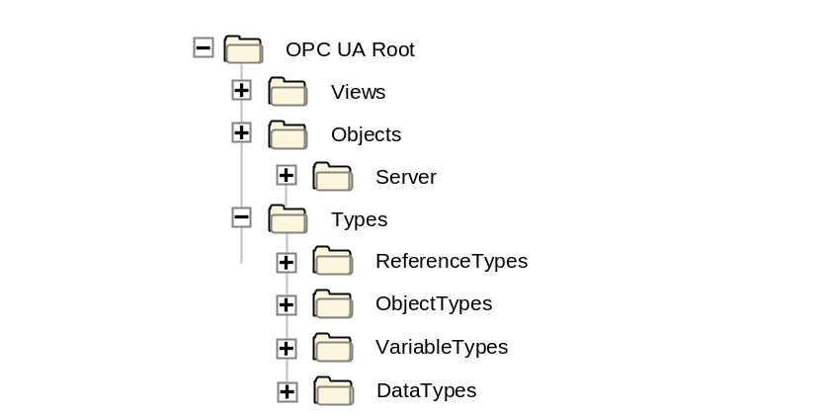
Figure 1 – Standard AddressSpace Structure
The remainder of this provides descriptions of these standard Nodes and the organization of Nodes beneath them. Servers typically implement a subset of these standard Nodes, depending on their capabilities.

Root
This standard Object is the browse entry point for the AddressSpace. It contains a set of Organizes References that point to the other standard Objects. The “Root” Object shall not reference any other NodeClasses. It is formally defined in Table 69.
Table 69 – Root Definition
Attribute | Value
BrowseName | Root
References |  | NodeClass | BrowseName | Comment
HasTypeDefinition |  | ObjectType | FolderType | Defined in 6.6
Organizes |  | Object | Views | Defined in 8.2.3
Organizes |  | Object | Objects | Defined in 8.2.4
Organizes |  | Object | Types | Defined in 8.2.5

Views
This standard Object is the browse entry point for Views. Only Organizes References are used to relate View Nodes to the “Views” standard Object. All View Nodes in the AddressSpace shall be referenced by this Node, either directly or indirectly. I.e. the “Views” Object may reference other Objects using Organizes References. Those Objects may reference additional Views. Figure 2 illustrates this. The “Views” standard Object directly references the Views “View1” and “View2” and indirectly “View3” by referencing another Object called “Engineering”.
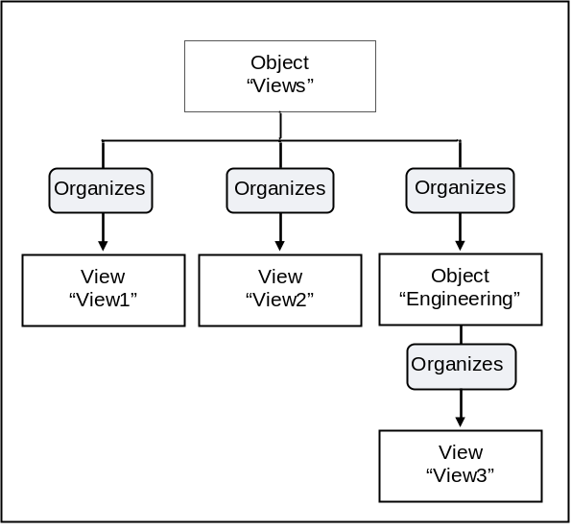
Figure 2 – Views Organization
The “Views” Object shall not reference any other NodeClasses. The “Views” Object is formally defined in Table 70.
Table 70 – Views Definition
Attribute | Value
BrowseName | Views
References |  | NodeClass | BrowseName | Comment
HasTypeDefinition |  | ObjectType | FolderType | Defined in 6.6

Objects
This standard Object is the browse entry point for Object Nodes. Figure 3 illustrates the structure beneath this Node. Only Organizes References are used to relate Objects to the “Objects” standard Object. A View Node can be used as entry point into a subset of the AddressSpace containing Objects and Variables and thus the “Objects“ Object can also reference View Nodes using Organizes References. The intent of the “Objects” Object is that all Objects and Variables that are not used for type definitions or other organizational purposes (e.g. organizing the Views) are accessible through hierarchical References starting from this Node. However, this is not a requirement, because not all servers may be able to support this. This Object references the standard Server Object defined in 8.3.2.
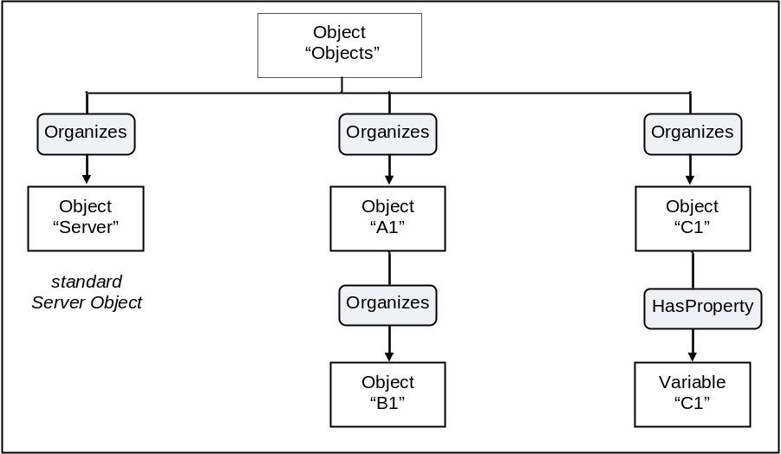
Figure 3 – Objects Organization
The “Objects” Object shall not reference any other NodeClasses. The “Objects” Object is formally defined in Table 71.
Table 71 – Objects Definition
Attribute | Value
BrowseName | Objects
References |  | NodeClass | BrowseName | Comment
HasTypeDefinition |  | ObjectType | FolderType | Defined in 6.6
Organizes |  | Object | Server | Defined in 8.3.2

Types
This standard Object Node is the browse entry point for type Nodes. Figure 1 illustrates the structure beneath this Node. Only Organizes References are used to relate Objects to the “Types” standard Object. The “Types” Object shall not reference any other NodeClasses. It is formally defined in Table 72.
Table 72 – Types Definition
Attribute | Value
BrowseName | Types
References |  | NodeClass | BrowseName | Comment
HasTypeDefinition |  | ObjectType | FolderType | Defined in 6.6
Organizes |  | Object | ObjectTypes | Defined in 8.2.6
Organizes |  | Object | VariableTypes | Defined in 8.2.7
Organizes |  | Object | ReferenceTypes | Defined in 8.2.8
Organizes |  | Object | DataTypes | Defined in 8.2.9

ObjectTypes
This standard Object Node is the browse entry point for ObjectType Nodes. Figure 4 illustrates the structure beneath this Node showing some of the standard ObjectTypes defined in 6. Only Organizes References are used to relate Objects and ObjectTypes to the “ObjectTypes” standard Object. The “ObjectTypes” Object shall not reference any other NodeClasses.
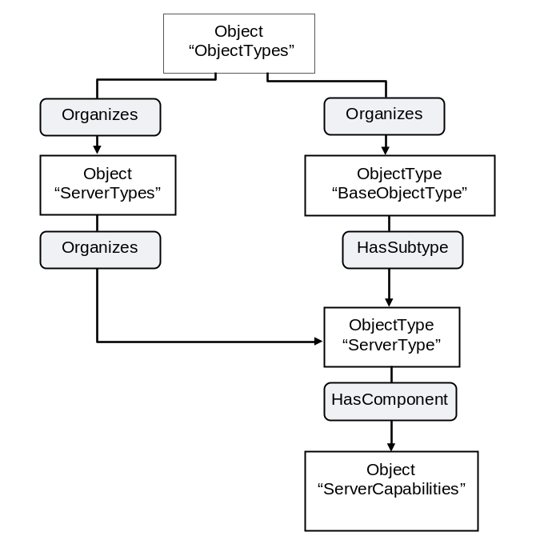
Figure 4 – ObjectTypes Organization
The intention of the “ObjectTypes” Object is that all ObjectTypes of the server are either directly or indirectly accessible browsing HierarchicalReferences starting from this Node. However, this is not required and servers might not provide some of their ObjectTypes because they may be well-known in the industry, such as the Server Type defined in 6.3.1.
This Object also indirectly references the BaseEventType defined in 6.4.2, which is the base type of all EventTypes. Thereby it is the entry point for all EventTypes provided by the server. It is required that the server expose all its EventTypes, so a client can usefully subscribe to Events.
The “ObjectTypes” Object is formally defined in Table 73.
Table 73 – ObjectTypes Definition
Attribute | Value
BrowseName | ObjectTypes
References |  | NodeClass | BrowseName | Comment
HasTypeDefinition |  | ObjectType | FolderType | Defined in 6.6
Organizes |  | ObjectType | BaseObjectType | Defined in 6.2

VariableTypes
This standard Object is the browse entry point for VariableType Nodes. Figure 5 illustrates the structure beneath this Node. Only Organizes References are used to relate Objects and VariableTypes to the “VariableTypes” standard Object. The “VariableTypes” Object shall not reference any other NodeClasses.
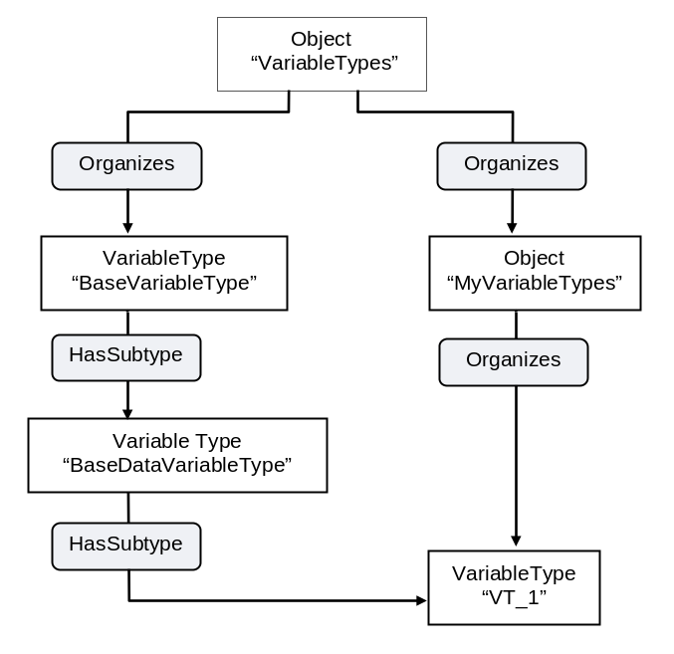
Figure 5 – VariableTypes Organization
The intent of the “VariableTypes” Object is that all VariableTypes of the server are either directly or indirectly accessible browsing HierarchicalReferences starting from this Node. However, this is not required and servers might not provide some of their VariableTypes, because they may be well-known in the industry, such as the “BaseVariableType” defined in 7.2.
The “VariableTypes” Object is formally defined in Table 74.
Table 74 – VariableTypes Definition
Attribute | Value
BrowseName | VariableTypes
References |  | NodeClass | BrowseName | Comment
HasTypeDefinition |  | ObjectType | FolderType | Defined in 6.6
Organizes |  | VariableType | BaseVariableType | Defined in 7.2

ReferenceTypes
This standard Object is the browse entry point for ReferenceType Nodes. Figure 6 illustrates the organization of ReferenceTypes. Organizes References are used to define ReferenceTypes and Objects referenced by the “ReferenceTypes” Object. The “ReferenceTypes” Object shall not reference any other NodeClasses. See 11 for a discussion of the standard ReferenceTypes that appear beneath the “ReferenceTypes” Object.
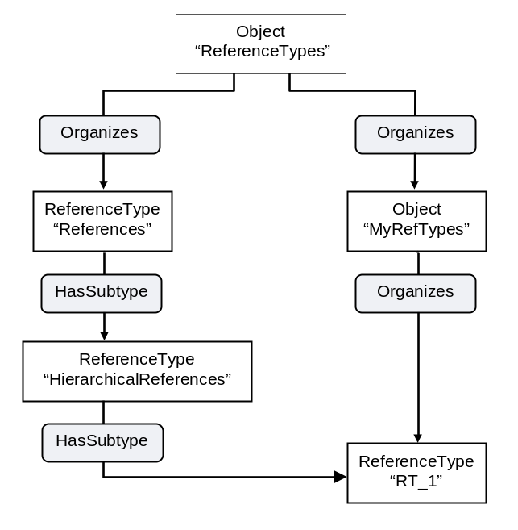
Figure 6 – ReferenceType Definitions
Since ReferenceTypes will be used as filters in the browse Service and in queries, the server shall provide all its ReferenceTypes, directly or indirectly following hierarchical References starting from the “ReferenceTypes” Object. This means that, whenever the client follows a Reference, the server shall expose the type of this Reference in the ReferenceType hierarchy. It shall provide all ReferenceTypes so that the client would be able, following the inverse subtype of References, to come to the base References ReferenceType. It does not mean that the server shall expose the ReferenceTypes that the client has not used any Reference of.
The “ReferenceTypes” Object is formally defined in Table 75.
Table 75 – ReferenceTypes Definition
Attribute | Value
BrowseName | ReferenceTypes
References |  | NodeClass | BrowseName | Comment
HasTypeDefinition |  | ObjectType | FolderType | Defined in 6.6
Organizes |  | ReferenceType | References | Defined in 11.1

DataTypes
This standard Object is the browse entry point for DataTypes that the server wishes to expose in the AddressSpace. The standard Object uses Organizes References to reference Objects of the DataTypeSystemType representing DataTypeSystems. Referenced by those Objects are DataTypeDictionaries that refer to their DataTypeDescriptions. However, it is not required to provide the DataTypeSystem Objects, and the DataTypeDictionary need not to be provided.
Because DataTypes are not related to DataTypeDescriptions using hierarchical References, DataType Nodes should be made available using Organizes References pointing either directly from the “DataTypes” Object to the DataType Nodes or using additional Folder Objects for grouping purposes. The intent is that all DataTypes of the server exposed in the AddressSpace are accessible following hierarchical References starting from the “DataTypes” Object. However, this is not required.
Figure 7 illustrates this hierarchy using the “OPC Binary” and “XML Schema” standard DataTypeSystems as examples. Other DataTypeSystems may be defined under this Object.
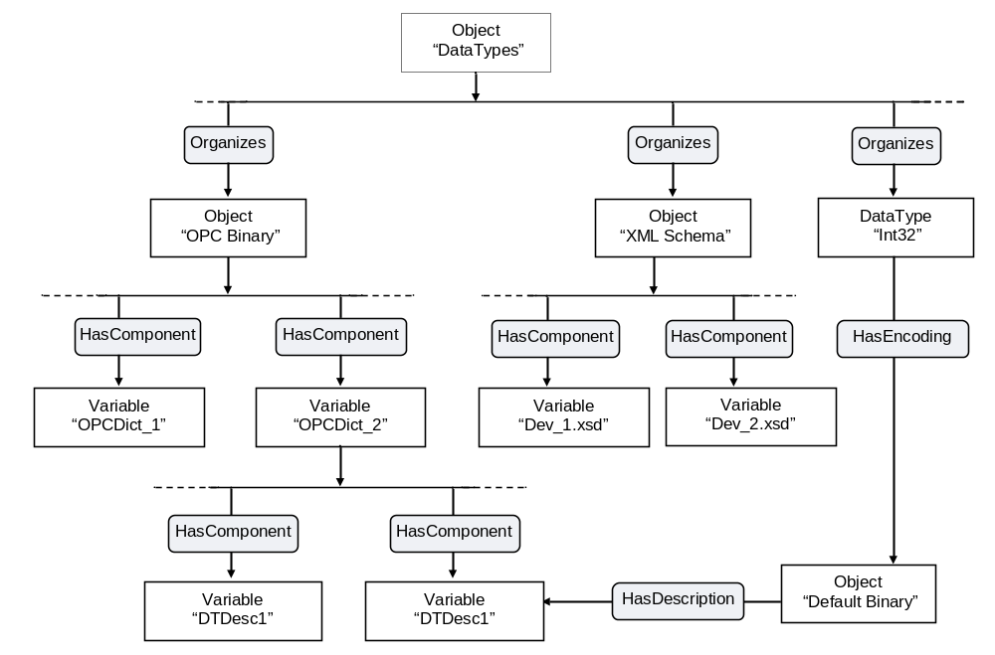
Figure 7 – DataTypes Organization
Each DataTypeSystem Object is related to its DataTypeDictionary Nodes using HasComponent References. Each DataTypeDictionary Node is related to its DataTypeDescription Nodes using HasComponent References. These References indicate that the DataTypeDescriptions are defined in the dictionary.
In the example, the “DataTypes” Object references the DataType “Int32” using an Organizes Reference. The DataType uses the non-hierarchical HasEncoding Reference to point to its default encoding, which references a DataTypeDescription using the non-hierarchical HasDescription Reference.
The “DataTypes” Object is formally defined in Table 76.
Table 76 – DataTypes Definition
Attribute | Value
BrowseName | DataTypes
References |  | NodeClass | BrowseName | Comment
HasTypeDefinition |  | ObjectType | FolderType | Defined in 6.6
Organizes |  | Object | OPC Binary | Defined in 8.2.10
Organizes |  | Object | XML Schema | Defined in 8.2.11
Organizes |  | DataType | BaseDataType | Defined in 12.2

OPC Binary
OPC Binary is a standard DataTypeSystem defined by OPC. It is represented in the AddressSpace by an Object Node. The OPC Binary DataTypeSystem is defined in Part 3. OPC Binary uses XML to describe complex binary data values. The “OPC Binary” Object is formally defined in Table 77.
Table 77 – OPC Binary Definition
Attribute | Value
BrowseName | OPC Binary
References |  | NodeClass | BrowseName | Comment
HasTypeDefinition |  | ObjectType | DataTypeSystemType | Defined in 6.8

XML Schema
XML Schema is a standard DataTypeSystem defined by the W3C. It is represented in the AddressSpace by an Object Node. XML Schema documents are XML documents whose xmlns attribute in the first line is:
schema xmlns =http://www.w3.org/1999/XMLSchema
The “XML Schema” Object is formally defined in Table 78.
Table 78 – XML Schema Definition
Attribute | Value
BrowseName | XML Schema
References |  | NodeClass | BrowseName | Comment
HasTypeDefinition |  | ObjectType | DataTypeSystemType | Defined in 6.8

Server Object and its containing Objects

General
The Server Object and its containing Objects and Variables are built in a way that the information can be gained in several ways, suitable for different kinds of clients having different requirements. Appendix A gives an overview of the design decisions made in providing the information in that way, and discusses the pros and cons of the different approaches. Figure 8 gives an overview of the containing Objects and Variables of the diagnostic information of the Server Object and where the information can be found.
The SessionsDiagnosticsSummary Object contains one Object per session and a Variable with an array with one entry per session. This array is of a complex DataType holding the diagnostic information about the session. Each Object representing a session references a complex Variable containing the information about the session using the same DataType as the array containing information about all sessions. Such a Variable also exposes all its information as Variables with simple DataTypes containing the same information as in the complex DataType. Not shown in Figure 8 is the security-related information per session, which follows the same rules.
The server provides an array with an entry per subscription containing diagnostic information about this subscription. Each entry of this array is also exposed as a complex Variable with Variables for each individual value. Each Object representing a session also provides such an array, but providing the subscriptions of the session.
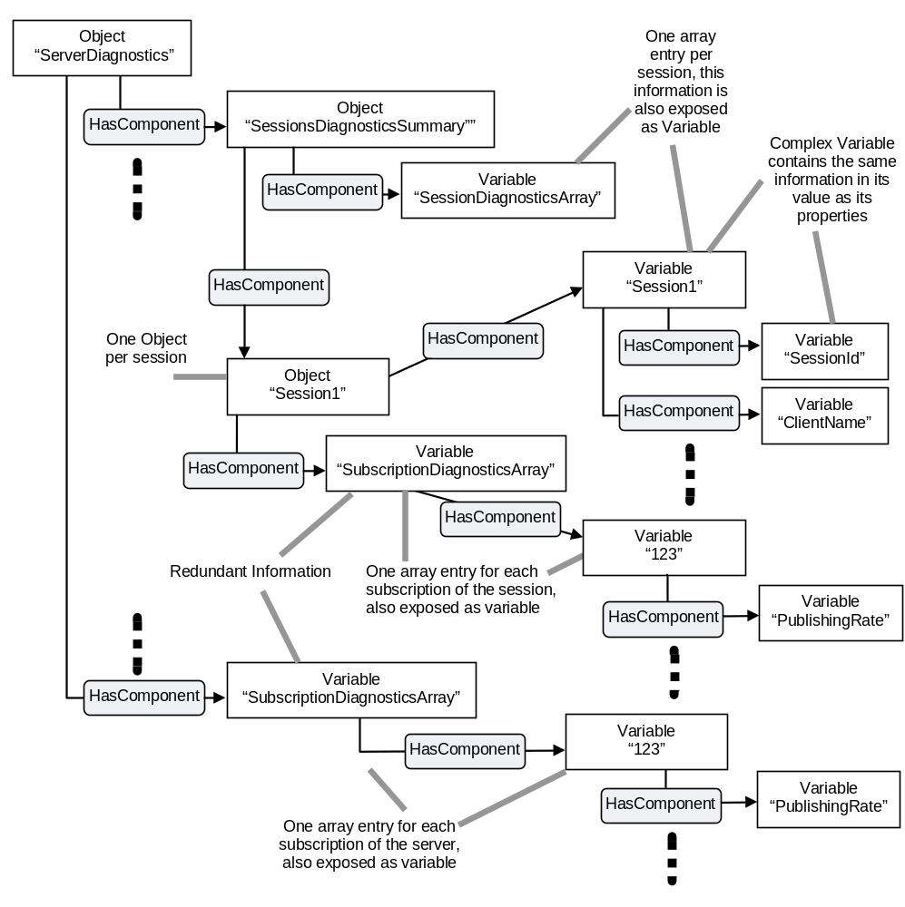
Figure 8 – Excerpt of Diagnostic Information of the Server

Server Object
This Object is used as the browse entry point for information about the server. The content of this Object is already defined by its type definition in 6.3.1. It is formally defined in Table 79. The Server Object serves as root notifier, i.e. its EventNotifier Attribute shall be set providing Events. All Events of the server shall be accessible subscribing to the Events of the Server Object.
Table 79 – Server Definition
Attribute | Value
BrowseName | Server
References |  | Node  Class | BrowseName | DataType | TypeDefinition | ModellingRule
HasTypeDefinition |  | Object  Type | ServerType | Defined in 6.3.1
HasProperty |  | Variable | ServerArray | String[] | PropertyType | Mandatory
HasProperty |  | Variable | NamespaceArray | String[] | PropertyType | Mandatory
HasComponent |  | Variable | ServerStatus¹ | ServerStatusDataType | PropertyType | Mandatory
HasProperty |  | Variable | ServiceLevel | Byte | PropertyType | Mandatory
HasComponent |  | Object | ServerCapabilities¹ | -- | ServerCapabilities | Mandatory
HasComponent |  | Object | ServerDiagnostics¹ | -- | ServerDiagnosticsType | Mandatory
HasComponent |  | Object | VendorServerInfo | -- | vendor-specific² | Mandatory
HasComponent |  | Object | ServerRedundancy¹ | -- | depends on supported redundancy³ | Mandatory
Notes –
- Containing Objects and Variables of these Objects and Variables are defined by their BrowseName defined in the corresponding TypeDefinitionNode. The NodeId is defined by the composed symbolic name described in 4.1.
- Shall be the VendorServerInfo ObjectType or one of its subtypes
- Shall be the ServerRedundancyType or one of its subtypes

ModellingRule Objects

ExposesItsArray
The ModellingRule ExposesItsArray is defined in Part 3. Its representation in the AddressSpace – the “ExposesItsArray” Object – is formally defined in Table 80.
Table 80 – ExposesItsArray Definition
Attribute | Value
BrowseName | ExposesItsArray
References |  | NodeClass | BrowseName | Comment
HasTypeDefinition |  | ObjectType | ModellingRuleType | Defined in 6.5
HasProperty |  | Variable | NamingRule | Value set to “Constraint”

Mandatory
The ModellingRule Mandatory is defined in Part 3. Its representation in the AddressSpace – the “Mandatory” Object – is formally defined in Table 81.
Table 81 – Mandatory Definition
Attribute | Value
BrowseName | Mandatory
References |  | NodeClass | BrowseName | Comment
HasTypeDefinition |  | ObjectType | ModellingRuleType | Defined in 6.5
HasProperty |  | Variable | NamingRule | Value set to “Mandatory”

Optional
The ModellingRule Optional is defined in Part 3. Its representation in the AddressSpace – the “Optional” Object – is formally defined in Table 82.
Table 82 – Optional Definition
Attribute | Value
BrowseName | Optional
References |  | NodeClass | BrowseName | Comment
HasTypeDefinition |  | ObjectType | ModellingRuleType | Defined in 6.5
HasProperty |  | Variable | NamingRule | Value set to “Optional”

Standard Methods
There are no core OPC UA Methods defined.

Standard Views
There are no core OPC UA Views defined.

Standard ReferenceTypes

References
This standard ReferenceType is defined in Part 3. Its representation in the AddressSpace is specified in Table 83.
Table 83 – References ReferenceType
Attributes | Value
BrowseName | References
InverseName | --
Symmetric | True
IsAbstract | True
References | NodeClass | BrowseName | Comment
HasSubtype | ReferenceType | HierarchicalReferences | Defined in 11.2
HasSubtype | ReferenceType | NonHierarchicalReferences | Defined in 11.3

HierarchicalReferences
This standard ReferenceType is defined in Part 3. Its representation in the AddressSpace is specified in Table 84.
Table 84 – HierarchicalReferences ReferenceType
Attributes | Value
BrowseName | HierarchicalReferences
InverseName | --
Symmetric | False
IsAbstract | True
References | NodeClass | BrowseName | Comment
HasSubtype | ReferenceType | HasChild | Defined in 11.4
HasSubtype | ReferenceType | Organizes | Defined in 11.6
HasSubtype | ReferenceType | HasEventSource | Defined in 11.15

NonHierarchicalReferences
This standard ReferenceType is defined in Part 3. Its representation in the AddressSpace is specified in Table 85.
Table 85 – NonHierarchicalReferences ReferenceType
Attributes | Value
BrowseName | NonHierarchicalReferences
InverseName | --
Symmetric | True
IsAbstract | True
References | NodeClass | BrowseName | Comment
HasSubtype | ReferenceType | HasModellingRule | Defined in 11.11
HasSubtype | ReferenceType | HasTypeDefinition | Defined in 11.12
HasSubtype | ReferenceType | HasEncoding | Defined in 11.13
HasSubtype | ReferenceType | HasDescription | Defined in 11.14
HasSubtype | ReferenceType | GeneratesEvent | Defined in 11.17

HasChild
This standard ReferenceType is defined in Part 3. Its representation in the AddressSpace is specified in Table 87.
Table 86 – HasChild ReferenceType
Attributes | Value
BrowseName | HasChild
InverseName | --
Symmetric | False
IsAbstract | True
References | NodeClass | BrowseName | Comment
HasSubtype | ReferenceType | Aggregates | Defined in 11.5

Aggregates
This standard ReferenceType is defined in Part 3. Its representation in the AddressSpace is specified in Table 87.
Table 87 – Aggregates ReferenceType
Attributes | Value
BrowseName | Aggregates
InverseName | --
Symmetric | False
IsAbstract | True
References | NodeClass | BrowseName | Comment
HasSubtype | ReferenceType | HasComponent | Defined in 11.7
HasSubtype | ReferenceType | HasProperty | Defined in 11.9
HasSubtype | ReferenceType | HasSubtype | Defined in 11.10

Organizes
This standard ReferenceType is defined in Part 3. Its representation in the AddressSpace is specified in Table 88.
Table 88 – Organizes ReferenceType
Attributes | Value
BrowseName | Organizes
InverseName | OrganizedBy
Symmetric | False
IsAbstract | False
References | NodeClass | BrowseName | Comment

HasComponent
This standard ReferenceType is defined in Part 3. Its representation in the AddressSpace is specified in Table 89.
Table 89 – HasComponent ReferenceType
Attributes | Value
BrowseName | HasComponent
InverseName | ComponentOf
Symmetric | False
IsAbstract | False
References | NodeClass | BrowseName | Comment
HasSubtype | ReferenceType | HasOrderedComponent | Defined in 11.8

HasOrderedComponent
This standard ReferenceType is defined in Part 3. Its representation in the AddressSpace is specified in Table 90.
Table 90 – HasOrderedComponent ReferenceType
Attributes | Value
BrowseName | HasOrderedComponent
InverseName | OrderedComponentOf
Symmetric | False
IsAbstract | False
References | NodeClass | BrowseName | Comment

HasProperty
This standard ReferenceType is defined in Part 3. Its representation in the AddressSpace is specified in Table 91.
Table 91 – HasProperty ReferenceType
Attributes | Value
BrowseName | HasProperty
InverseName | PropertyOf
Symmetric | False
IsAbstract | False
References | NodeClass | BrowseName | Comment

HasSubtype
This standard ReferenceType is defined in Part 3. Its representation in the AddressSpace is specified in Table 92.
Table 92 – HasSubtype ReferenceType
Attributes | Value
BrowseName | HasSubtype
InverseName | SubtypeOf
Symmetric | False
IsAbstract | False
References | NodeClass | BrowseName | Comment

HasModellingRule
This standard ReferenceType is defined in Part 3. Its representation in the AddressSpace is specified in Table 93.
Table 93 – HasModellingRule ReferenceType
Attributes | Value
BrowseName | HasModellingRule
InverseName | ModellingRuleOf
Symmetric | False
IsAbstract | False
References | NodeClass | BrowseName | Comment

HasTypeDefinition
This standard ReferenceType is defined in Part 3. Its representation in the AddressSpace is specified in Table 94.
Table 94 – HasTypeDefinition ReferenceType
Attributes | Value
BrowseName | HasTypeDefinition
InverseName | TypeDefinitionOf
Symmetric | False
IsAbstract | False
References | NodeClass | BrowseName | Comment

HasEncoding
This standard ReferenceType is defined in Part 3. Its representation in the AddressSpace is specified in Table 94.
Table 95 – HasEncoding ReferenceType
Attributes | Value
BrowseName | HasEncoding
InverseName | EncodingOf
Symmetric | False
IsAbstract | False
References | NodeClass | BrowseName | Comment

HasDescription
This standard ReferenceType is defined in Part 3. Its representation in the AddressSpace is specified in Table 94.
Table 96 – HasDescription ReferenceType
Attributes | Value
BrowseName | HasDescription
InverseName | DescriptionOf
Symmetric | False
IsAbstract | False
References | NodeClass | BrowseName | Comment

HasEventSource
This standard ReferenceType is defined in Part 3. Its representation in the AddressSpace is specified in Table 97.
Table 97 – HasEventSource ReferenceType
Attributes | Value
BrowseName | HasEventSource
InverseName | EventSourceOf
Symmetric | False
IsAbstract | False
References | NodeClass | BrowseName | Comment
HasSubtype | ReferenceType | HasNotifier | Defined in 11.16

HasNotifier
This standard ReferenceType is defined in Part 3. Its representation in the AddressSpace is specified in Table 98.
Table 98 – HasNotifier ReferenceType
Attributes | Value
BrowseName | HasNotifier
InverseName | NotifierOf
Symmetric | False
IsAbstract | False
References | NodeClass | BrowseName | Comment

GeneratesEvent
This standard ReferenceType is defined in Part 3. Its representation in the AddressSpace is specified in Table 99.
Table 99 – GeneratesEvent ReferenceType
Attributes | Value
BrowseName | GeneratesEvent
InverseName | GeneratedBy
Symmetric | False
IsAbstract | False
References | NodeClass | BrowseName | Comment

Standard DataTypes

Overview
An OPC UA server need not expose its DataTypes in its AddressSpace. Independent of the exposition of DataTypes, it shall support the DataTypes as described in the following subclauses. The DataTypeEncodings, the DataTypeDescriptions and the DataTypeDictionaries of the structured DataTypes and the References to them are specified in Part 6 as well as the EnumStrings Properties for enumerated DataTypes.

DataTypes defined in Part 3
Part 3 defines a set of DataTypes. Their representation in the AddressSpace is defined in Table 100.
Table 100 – Part 3 DataType Definitions
BrowseName
BaseDataType
Argument
Boolean
Byte
ByteString
DateTime
Double
Duration
Enumeration
Float
Guid
IdType
SByte
Integer
Int16
Int32
Int64
Image
ImageBMP
ImageGIF
ImageJPG
ImagePNG
LocaleId
LocalizedText
NamingRuleType
NodeClass
NodeId
Number
QualifiedName
String
Structure
Time
UInteger
UInt16
UInt32
UInt64
UtcTime
XmlElement

Of the DataTypes defined in Table 100 only some are the sources of References as defined in the following tables.
The References of the BaseDataType are defined in Table 101.
Table 101 – BaseDataType Definition
Attributes | Value
BrowseName | BaseDataType
IsAbstract | TRUE
References |  | NodeClass | BrowseName | IsAbstract
HasSubtype |  | DataType | Boolean | FALSE
HasSubtype |  | DataType | ByteString | FALSE
HasSubtype |  | DataType | DateTime | FALSE
HasSubtype |  | DataType | DataValue | FALSE
HasSubtype |  | DataType | DiagnosticInfo | FALSE
HasSubtype |  | DataType | Enumeration | TRUE
HasSubtype |  | DataType | ExpandedNodeId | FALSE
HasSubtype |  | DataType | Guid | FALSE
HasSubtype |  | DataType | LocalizedText | FALSE
HasSubtype |  | DataType | NodeId | FALSE
HasSubtype |  | DataType | Number | TRUE
HasSubtype |  | DataType | QualifiedName | FALSE
HasSubtype |  | DataType | String | FALSE
HasSubtype |  | DataType | Structure | TRUE
HasSubtype |  | DataType | XmlElement | FALSE

The References of Structure are defined in Table 102.
Table 102 – Structure Definition
Attributes | Value
BrowseName | Structure
IsAbstract | TRUE
References |  | NodeClass | BrowseName | IsAbstract
HasSubtype |  | DataType | Argument | FALSE
HasSubtype |  | DataType | UserIdentityToken | TRUE
HasSubtype |  | DataType | AddNodesItem | FALSE
HasSubtype |  | DataType | AddReferencesItem | FALSE
HasSubtype |  | DataType | DeleteNodesItem | FALSE
HasSubtype |  | DataType | DeleteReferencesItem | FALSE
HasSubtype |  | DataType | ApplicationDescription | FALSE
HasSubtype |  | DataType | BuildInfo | FALSE
HasSubtype |  | DataType | RedundantServerDataType | FALSE
HasSubtype |  | DataType | SamplingRateDiagnosticsDataType | FALSE
HasSubtype |  | DataType | ServerDiagnosticsSummaryDataType | FALSE
HasSubtype |  | DataType | ServerStatusDataType | FALSE
HasSubtype |  | DataType | SessionDiagnosticsDataType | FALSE
HasSubtype |  | DataType | SessionSecurityDiagnosticsDataType | FALSE
HasSubtype |  | DataType | ServiceCounterDataType | FALSE
HasSubtype |  | DataType | StatusResult | FALSE
HasSubtype |  | DataType | SubscriptionDiagnosticsDataType | FALSE
HasSubtype |  | DataTypes | ModelChangeStructureDataType | FALSE
HasSubtype |  | DataTypes | SemanticChangeStructureDataType | FALSE
HasSubtype |  | DataType | SignedSoftwareCertificate | FALSE

The References of Enumeration are defined in Table 103.
Table 103 – Enumeration Definition
Attributes | Value
BrowseName | Enumeration
IsAbstract | TRUE
References |  | NodeClass | BrowseName | IsAbstract
HasSubtype |  | DataType | IdType | FALSE
HasSubtype |  | DataType | NamingRuleType | FALSE
HasSubtype |  | DataType | NodeClass | FALSE
HasSubtype |  | DataType | SecurityTokenRequestType | FALSE
HasSubtype |  | DataType | MessageSecurityMode | FALSE
HasSubtype |  | DataType | RedundancySupport | FALSE
HasSubtype |  | DataType | ServerState | FALSE

The References of ByteString are defined in Table 104.
Table 104 – ByteString Definition
Attributes | Value
BrowseName | ByteString
IsAbstract | TRUE
References | NodeClass | BrowseName | IsAbstract
HasSubtype | DataType | Image | TRUE

The References of Number are defined in Table 105.
Table 105 – Number Definition
Attributes | Value
BrowseName | Number
IsAbstract | TRUE
References | NodeClass | BrowseName | IsAbstract
HasSubtype | DataType | Integer | TRUE
HasSubtype | DataType | UInteger | TRUE
HasSubtype | DataType | Double | FALSE
HasSubtype | DataType | Float | FALSE
The References of Double are defined in Table 106.
Table 106 – Double Definition
Attributes | Value
BrowseName | Double
IsAbstract | FALSE
References | NodeClass | BrowseName | IsAbstract
HasSubtype | DataType | Duration | FALSE

The References of Integer are defined in Table 107.
Table 107 – Integer Definition
Attributes | Value
BrowseName | Integer
IsAbstract | TRUE
References | NodeClass | BrowseName | IsAbstract
HasSubtype | DataType | SByte | FALSE
HasSubtype | DataType | Int16 | FALSE
HasSubtype | DataType | Int32 | FALSE
HasSubtype | DataType | Int64 | FALSE

The References of DateTime are defined in Table 108.
Table 108 – DateTime Definition
Attributes | Value
BrowseName | DateTime
IsAbstract | FALSE
References | NodeClass | BrowseName | IsAbstract
HasSubtype | DataType | UtcTime | FALSE

The References of String are defined in Table 107.
Table 109 – String Definition
Attributes | Value
BrowseName | String
IsAbstract | FALSE
References | NodeClass | BrowseName | IsAbstract
HasSubtype | DataType | LocaleId | FALSE
HasSubtype | DataType | NumericRange | FALSE

The References of UInteger are defined in Table 110.
Table 110 – UInteger Definition
Attributes | Value
BrowseName | UInteger
IsAbstract | TRUE
References | NodeClass | BrowseName | IsAbstract
HasSubtype | DataType | Byte | FALSE
HasSubtype | DataType | UInt16 | FALSE
HasSubtype | DataType | UInt32 | FALSE
HasSubtype | DataType | UInt64 | FALSE

The References of Image are defined in Table 111.
Table 111 – Image Definition
Attributes | Value
BrowseName | Image
IsAbstract | TRUE
References | NodeClass | BrowseName | IsAbstract
HasSubtype | DataType | ImageBMP | FALSE
HasSubtype | DataType | ImageGIF | FALSE
HasSubtype | DataType | ImageJPG | FALSE
HasSubtype | DataType | ImagePNG | FALSE

DataTypes defined in Part 4
Part 4 defines a set of DataTypes. Their representation in the AddressSpace is defined in Table 112.
Table 112 – Part 4 DataType Definitions
BrowseName
AnonymousIdentityToken
DataValue
DiagnosticInfo
ExpandedNodeId
SignedSoftwareCertificate
UserIdentityToken
UserNameIdentityToken
X509IdentityToken
WssIdentityToken
SecurityTokenRequestType
AddNodesItem
AddReferencesItem
DeleteNodesItem
DeleteReferencesItem
NumericRange
MessageSecurityMode
ApplicationDescription

The SecurityTokenRequestType is an enumeration that is defined as the type of the requestType parameter of the OpenSecureChannel Service in Part 4.
The AddNodesItem is a structure that is defined as the type of the nodesToAdd parameter of the AddNodes Service in Part 4.
The AddReferencesItem is a structure that is defined as the type of the referencesToAdd parameter of the AddReferences Service in Part 4.
The DeleteNodesItem is a structure that is defined as the type of the nodesToDelete parameter of the DeleteNodes Service in Part 4.
The DeleteReferencesItem is a structure that is defined as the type of the referencesToDelete parameter of the DeleteReferences Service in Part 4.
The References of UserIdentityToken are defined in Table 113.
Table 113 – UserIdentityToken Definition
Attributes | Value
BrowseName | UserIdentityToken
IsAbstract | TRUE
References | NodeClass | BrowseName | IsAbstract
HasSubtype | DataType | UserNameIdentityToken | FALSE
HasSubtype | DataType | X509IdentityToken | FALSE
HasSubtype | DataType | WssIdentityToken | FALSE
HasSubtype | DataType | AnonymousIdentityToken | FALSE

BuildInfo
This structure contains elements that describe the build information of the server. Its elements are defined in Table 114.
Table 114 – BuildInfo Structure
Name | Type | Description
BuildInfo | structure | Information that describes the build of the software.
productUri | String | URI that identifies the software
manufacturerName | String | Name of the software manufacturer.
productName | String | Name of the software.
softwareVersion | String | Software version
buildNumber | String | Build number
buildDate | UtcTime | Date and time of the build.

Its representation in the AddressSpace is defined in Table 115.
Table 115 – BuildInfo Definition
Attributes | Value
BrowseName | BuildInfo

RedundancySupport
This DataType is an enumeration that defines the redundancy support of the server. Its values are defined in Table 116.
Table 116 – RedundancySupport Values
Value | Description
NONE_0 | None means that there is no redundancy support.
COLD_1 | Cold means that the redundant servers are operational, but do not have any subscriptions defined and do not accept requests to create one.
WARM_2 | Warm means that the redundant servers have redundant subscriptions, but with sampling disabled.
HOT_3 | Hot means that the redundant servers have redundant subscriptions with sampling enabled, but not reporting.
See Part 1 for a more detailed description of the different values.
Its representation in the AddressSpace is defined in Table 117.
Table 117 – RedundancySupport Definition
Attributes | Value
BrowseName | RedundancySupport

ServerState
This DataType is an enumeration that defines the execution state of the server. Its values are defined in Table 118.
Table 118 – ServerState Values
Value | Description
RUNNING_0 | The server is running normally. This is the usual state for a server.
FAILED_1 | A vendor-specific fatal error has occurred within the server. The server is no longer functioning. The recovery procedure from this situation is vendor-specific. Most Service requests should be expected to fail.
NO_CONFIGURATION_2 | The server is running but has no configuration information loaded and therefore does not transfer data.
SUSPENDED_3 | The server has been temporarily suspended by some vendor-specific method and is not receiving or sending data.
SHUTDOWN_4 | The server has shut down. Depending on the implementation, this might or might not be visible to clients.
TEST_5 | The server is in Test Mode. The outputs are disconnected from the real hardware, but the server will otherwise behave normally. Inputs may be real or may be simulated depending on the vendor implementation. StatusCode will generally be returned normally.
COMMUNICATION_FAULT_6 | The server is running properly, but is having difficulty accessing data from its data sources. This may be due to communication problems or some other problem preventing the underlying device, control system, etc. from returning valid data. It may be a complete failure, meaning that no data is available, or a partial failure, meaning that some data is still available. It is expected that items affected by the fault will individually return with a BAD FAILURE status code indication for the items.
UNKNOWN_7 | This state is used only to indicate that the OPC UA server does not know the state of underlying servers.

Its representation in the AddressSpace is defined in Table 119.
Table 119 – ServerState Definition
Attributes | Value
BrowseName | ServerState

RedundantServerDataType
This structure contains elements that describe the status of the server. Its composition is defined in Table 120.
Table 120 – RedundantServerDataType Structure
Name | Type | Description
RedundantServerDataType | structure
serverId | String | The Id of the server (not the URI).
serviceLevel | Byte | The service level of the server
serverState | ServerState | The current state of the server.

Its representation in the AddressSpace is defined in Table 121.
Table 121 – RedundantServerDataType Definition
Attributes | Value
BrowseName | RedundantServerDataType

SamplingRateDiagnosticsDataType
This structure contains diagnostic information about the sampling rates currently used by the server. Its elements are defined in Table 122.
Table 122 – SamplingRateDiagnosticsDataType Structure
Name | Type | Description
SamplingRateDiagnosticsDataType | structure
samplingRate | Duration | The sampling rate in milliseconds
samplingErrorCount | UInt32 | The number of times access to a MonitoredItem at this sample rate failed since the server was started (restarted).
sampledMonitoredItemsCount | UInt32 | The number of MonitoredItems being sampled at this sample rate.
maxSampledMonitoredItemsCount | UInt32 | The maximum number of MonitoredItems being sampled at this sample rate at the same time since the server was started (restarted).
disabledMonitoredItemsSamplingCount | UInt32 | The number of MonitoredItems at this sample rate whose sampling currently disabled.

Its representation in the AddressSpace is defined in Table 123.
Table 123 – SamplingRateDiagnosticsDataType Definition
Attributes | Value
BrowseName | SamplingRateDiagnosticsDataType

ServerDiagnosticsSummaryDataType
This structure contains diagnostic summary information for the server. Its elements are defined in Table 124.
Table 124 – ServerDiagnosticsSummaryDataType Structure
Name | Type | Description
ServerDiagnosticsSummaryDataType | structure
serverViewCount | UInt32 | The number of server-created views in the server.
currentSessionCount | UInt32 | The number of client sessions currently established in the server.
cumulatedSessionCount | UInt32 | The cumulative number of client sessions that have been established in the server since the server was started (or restarted). This includes the currentSessionCount.
securityRejectedSessionCount | UInt32 | The number of client session establishment requests that were rejected due to security constraints since the server was started (or restarted).
rejectedSessionCount | UInt32 | The number of client session establishment requests that were rejected since the server was started (or restarted). This number includes the securityRejectedSessionCount.
sessionTimeoutCount | UInt32 | The number of client sessions that were closed due to timeout since the server was started (or restarted).
sessionAbortCount | UInt32 | The number of client sessions that were closed due to errors since the server was started (or restarted).
samplingRateCount | UInt32 | The number of sampling rates currently used in the server.
publishingIntervalCount | UInt32 | The number of publishing intervals currently supported in the server.
currentSubscriptionCount | UInt32 | The number of subscriptions currently established in the server.
cumulatedSubscriptionCount | UInt32 | The cumulative number of subscriptions that have been established in the server since the server was started (or restarted). This includes the currentSubscriptionCount.
securityRejectedRequestsCount | UInt32 | The number of requests that were rejected due to security constraints since the server was started (or restarted). The requests include all Services defined in Part 4, also requests to create sessions.
rejectedRequestsCount | UInt32 | The number of requests that were rejected since the server was started (or restarted). The requests include all Services defined in Part 4, also requests to create sessions. This number includes the securityRejectedRequestsCount.

Its representation in the AddressSpace is defined in Table 125.
Table 125 – ServerDiagnosticsSummaryDataType Definition
Attributes | Value
BrowseName | ServerDiagnosticsSummaryDataType

ServerStatusDataType
This structure contains elements that describe the status of the server. Its composition is defined in Table 126.
Table 126 – ServerStatusDataType Structure
Name | Type | Description
ServerStatusDataType | structure
startTime | UtcTime | Time (UTC) the server was started. This is constant for the server instance and is not reset when the server changes state. Each instance of a server should keep the time when the process started.
currentTime | UtcTime | The current time (UTC) as known by the server.
state | ServerState | The current state of the server. Its values are defined in 12.6.
buildInfo | BuildInfo
secondsTillShutdown | UInt32 | Approximate number of seconds until the server will be shut down. The value is only relevant once the state changes into SHUTDOWN.
shutdownReason | LocalizedText | An optional localized text indicating the reason for the shutdown. The value is only relevant once the state changes into SHUTDOWN.

Its representation in the AddressSpace is defined in Table 127.
Table 127 – ServerStatusDataType Definition
Attributes | Value
BrowseName | ServerStatusDataType

SessionDiagnosticsDataType
This structure contains diagnostic information about client sessions. Its elements are defined in Table 128. Most of the values represented in this structure provide information about the number of calls of a Service, the number of currently used MonitoredItems, etc. Those numbers need not provide the exact value; they need only provide the approximate number, so that the server is not burdened with providing the exact numbers.
Table 128 – SessionDiagnosticsDataType Structure
Name | Type | Description
SessionDiagnosticsDataType | structure
sessionId | NodeId | Server-assigned identifier of the session.
sessionName | String | The name of the session provided in the CreateSession request.
clientDesription | Application  Description | The description provided by the client in the CreateSession request.
serverUri | String | The serverUri request in the CreateSession request.
endpointUrl | String | The endpointUrl passed by the client to the CreateSession request.
localeIds | LocaleId[] | Array of LocaleIds specified by the client in the open session call.
actualSessionTimeout | Duration | The requested session timeout specified by the client in the open session call.
clientConnectionTime | UtcTime | The server timestamp when the client opens the session.
clientLastContactTime | UtcTime | The server timestamp of the last request of the client in the context of the session.
currentSubscriptionsCount | UInt32 | The number of subscriptions currently used by the session.
currentMonitoredItemsCount | UInt32 | The number of MonitoredItems currently used by the session
currentPublishRequestsInQueue | UInt32 | The number of publish requests currently in the queue for the session.
currentPublishTimerExpirations | UInt32 | The number of publish timer expirations when there are data to be sent, but there are no publish requests for this session. The value shall be 0 if there are no data to be sent or publish requests queued.
keepAliveCount | UInt32 | Number of publish responds sent from the server without data for this session.
currentRepublishRequestsInQueue | UInt32 | The number of republish requests currently in the queue for the session.
maxRepublishRequestsInQueue | UInt32 | Maximum number of republish requests in the queue for the session.
republishCounter | UInt32 | Number of republish requests for the session, including currentRepublishRequestsInQueue.
publishingCount | UInt32 | The number of Notifications that have been published for the session.
publishingQueueOverflowCount | UInt32 | The number of times an overflow condition occurred for the publishing queue of a MonitoredItem Property. Overflow behaviour is defined by the Queue Model of a MonitoredItem, as specified for the Subscription Service Set in Part 4.
readCount | ServiceCounter  DataType | Counter of the Read Service, identifying the number of received requests of this Service on the session.
historyReadCount | ServiceCounter  DataType | Counter of the HistoryRead Service, identifying the number of received requests of this Service on the session.
writeCount | ServiceCounter  DataType | Counter of the Write Service, identifying the number of received requests of this Service on the session.
historyUpdateCount | ServiceCounter  DataType | Counter of the HistoryUpdate Service, identifying the number of received requests of this Service on the session.
callCount | ServiceCounter  DataType | Counter of the Call Service, identifying the number of received requests of this Service on the session.
createMonitoredItemsCount | ServiceCounter  DataType | Counter of the CreateMonitoredItem Service, identifying the number of received requests of this Service on the session.
modifyMonitoredItemsCount | ServiceCounter  DataType | Counter of the ModifyMonitoredItem Service, identifying the number of received requests of this Service on the session.
setMonitoringModeCount | ServiceCounter  DataType | Counter of the SetMonitoringMode Service, identifying the number of received requests of this Service on the session.
setTriggeringCount | ServiceCounter  DataType | Counter of the SetTriggering Service, identifying the number of received requests of this Service on the session.
deleteMonitoredItemsCount | ServiceCounter  DataType | Counter of the DeleteMonitoredItems Service, identifying the number of received requests of this Service on the session.
createSubscriptionCount | ServiceCounter  DataType | Counter of the CreateSubscription Service, identifying the number of received requests of this Service on the session.
modifySubscriptionCount | ServiceCounter  DataType | Counter of the ModifySubscription Service, identifying the number of received requests of this Service on the session.
setPublishingModeCount | ServiceCounter  DataType | Counter of the SetPublishingMode Service, identifying the number of received requests of this Service on the session.
publishCount | ServiceCounter  DataType | Counter of the Publish Service, identifying the number of received requests of this Service on the session.
republishCount | ServiceCounter  DataType | Counter of the Republish Service, identifying the number of received requests of this Service on the session.
transferSubscriptionsCount | ServiceCounter  DataType | Counter of the TransferSubscriptions Service, identifying the number of received requests of this Service on the session.
deleteSubscriptionsCount | ServiceCounter  DataType | Counter of the DeleteSubscriptions Service, identifying the number of received requests of this Service on the session.
addNodesCount | ServiceCounter  DataType | Counter of the AddNodes Service, identifying the number of received requests of this Service on the session.
addReferencesCount | ServiceCounter  DataType | Counter of the AddReferences Service, identifying the number of received requests of this Service on the session.
deleteNodesCount | ServiceCounter  DataType | Counter of the DeleteNodes Service, identifying the number of received requests of this Service on the session.
deleteReferencesCount | ServiceCounter  DataType | Counter of the DeleteReferences Service, identifying the number of received requests of this Service on the session.
browseCount | ServiceCounter  DataType | Counter of the Browse Service, identifying the number of received requests of this Service on the session.
browseNextCount | ServiceCounter  DataType | Counter of the BrowseNext Service, identifying the number of received requests of this Service on the session.
translateBrowsePathsToNodeIdsCount | ServiceCounter  DataType | Counter of the TranslateBrowsePathsToNodeIds Service, identifying the number of received requests of this Service on the session.
queryFirstCount | ServiceCounter  DataType | Counter of the QueryFirst Service, identifying the number of received requests of this Service on the session.
queryNextCount | ServiceCounter  DataType | Counter of the QueryNext Service, identifying the number of received requests of this Service on the session.
registerNodesCount | ServiceCounter  DataType | Counter of the RegisterNodesCount Service, identifying the number of received requests of this Service on the session.
unregisterNodesCount | ServiceCounter  DataType | Counter of the UnregisterNodesCountService, identifying the number of received requests of this Service on the session.

Its representation in the AddressSpace is defined in Table 129.
Table 129 – SessionDiagnosticsDataType Definition
Attributes | Value
BrowseName | SessionDiagnosticsDataType

SessionSecurityDiagnosticsDataType
This structure contains security-related diagnostic information about client sessions. Its elements are defined in Table 130. Because this information is security-related, it should not be made accessible to all users, but only to authorised users.
Table 130 – SessionSecurityDiagnosticsDataType Structure
Name | Type | Description
SessionSecurityDiagnosticsDataType | structure
sessionId | NodeId | Server-assigned identifier of the session.
clientUserIdOfSession | String | Name of authenticated user when creating the session
clientUserIdHistory | String[] | Array containing the name of the authenticated user currently active (either from creating the session or from calling the ActivateSession Service) and the history of those names. Each time the active user changes, an entry shall be made at the end of the array. The active user is always at the end of the array. Servers may restrict the size of this array, but shall support at least a size of 2.  How the name of the authenticated user can by obtained from the system via the information received as part of the session establishment is defined in 6.4.3.
authenticationMechanism | String | Type of authentication (user name and password, X.509, Kerberos).
encoding | String | Which encoding is used on the wire, e.g. XML or UA Binary.
transportProtocol | String | Which transport protocol is used, e.g. TCP or HTTP.
securityMode | MessageSecurityMode | The message security mode used for the session.
securityPolicyUri | String | The name of the security policy used for the session.
clientCertificate | ByteString | The application instance certificate provided by the client in the CreateSession request.

Its representation in the AddressSpace is defined in Table 131.
Table 131 – SessionSecurityDiagnosticsDataType Definition
Attributes | Value
BrowseName | SessionSecurityDiagnosticsDataType

ServiceCounterDataType
This structure contains diagnostic information about subscriptions. Its elements are defined in Table 132.
Table 132 – ServiceCounterDataType Structure
Name | Type | Description
ServiceCounterDataType | structure
totalCount | UInt32 | The number of Service requests that have been received.
unauthorizedCount | UInt32 | The number of Service requests that were rejected due to authorization failure.
errorCount | UInt32 | The total number of Service requests that were rejected. This number includes the unauthorizedCount.

Its representation in the AddressSpace is defined in Table 133.
Table 133 – ServiceCounterDataType Definition
Attributes | Value
BrowseName | ServiceCounterDataType

StatusResult
This structure combines a StatusCode and diagnostic information and can for example be used by Methods to return several StatusCodes and the corresponding diagnostic information that are not handled in the Call Service parameters. The elements of this DataType are defined in Table 134. Whether the DiagnosticInformation is returned depends on the setting of the Service calls.
Table 134 – StatusResult Structure
Name | Type | Description
StatusResult | structure
statusCode | StatusCode | The StatusCode.
diagnosticInfo | DiagnosticInfo | The diagnostic information for the statusCode.

Its representation in the AddressSpace is defined in Table 135.
Table 135 – StatusResult Definition
Attributes | Value
BrowseName | StatusResult

SubscriptionDiagnosticsDataType
This structure contains diagnostic information about subscriptions. Its elements are defined in Table 136.
Table 136 – SubscriptionDiagnosticsDataType Structure
Name | Type | Description
SubscriptionDiagnosticsDataType | structure
sessionId | NodeId | Server-assigned identifier of the session the subscription belongs to.
subscriptionId | UInt32 | Server-assigned identifier of the subscription.
priority | Byte | The priority the client assigned to the subscription.
publishingInterval | Duration | The publishing interval of the subscription in milliseconds
maxKeepAliveCount | UInt32 | The maximum keep-alive count of the subscription.
maxNotificationsPerPublish | UInt32 | The maximum number of notifications per publish response.
lifetimeCount | UInt32 | The lifetime count of the subscription.
publishingEnabled | Boolean | Whether publishing is enabled for the subscription.
modifyCount | UInt32 | The number of ModifySubscription requests received for the subscription.
enableCount | UInt32 | The number of times the subscription has been enabled.
disableCount | UInt32 | The number of times the subscription has been disabled.
republishRequestCount | UInt32 | The number of Republish Service requests that have been received and processed for the subscription.
republishMessageRequestCount | UInt32 | The total number of messages that have been requested to be republished for the subscription
republishMessageCount | UInt32 | The number of messages that have been successfully republished for the subscription.
transferRequestCount | UInt32 | The total number of TransferSubscriptions Service requests that have been received for the subscription.
transferredToAltClientCount | UInt32 | The number of times the subscription has been transferred to an alternate client.
transferredToSameClientCount | UInt32 | The number of times the subscription has been transferred to an alternate session for the same client.
publishRequestCount | UInt32 | The number of Publish Service requests that have been received and processed for the subscription.
dataChangeNotificationsCount | UInt32 | The number of data change Notifications sent by the subscription.
eventNotificationsCount | UInt32 | The number of Event Notifications sent by the subscription.
notificationsCount | UInt32 | The total number of Notifications sent by the subscription.
lateStateCount | UInt32 | The number of times the subscription has entered the LATE State.
keepAliveStateCount | UInt32 | The number of times the subscription has entered the KEEPALIVE State.

Its representation in the AddressSpace is defined in Table 137.
Table 137 – SubscriptionDiagnosticsDataType Definition
Attributes | Value
BrowseName | SubscriptionDiagnosticsDataType

ModelChangeStructureDataType
This structure contains elements that describe changes of the model. Its composition is defined in Table 138.
Table 138 – ModelChangeStructureDataType Structure
Name | Type | Description
ModelChangeStructureDataType | structure
affected | NodeId | NodeId of the Node that was changed. The client should assume that the affected Node has been created or deleted, had a Reference added or deleted, or the DataType has changed as described by the verb.
affectedType | NodeId | If the affected Node was an Object or Variable, affectedType contains the NodeId of the TypeDefinitionNode of the affected Node. Otherwise it is set to null.
verb | Byte | Describes the changes happening to the affected Node.  The verb is an 8-bit unsigned integer used as bit mask with the structure defined in the following table:  A verb may identify several changes on the affected Node at once. This feature should be used if event compression is used (see Part 3 for details).  Note that all verbs shall always be considered in the context where the ModelChangeStructureDataType is used. A NodeDeleted may indicate that a Node was removed from a view but still exists in other Views.
  Field | Bit | Description
  NodeAdded | 0 | Indicates the affected Node has been added.
  NodeDeleted | 1 | Indicates the affected Node has been deleted.
  ReferenceAdded | 2 | Indicates a Reference has been added. The affected Node may be either a SourceNode or TargetNode. Note that an added bidirectional Reference is reflected by two ChangeStructures.
  ReferenceDeleted | 3 | Indicates a Reference has been deleted. The affected Node may be either a SourceNode or TargetNode. Note that a deleted bidirectional Reference is reflected by two ChangeStructures.
  DataTypeChanged | 4 | This verb may be used only for affected Nodes that are Variables or VariableTypes. It indicates that the DataType Attribute has changed.
  Reserved | 5:7 | Reserved for future use. Shall always be zero.

Its representation in the AddressSpace is defined in Table 127.
Table 139 – ModelChangeStructureDataType Definition
Attributes | Value
BrowseName | ModelChangeStructureDataType

SemanticChangeStructureDataType
This structure contains elements that describe a change of the model. Its composition is defined in Table 140.
Table 140 – SemanticChangeStructureDataType Structure
Name | Type | Description
SemanticChangeStructureDataType | structure
affected | NodeId | NodeId of the Node that owns the Property that has changed. The client should assume that the affected Node has been created or deleted, had a Reference added or deleted, or the DataType has changed as described by the verb.
affectedType | NodeId | If the affected Node was an Object or Variable, affectedType contains the NodeId of the TypeDefinitionNode of the affected Node. Otherwise it is set to null.

Its representation in the AddressSpace is defined in Table 127.
Table 141 – SemanticChangeStructureDataType Definition
Attributes | Value
BrowseName | SemanticChangeStructureDataType

- (informative): Design decisions when modelling the server information
  - Overview
This Appendix describes the design decisions of modelling the information provided by each OPC UA server, exposing its capabilities, diagnostic information, and other data needed to work with the server, such as the NamespaceArray.
This Appendix gives an example of what should be considered when modelling data using the Address Space Model. General considerations for using the Address Space Model can be found in Appendix A of Part 3.
This Appendix is informative, that is each server vendor can model its data in the appropriate way that fits its needs.
The following subclauses describe the design decisions made while modelling the Server Object. General DataTypes, VariableTypes and ObjectTypes such as the EventTypes described in this Part are not taken into account.
  - ServerType and Server Object
The first decision is to decide at what level types are needed. Typically, each server will provide one Server Object with a well known NodeId. The NodeIds of the containing Nodes are also well-known because their symbolic name is specified in this part and the NodeId is based on the symbolic name in Part 6. Nevertheless, aggregating servers may want to expose the Server Objects of the OPC UA servers they are aggregating in their AddressSpace. Therefore, it is very helpful to have a type definition for the Server Object. The Server Object is an Object, because it groups a set of Variables and Objects containing information about the server. The ServerType is a complex ObjectType, because the basic structure of the Server Object should be well-defined. However, the Server Object can be extended by adding Variables and Objects in an appropriate structure of the Server Object or its containing Objects.
  - Typed complex Objects beneath the Server Object
Objects beneath the Server Object used to group information, such as server capabilities or diagnostics, are also typed because an aggregating server may want to provide only part of the server information, such as diagnostics information, in its AddressSpace. Clients are able to program against these structures if they are typed, because they have its type definition.
  - Properties vs. DataVariables
Since the general description in Part 3 about the semantic difference between Properties and DataVariables are not applicable for the information provided about the server the rules described in A.4.2 of Part 3 are used.
If simple data structures should be provided, Properties are used. Examples of Properties are the NamespaceArray of the Server Object and the MinSupportedSampleRate of the ServerCapabilities Object.
If complex data structures are used, DataVariables are used. Examples of DataVariables are the ServerStatus of the Server Object and the ServerDiagnosticsSummary of the ServerDiagnostics Object.
  - Complex Variables using complex DataTypes
DataVariables providing complex data structures expose their information as complex DataTypes, as well as components in the AddressSpace. This allows access to simple values as well as access to the whole information at once in a transactional context.
For example, the ServerStatus Variable of the Server Object is modelled as a complex DataVariable having the ServerStatusDataType providing all information about the server status. But it also exposes the CurrentTime as a simple DataVariable, because a client may want to read only the current time of the server, and is not interested in the build information, etc.
  - Complex Variables having an array
A special case of providing complex data structures is an array of complex data structures. The SubscriptionDiagnosticsArrayType is an example of how this is modelled. It is an array of a complex data structure, providing information of a subscription. Because a server typically has several subscriptions, it is an array. Some clients may want to read the diagnostic information about all subscriptions at once; therefore it is modelled as an array in a Variable. On the other hand, a client may be interested in only a single entry of the complex structure, such as the PublishRequestCount. Therefore, each entry of the array is also exposed individually as a complex DataVariable, having each entry exposed as simple data.
Note that it is never necessary to expose the individual entries of an array to access them separately. The Services already allow accessing individual entries of an array of a Variable. However, if the entries should also be used for other purposes in the AddressSpace – such as having References or additional Properties or exposing their complex structure using DataVariables – it is useful to expose them individually.
  - Redundant information
Providing redundant information should generally be avoided. But to fulfil the needs of different clients, it may be helpful.
Using complex DataVariables automatically leads to providing redundant information, because the information is directly provided in the complex DataType of the Value Attribute of the complex Variable, and also exposed individually in the components of the complex Variable.
The diagnostics information about subscriptions is provided in two different locations. One location is the SubscriptionDiagnosticsArray of the ServerDiagnostics Object, providing the information for all subscriptions of the server. The second location is the SubscriptionDiagnosticsArray of each individual SessionDiagnosticsObject Object, providing only the subscriptions of the session. This is useful because some clients may be interested in only the subscriptions grouped by sessions, whereas other clients may want to access the diagnostics information of all sessions at once.
The SessionDiagnosticsArray and the SessionSecurityDiagnosticsArray of the SessionsDiagnosticsSummary Object do not expose their individual entries, although they represent an array of complex data structures. But the information of the entries can also be accessed individually as components of the SessionDiagnostics Objects provided for each session by the SessionsDiagnosticsSummary Object. A client can either access the arrays (or parts of the arrays) directly or browse to the SessionDiagnostics Objects to get the information of the individual entries. Thus, the information provided is redundant, but the Variables containing the arrays do not expose their individual entries.
  - Usage of the BaseDataVariableType
All DataVariables used to expose complex data structures of complex DataVariables have the BaseDataVariableType as type definition if they are not complex by themselves. The reason for this approach is that the complex DataVariables already define the semantic of the containing DataVariables and this semantic is not used in another context. It is not expected that they are subtyped, because they should reflect the data structure of the DataType of the complex DataVariable.
  - Subtyping
Subtyping is used for modelling information about the redundancy support of the server. Because the provided information shall differ depending on the supported redundancy of the server, subtypes of the ServerRedundancyType will be used for this purpose.
Subtyping is also used as an extensibility mechanism (see next Clause).
  - Extensibility mechanism
The information of the server will be extended by other parts of this multi-part specification, by companion specifications or by server vendors. There are preferred ways to provide the additional information.
Do not subtype DataTypes to provide additional information about the server. Clients might not be able to read those new defined DataTypes and are not able to get the information – including the basic information. If information is added by several sources, the DataType hierarchy may be difficult to maintain. Note that this rule applies to the information about the server; in other scenarios this may be a useful way to add information.
Add Objects containing Variables or add Variables to the Objects defined in this part. If, for example, additional diagnostic information per subscription is needed, add a new Variable containing in array with an entry per subscription in the same places that the SubscriptionDiagnosticsArray is used.
Use subtypes of the ServerVendorCapabilityType to add information about the server-specific capabilities on the ServerCapabilities Objects. Because this extensibility point is already defined in this part, clients will look there for additional information.
Use a subtype of the VendorServerInfoType to add server-specific information. Because an Object of this type is already defined in this part, clients will look there for server-specific information.
- (normative): StateMachines
  - Scope
This Appendix describes the basic infrastructure to model state machines. It defines ObjectTypes, VariableTypes and ReferenceTypes and explains how they should be used.
This Appendix is normative, i.e. the types defined in the Appendix have to be used as defined. However, it is not required but strongly recommended that a server uses these types to expose its state machines. The defined types may be subtyped to refine their behaviour.
The scope of the state machines described in this Appendix is to provide an appropriate foundation for state machines needed by Part 9 and Part 10. It does not provide more complex functionality of a state machine like parallel states, forks and joins, history states, choices and junctions etc. However, the base state machine defined in this Appendix can be extended to support such concepts.
The following clauses describe examples of state machines, define state machines in the context of this Appendix and define the representation of state machines in OPC UA. Finally, some examples of state machines, represented in OPC UA, are given.
  - Examples of finite state machines
    - Simple state machine
The following example provides an overview of the base features that the state machines defined in this Appendix will support. In the following a more complex example is given, that also supports sub-state machines.
Figure 9 gives an overview over a simple state machine. It contains the three states “State1”, “State2” and “State3”. There are transitions from “State1” to “State2”, “State2” to “State2”, etc. Some of the transitions provide additional information with regard to what causes (or triggers) the transition, e.g. the call of “Method1” for the transition from “State1” to “State2”. The effect (or action) of the transition can also be specified, e.g. the generation of an Event of the “EventType1” in the same transition. The notation used to identify the cause is simply listing it on the transition, the effect is prefixed with a “/”. More than one cause or effect are separated by a “,”. Not every transition has to have a cause or effect, for example the transition between “State2” and “State3”.
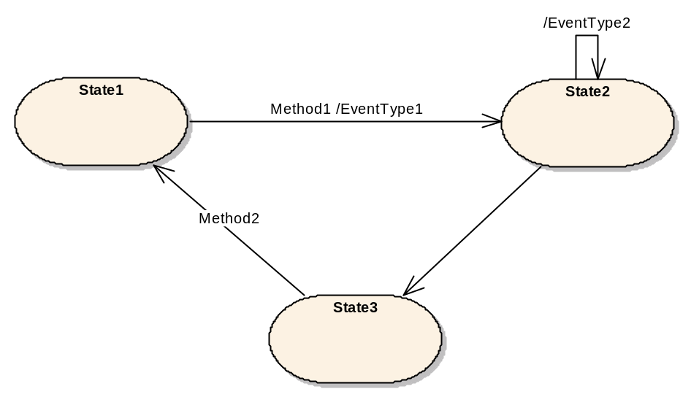
Figure 9 – Example of a simple state machine
For simplicity, the state machines described in this Appendix will only support causes in form of specifying Methods that have to be called and effects in form of EventTypes of Events that are generated. However, the defined infrastructure allows extending this to support additional different causes and effects.
    - State machine containing substates
Figure 10 shows an example of a state machine where “State6” is a sub-state-machine. This means, that when the overall state machine is in State6, this state can be distinguish to be in the sub-states “State7” or “State8”. Sub-state-machines can be nested, i.e. “State7” could be another sub-state-machine.
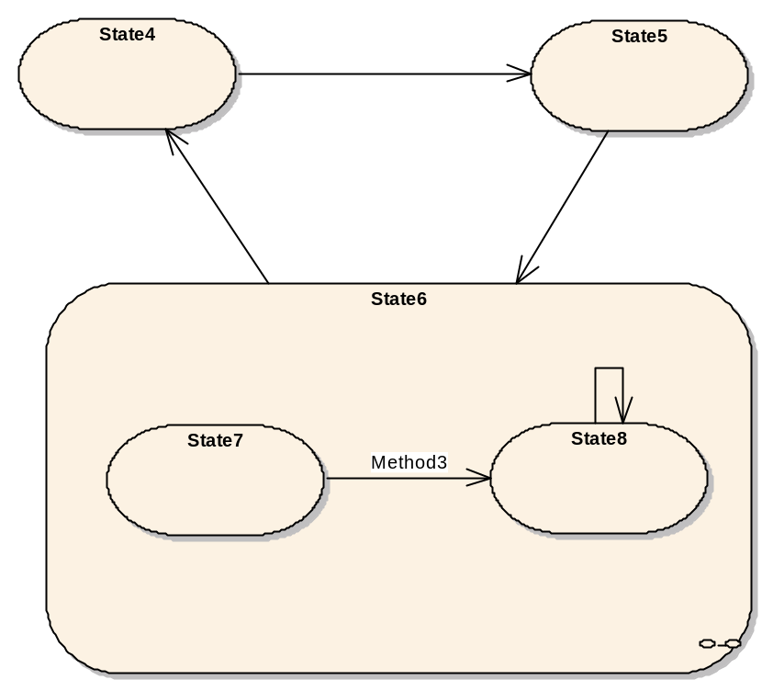
Figure 10 – Example of a state machine having a sub-machine
  - Definition of state machine
The infrastructure of state machines defined in this Appendix only deals with the basics of state machines needed to support Part 9 and Part 10. The intention is to keep the basic simple but extensible.
For the state machines defined in this Appendix we assume that state machines are typed and instances of a type have their states and semantics specified by the type. For some types this means that the states and transitions are fixed. For other types the states and transitions may be dynamic or unknown. A state machine where all the states are specified explicitly by the type is called a finite state machine.
Therefore we distinguish between StateMachineType and StateMachine. The StateMachineType specifies a description of the state machine – its states, transitions, etc. – whereas the StateMachine is an instance of the StateMachineType and only contains the current state.
Each StateMachine contains information about the current state. If the StateMachineType has SubStateMachines, the StateMachine also contains information about the current state of the SubStateMachines. StateMachines which have their states completely defined by the type are instances of a FiniteStateMachineType.
Each FiniteStateMachineType has one or more States. For simplicity we do not distinguish between different States like the start or the end states.
Each State can have one or more SubStateMachines.
Each FiniteStateMachineType may have one or more Transitions. A Transition is directed and points from one State to another State.
Each Transition can have one or more Causes. A Cause leads a FiniteStateMachine to change its current State from the source of the Transition to its target. In this Appendix we only specify Method calls to be Causes of Transitions. Transitions do not have to have a Cause. A Transition can always be caused by some server-internal logic that is not exposed in the AddressSpace.
Each Transition can have one or more Effects. An Effect occurs if the Transition is used to change the State of a StateMachine. In this Appendix we only specify the generation of Events to be Effects of a Transition. A Transition is not required to expose any Effects in the AddressSpace.
Although this Appendix only specifies simple concepts for state machines, the provided infrastructure is extensible. If needed, special States can be defined as well as additional Causes or Effects.
  - Representation of state machines in the AddressSpace
    - Overview
The types defined in this Appendix are illustrated in Figure 11. The MyFiniteStateMachineType is a minimal example which illustrates how these Types can be used to describe a StateMachine. See Part 9 and Part 10 for additional examples of StateMachines.

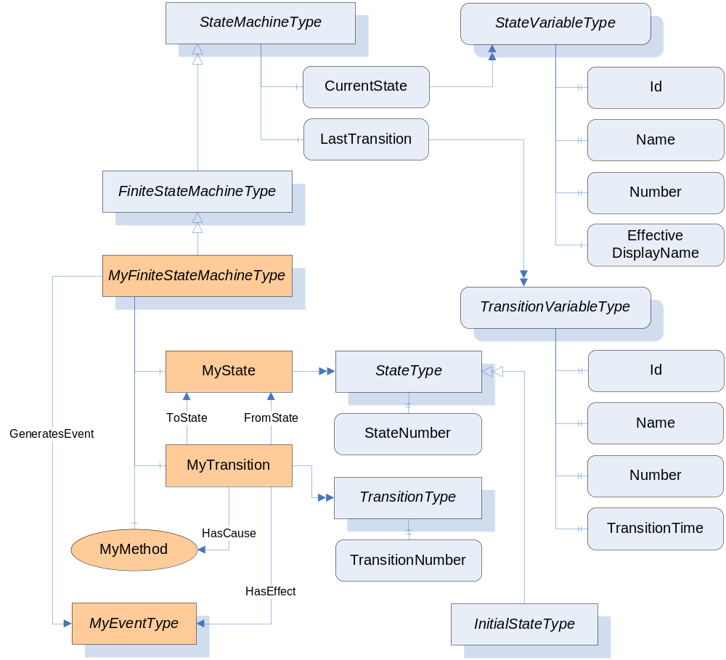
Figure 11 – The StateMachine Information Model
    - StateMachineType
The StateMachineType is the base ObjectType for all StateMachineTypes. It defines a single Variable which represents the current state of the machine. An instance of this ObjectType shall generate an Event whenever a significant state change occurs. The Server decides which state changes are significant. Servers shall use the GeneratesEvent ReferenceType to indicate which Event(s) could be produced by the StateMachine.
Subtypes may add Methods which affect the state of the machine. The Executable Attribute is used to indicate whether the Method is valid given the current state of the machine. The generation of AuditEvents for Methods is defined in Part 4. A StateMachine may not be active. In this case, the CurrentState and LastTransition Variables shall have a status equal to Bad_StateNotActive (see Table 158).
Subtypes may add components which are instances of StateMachineTypes. These components are considered to be sub-states of the StateMachine. SubStateMachines are only active when the parent machine is in an appropriate state.
Events produced by SubStateMachines may be suppressed by the parent machine. In some cases, the parent machine will produce a single Event that reflects changes in multiple SubStateMachines.
FiniteStateMachineType is subtype of StateMachineType that provides a mechanism to explicitly define the states and transitions. A Server should use this mechanism if it knows what the possible states are and the state machine is not trivial. The FiniteStateMachineType is defined in B.4.5
The StateMachineType is formally defined in Table 142.
Table 142 – StateMachineType Definition
Attribute | Value
BrowseName | StateMachineType
IsAbstract | False
References |  | Node  Class | BrowseName | DataType | TypeDefinition | Modelling  Rule
Subtype of the BaseObjectType defined in 6.2.
Note that a Reference to this sub type is not shown in the definition of the BaseObjectType.
HasSubtype |  | ObjectType | FiniteStateMachineType | Defined in B.4.5
HasComponent |  | Variable | CurrentState | LocalizedText | StateVariableType | Mandatory
HasComponent |  | Variable | LastTransition | LocalizedText | TransitionVariableType | Optional

CurrentState stores the current state of an instance of the StateMachineType. CurrentState provides a human readable name for the current state which may not be suitable for use in application control logic. Applications should use the Id Property of CurrentState if they need a unique identifier for the state.
LastTransition stores the last transition which occurred in an instance of the StateMachineType. LastTransition provides a human readable name for the last transition which may not be suitable for use in application control logic. Applications should use the Id Property of LastTransition if they need a unique identifier for the transition.
    - StateVariableType
The StateVariableType is the base VariableType for Variables that store the current state of a StateMachine as a human readable name.
The StateVariableType is formally defined in Table 142.
Table 143 – StateVariableType Definition
Attribute | Value
BrowseName | StateVariableType
DataType | LocalizedText
ValueRank | -1 (-1 = Scalar)
IsAbstract | False
References |  | Node  Class | BrowseName | DataType | TypeDefinition | Modelling  Rule
Subtype of the BaseDataVariableType defined in 7.4.
Note that a Reference to this subtype is not shown in the definition of the BaseDataVariableType.
HasSubtype |  | VariableType | FiniteStateVariableType | Defined in B.4.6
HasProperty |  | Variable | Id | BaseDataType | PropertyType | Mandatory
HasProperty |  | Variable | Name | QualifiedName | PropertyType | Optional
HasProperty |  | Variable | Number | UInt32 | PropertyType | Optional
HasProperty |  | Variable | EffectiveDisplayName | LocalizedText | PropertyType | Optional

Id is a name which uniquely identifies the current state within the StateMachineType. A subtype may restrict the DataType.
Name is a QualifiedName which uniquely identifies the current state within the StateMachineType.
Number is an integer which uniquely identifies the current state within the StateMachineType.
EffectiveDisplayName contains a human readable name for the current state of the state machine after taking the state of any SubStateMachines in account. There is no rule specified for which state or sub-state should be used. It is up to the server and will depend on the semantics of the StateMachineType.
StateMachines produce Events which may include the current state of a StateMachine. In that case servers shall provide all the optional Properties of the StateVariableType in the Event, even if they are not provided on the instances in the AddressSpace.
    - TransitionVariableType
The TransitionVariableType is the base VariableType for Variables that store a Transition that occurred within a StateMachine as a human readable name.
The SourceTimestamp for the value specifies when the Transition occurred. This value may also be exposed with the TransitionTime Property.
The TransitionVariableType is formally defined in Table 144.
Table 144 – TransitionVariableType Definition
Attribute | Value
BrowseName | TransitionVariableType
DataType | LocalizedText
ValueRank | -1 (-1 = Scalar)
IsAbstract | False
References |  | Node  Class | BrowseName | DataType | TypeDefinition | Modelling  Rule
Subtype of the BaseDataVariableType defined in 7.4.
Note that a Reference to this subtype is not shown in the definition of the BaseDataVariableType.
HasSubtype |  | VariableType | FiniteTransitionVariableType | Defined in B.4.7
HasProperty |  | Variable | Id | BaseDataType | PropertyType | Mandatory
HasProperty |  | Variable | Name | QualifiedName | PropertyType | Optional
HasProperty |  | Variable | Number | UInt32 | PropertyType | Optional
HasProperty |  | Variable | TransitionTime | UtcTime | PropertyType | Optional

Id is a name which uniquely identifies a Transition within the StateMachineType. A subtype may restrict the DataType.
Name is a QualifiedName which uniquely identifies a transition within the StateMachineType.
Number is an integer which uniquely identifies a transition within the StateMachineType.
TransitionTime specifies when the transition occurred.
    - FiniteStateMachineType
The FiniteStateMachineType is the base ObjectType for StateMachines that explicitly define the possible States and Transitions. Once the States are defined subtypes shall not add new States (See B.4.18 ).
The States of the machine are represented with instances of the StateType ObjectType. Each State shall have a BrowseName which is unique within the StateMachine and shall have a StateNumber which shall also be unique across all States defined in the StateMachine. A concrete subtype of FiniteStateMachineType shall define at least one State.
A StateMachine may define one State which is an instance of the InitialStateType. This State is the State that the machine goes into when it is activated.
The Transitions that may occur are represented with instances of the TransitionType. Each Transition shall have a BrowseName which is unique within the StateMachine and may have a TransitionNumber which shall also be unique across all Transitions defined in the StateMachine.
The initial State for a Transition is a StateType Object which is the target of a FromState Reference. The final State for a Transition is a StateType Object which is the target of a ToState Reference. The FromState and ToState References shall always be specified.
A Transition may produce an Event. The Event is indicated by a HasEffect Reference to a subtype of BaseEventType. The StateMachineType shall have GeneratesEvent References to the targets of a HasEffect Reference for each of its Transitions.
A FiniteStateMachineType may define Methods that cause a transition to occur. These Methods are targets of HasCause References for each of the Transitions that may be triggered by the Method. The Executable Attribute for a Method is used to indicate whether the current State of the machine allows the Method to be called.
A FiniteStateMachineType may have sub-state-machines which are represented as instances of StateMachineType ObjectTypes. Each State shall have a HasSubStateMachine Reference to the StateMachineType Object which represents the child States. The SubStateMachine is not active if the parent State is not active.
The FiniteStateMachineType is formally defined in Table 145.
Table 145 – FiniteStateMachineType Definition
Attribute | Value
BrowseName | FiniteStateMachineType
IsAbstract | True
References |  | Node  Class | BrowseName | DataType | TypeDefinition | Modelling  Rule
Subtype of the StateMachineType defined in 6.2.
HasComponent |  | Variable | CurrentState | LocalizedText | FiniteStateVariableType | Mandatory
HasComponent |  | Variable | LastTransition | LocalizedText | FiniteTransitionVariableType | Optional

    - FiniteStateVariableType
The FiniteStateVariableType is a subtype of StateVariableType and is used to store the current state of a FiniteStateMachine as a human readable name.
The FiniteStateVariableType is formally defined in Table 146.
Table 146 – FiniteStateVariableType Definition
Attribute | Value
BrowseName | FiniteStateVariableType
DataType | LocalizedText
ValueRank | -1 (-1 = Scalar)
IsAbstract | False
References |  | Node  Class | BrowseName | DataType | TypeDefinition | Modelling  Rule
Subtype of the StateVariableType defined in B.4.3
HasProperty |  | Variable | Id | NodeId | PropertyType | Mandatory
HasProperty |  | Variable | Name | QualifiedName | PropertyType | Optional
HasProperty |  | Variable | Number | UInt32 | PropertyType | Optional
HasProperty |  | Variable | EffectiveDisplayName | LocalizedText | PropertyType | Optional

Id is inherited from the StateVariableType and overridden to reflect the required DataType. This value shall be the NodeId of one of the State Objects of the FiniteStateMachineType.
Name inherited from StateVariableType shall be the BrowseName of one of the State Objects of the FiniteStateMachineType.
Number inherited from StateVariableType shall be the StateNumber for one of the State Objects of the FiniteStateMachineType.
    - FiniteTransitionVariableType
The FiniteTransitionVariableType is a subtype of TransitionVariableType and is used to store a Transition that occurred within a FiniteStateMachine as a human readable name.
The TransitionVariableType is formally defined in Table 147.
Table 147 – FiniteTransitionVariableType Definition
Attribute | Value
BrowseName | FiniteTransitionVariableType
DataType | LocalizedText
ValueRank | -1 (-1 = Scalar)
IsAbstract | False
References |  | Node  Class | BrowseName | DataType | TypeDefinition | Modelling  Rule
Subtype of the BaseDataVariableType defined in 7.4.
Note that a Reference to this subtype is not shown in the definition of the BaseDataVariableType.
HasProperty |  | Variable | Id | NodeId | PropertyType | Mandatory

Id is inherited from the TransitionVariableType and overridden to reflect the required DataType. This value shall be the NodeId of one of the Transition Objects of the FiniteStateMachineType.
Name inherited from the TransitionVariableType shall be the BrowseName of one of the Transition Objects of the FiniteStateMachineType.
Number inherited from the TransitionVariableType shall be the TransitionNumber for one of the Transition Objects of the FiniteStateMachineType.
    - StateType
States of a FiniteStateMachine are represented as Objects of the StateType.
The StateType is formally defined in Table 148.
Table 148 – StateType Definition
Attribute | Value
BrowseName | StateType
IsAbstract | False
References |  | NodeClass | BrowseName | DataType | TypeDefinition | ModellingRule
Subtype of the BaseObjectType defined in 6.2. Note that a Reference to this subtype is not shown in the definition of the BaseObjectType.
HasProperty |  | Variable | StateNumber | UInt32 | PropertyType | Mandatory
HasSubtype |  | ObjectType | InitialStateType | Defined in B.4.9

    - InitialStateType
The InitialStateType is a subtype of the StateType and is formally defined in Table 148. An Object of the InitialStateType represents the State that a FiniteStateMachine enters when it activated. Each FiniteStateMachine can have at most one State of type InitialStateType, but a FiniteStateMachine does not have to have a State of this type.
A StateMachine goes into its initial state whenever the parent state is entered. However, a state machine may define a transition that goes directly to a state of the SubStateMachine. In this case the SubStateMachine goes into that State instead of the initial State. The two scenarios are illustrated in Figure 12. The transition from State5 to State6 causes the SubStateMachine to go into the initial State (State7), however, the transition from State4 to State8 causes the parent machine to go to State6 and the SubStateMachine will go to State8.
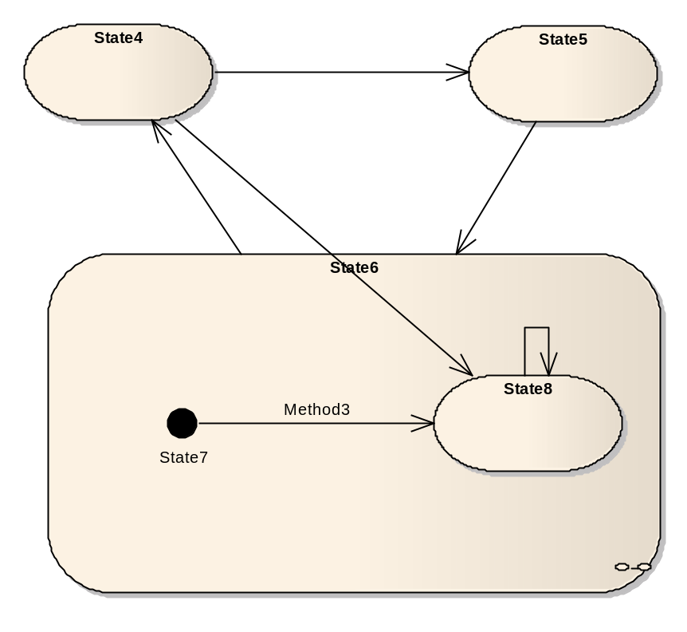
Figure 12 – Example of an initial State in a sub-machine
If no initial state for a SubStateMachine exists and the State having the SubStateMachine is entered directly, then the State of the SubStateMachine is server specific.
Table 149 – InitialStateType Definition
Attribute | Value
BrowseName | InitialStateType
IsAbstract | False
References |  | NodeClass | BrowseName | DataType | TypeDefinition | ModellingRule
Subtype of the StateType defined in B.4.8

    - TransitionType
Transitions of a FiniteStateMachine are represented as Objects of the ObjectType TransitionType formally defined in Table 150.
Each valid Transition shall have exactly one FromState Reference and exactly one ToState Reference, each pointing to an Object of the ObjectType StateType.
Each Transition can have one or more HasCause References pointing to the cause that triggers the Transition.
Each Transition can have one or more HasEffect References pointing to the effects that occur when the Transition was triggered.
Table 150 – TransitionType Definition
Attribute | Value
BrowseName | TransitionType
IsAbstract | False
References |  | NodeClass | BrowseName | DataType | TypeDefinition | ModellingRule
Subtype of the BaseObjectType defined in 6.2. Note that a Reference to this subtype is not shown in the definition of the BaseObjectType.
HasProperty |  | Variable | TransitionNumber | UInt32 | PropertyType | Mandatory

    - FromState
The FromState ReferenceType is a concrete ReferenceType and can be used directly. It is a subtype of NonHierarchicalReferences.
The semantic of this ReferenceType is to point form a Transition to the starting State the Transition connects.
The SourceNode of this ReferenceType shall be an Object of the ObjectType TransitionType or one of its subtypes. The TargetNode of this ReferenceType shall be an Object of the ObjectType StateType or one of its subtypes.
The representation of the FromState ReferenceType in the AddressSpace is specified in Table 151.
Table 151 – FromState ReferenceType
Attributes | Value
BrowseName | FromState
InverseName | ToTransition
Symmetric | False
IsAbstract | False
References | NodeClass | BrowseName | Comment

    - ToState
The ToState ReferenceType is a concrete ReferenceType and can be used directly. It is a subtype of NonHierarchicalReferences.
The semantic of this ReferenceType is to point form a Transition to the ending State the Transition connects.
The SourceNode of this ReferenceType shall be an Object of the ObjectType TransitionType or one of its subtypes. The TargetNode of this ReferenceType shall be an Object of the ObjectType StateType or one of its subtypes.
References of this ReferenceType may be only exposed uni-directional. Sometimes this is required, for example, if a Transition points to a State of a sub-machine.
The representation of the ToState ReferenceType in the AddressSpace is specified in Table 152.
Table 152 – ToState ReferenceType
Attributes | Value
BrowseName | ToState
InverseName | FromTransition
Symmetric | False
IsAbstract | False
References | NodeClass | BrowseName | Comment

    - HasCause
The HasCause ReferenceType is a concrete ReferenceType and can be used directly. It is a subtype of NonHierarchicalReferences.
The semantic of this ReferenceType is to point form a Transition to something that causes the Transition. In this Appendix we only define Methods as Causes. However, the ReferenceType is not restricted to point to Methods.
The SourceNode of this ReferenceType shall be an Object of the ObjectType TransitionType or one of its subtypes. The TargetNode can be of any NodeClass.
The representation of the HasCause ReferenceType in the AddressSpace is specified in Table 153.
Table 153 – HasCause ReferenceType
Attributes | Value
BrowseName | HasCause
InverseName | MayBeCausedBy
Symmetric | False
IsAbstract | False
References | NodeClass | BrowseName | Comment

    - HasEffect
The HasEffect ReferenceType is a concrete ReferenceType and can be used directly. It is a subtype of NonHierarchicalReferences.
The semantic of this ReferenceType is to point form a Transition to something that will be effected when the Transition is triggered. In this Appendix we only define EventTypes as Effects. However, the ReferenceType is not restricted to point to EventTypes.
The SourceNode of this ReferenceType shall be an Object of the ObjectType TransitionType or one of its subtypes. The TargetNode can be of any NodeClass.
The representation of the HasEffect ReferenceType in the AddressSpace is specified in Table 154.
Table 154 – HasEffect ReferenceType
Attributes | Value
BrowseName | HasEffect
InverseName | MayBeEffectedBy
Symmetric | False
IsAbstract | False
References | NodeClass | BrowseName | Comment

    - HasSubStateMachine
The HasSubStateMachine ReferenceType is a concrete ReferenceType and can be used directly. It is a subtype of NonHierarchicalReferences.
The semantic of this ReferenceType is to point from a State to an instance of a StateMachineType which represents the sub-states for the State.
The SourceNode of this ReferenceType shall be an Object of the ObjectType StateType. The TargetNode shall be an Object of the ObjectType StateMachineType or one of its subtypes. Each Object can be the TargetNode of at most one HasSubStateMachine Reference.
The SourceNode (the state) and the TargetNode (the SubStateMachine) shall belong to the same StateMachine, i.e. both shall be referenced from the same Object of type StateMachineType using a HasComponent Reference or a subtype of HasComponent.
The representation of the HasSubStateMachine ReferenceType in the AddressSpace is specified in Table 155.
Table 155 – HasSubStateMachine ReferenceType
Attributes | Value
BrowseName | HasSubStateMachine
InverseName | SubStateMachineOf
Symmetric | False
IsAbstract | False
References | NodeClass | BrowseName | Comment

    - TransitionEventType
The TransitionEventType is a subtype of the BaseEventType. It can be used to generate an Event identifying that a Transition of a StateMachine was triggered. It is formally defined in Table 156.
Table 156 - TransitionEventType
Attribute | Value
BrowseName | TransitionEventType
IsAbstract | True
References | NodeClass | BrowseName | DataType | TypeDefinition | ModellingRule
Subtype of the base BaseEventType defined in 6.4.2
HasComponent | Variable | Transition | LocalizedText | TransitionVariableType | Mandatory
HasComponent | Variable | FromState | LocalizedText | StateVariableType | Mandatory
HasComponent | Variable | ToState | LocalizedText | StateVariableType | Mandatory

The TransitionEventType inherits the Properties of the BaseEventType.
The inherited Property SourceNode shall be filled with the NodeId of the StateMachine instance were the Transition occurs. If the Transition occurs in a SubStateMachine, then the NodeId of the SubStateMachine has to be used. If the Transition occurs between a StateMachine and a SubStateMachine, then the NodeId of the StateMachine has to be used, independent of the direction of the Transition.
Transition identifies the Transition that triggered the Event.
FromState identifies the State before the Transition.
ToState identifies the State after the Transition.
    - AuditUpdateStateEventType
The AuditUpdateStateEventType is a subtype of the AuditUpdateMethodEventType. It can be used to generate an Event identifying that a Transition of a StateMachine was triggered. It is formally defined in Table 157.
Table 157 - AuditUpdateStateEventType
Attribute | Value
BrowseName | AuditUpdateStateEventType
IsAbstract | True
References | NodeClass | BrowseName | DataType | TypeDefinition | ModellingRule
Subtype of the AuditUpdateMethodEventType defined in 6.4.27
HasProperty | Variable | OldStateId | BaseDataType | PropertyType | Mandatory
HasProperty | Variable | NewStateId | BaseDataType | PropertyType | Mandatory

The AuditUpdateStateEventType inherits the Properties of the AuditUpdateMethodEventType.
The inherited Property SourceNode shall be filled with the NodeId of the StateMachine instance were the State changed. If the State changed in a SubStateMachine, then the NodeId of the SubStateMachine has to be used.
The SourceName for Events of this type should be the effect that generated the event (e.g. the name of a Method). If the effect was generated by a Method call, the SourceName should be the name of the Method prefixed with “Method/”.
OldStateId reflects the Id of the state prior the change.
NewStateId reflects the new Id of the state after the change.
    - Special Restrictions on subtyping StateMachines
In general, all rules on subtyping apply for StateMachine types as well. Some additional rules apply for StateMachine types. If a StateMachine type is not abstract, subtypes of it shall not change the behaviour of it. That means, that in that case a subtype shall not add States and it shall not add Transitions between its States. However, a subtype may add SubStateMachines, it may add Transitions from the States to the States of the SubStateMachine, and it may add Causes and Effects to a Transition. In addition, a subtype of a StateMachine type shall not remove States or Transitions.
    - Specific StatusCodes for StateMachines
In Table 158 specific StatusCodes used for StateMachines are defined.
Table 158 – Specific StatusCodes for StateMachines
Symbolic Id | Description
Bad_StateNotActive | The accessed state is not active.

  - Examples of StateMachines in the AddressSpace
    - StateMachineType using inheritance
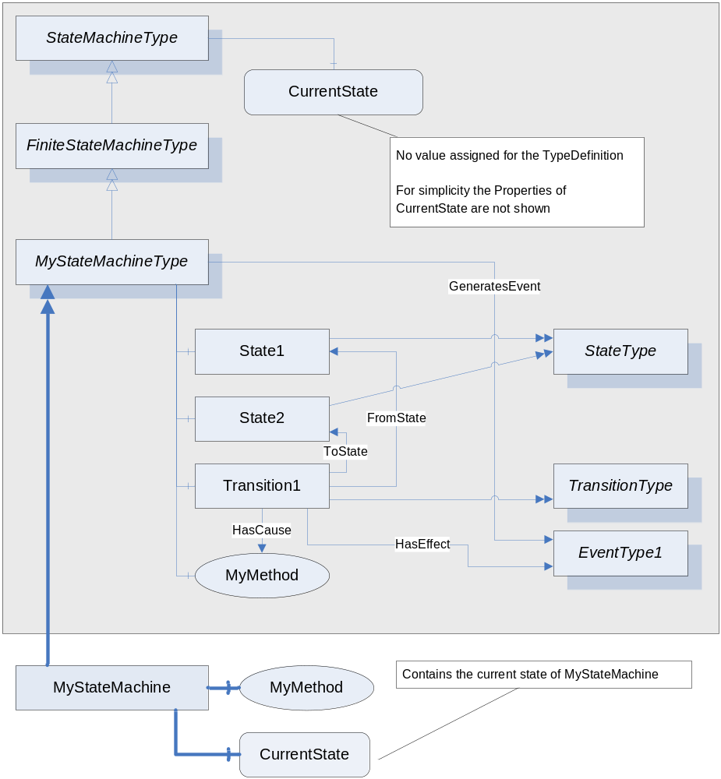
Figure 13 – Example of a StateMachineType using inheritance
In Figure 13 an example of a StateMachine is given using the Notation defined in the Appendix of Part 3. First, a new StateMachineType is defined, called “MyStateMachineType”, inheriting from the base FiniteStateMachineType. It contains two States, “State1” and “State2” and a Transition “Transition1” between them. The Transition points to a Method “MyMethod” as the Cause of the Transition and an EventType “EventType1” as the Effect of the Transition.
Instances of “MyStateMachineType” can be created, for example “MyStateMachine”. It has a Variable “CurrentState” representing the current State. The “MyStateMachine” Object only includes the Nodes which expose information specific to the instance.
    - StateMachineType with a sub-machine using inheritance
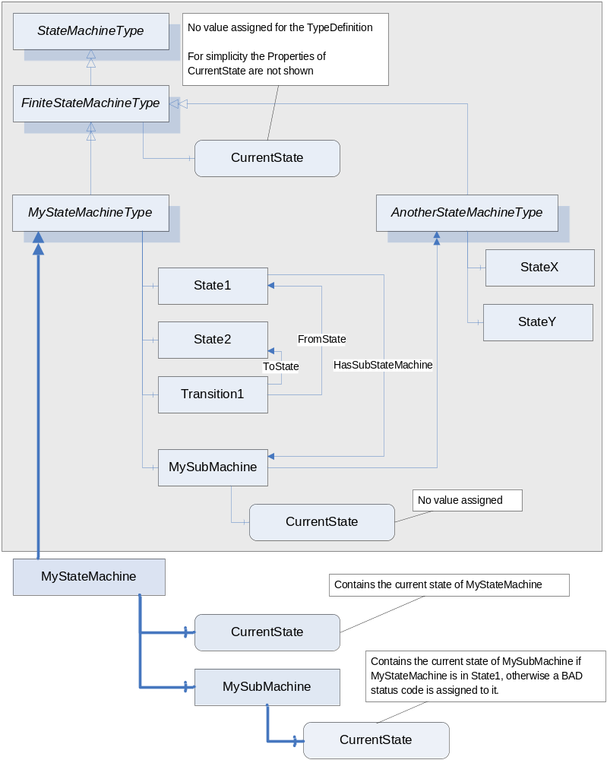
Figure 14 – Example of a StateMachineType with a SubStateMachine using inheritance
Figure 14 gives an example of a StateMachineType having a SubStateMachine for its “State1”. For simplicity no effects and causes are shown, as well as type information for the States or ModellingRules.
The “MyStateMachineType” contains an Object “MySubMachine” of type “AnotherStateMachineType” representing a SubStateMachine. The “State1” references this Object with a HasSubStateMachine Reference, thus it is a SubStateMachine of “State1”. Since “MySubMachine” is an Object of type “AnotherStateMachineType” it has a Variable representing the current State. Since it is used as an InstanceDeclaration, no value is assigned to this Variable.
An Object of “MyStateMachineType”, called “MyStateMachine” has Variables for the current State, but also has an Object “MySubMachine” and a Variable representing the current state of the SubStateMachine. Since the SubStateMachine is only used when “MyStateMachine” is in “State1”, a client would receive a Bad_StateNotActive StatusCode when reading the SubStateMachine CurrentState Variable if “MyStateMachine” is in a different State.
    - StateMachineType using containment
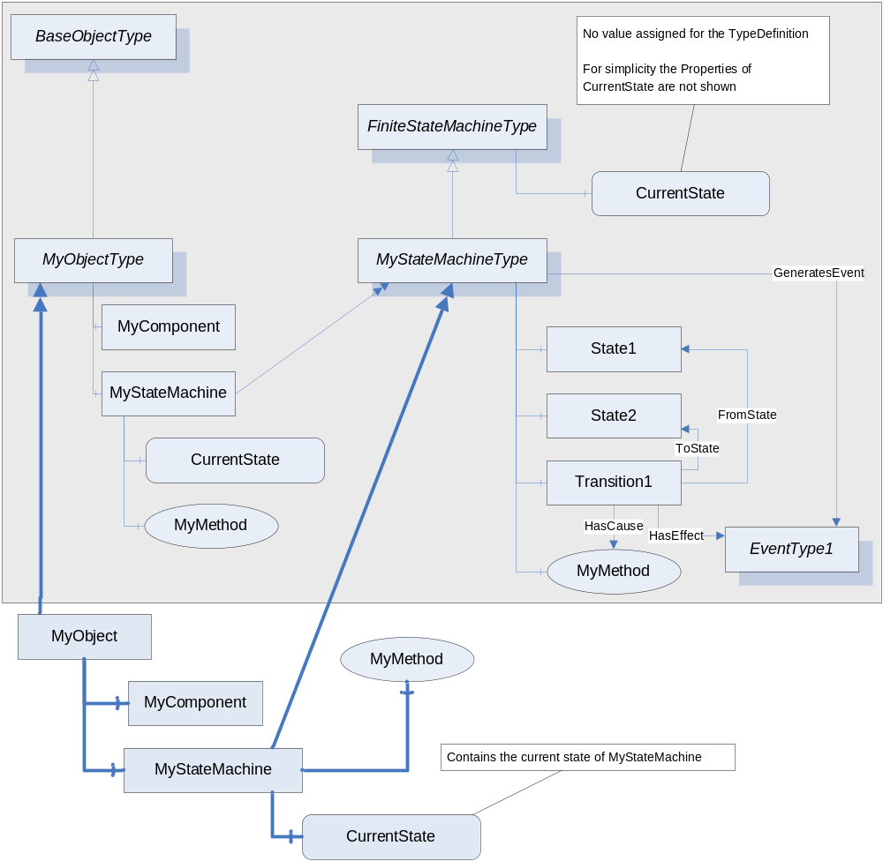
Figure 15 – Example of a StateMachineType using containment
Figure 15 gives an example of an ObjectType not only representing a StateMachine but also having some other functionality. The ObjectType “MyObjectType” has an Object “MyComponent” representing this other functionality. But is also contains a StateMachine “MyStateMachine” of the type “MyStateMachineType”. Objects of “MyObjectType” also contain such an Object representing the StateMachine and a Variable containing the current state of the StateMachine, as shown in the Figure.
    - Example of a StateMachine having Transitions to SubStateMachines
The StateMachines shown so far only had Transitions between States on the same level, i.e. on the same StateMachine. Of cause, it is possible and often required to have Transitions between States of the StateMachine and States of its SubStateMachine.
Because a SubStateMachine can be defined by another StateMachineType and this type can be used in several places, it is not possible to add a bi-directional Reference from one of the shared States of the SubStateMachine to another StateMachine. In this case it is suitable to expose the FromState or ToState References uni-directional, i.e. only pointing from the Transition to the State and not have the other direction browsable. If a Transition points from a State of a SubStateMachine to a State of another sub-machine, both, the FromState and the ToState Reference, are handled uni-directional.
A Client shall be able to handle the information of a StateMachine if the ToState and FromState References are only exposed as forward References and the inverse References are omitted.
Figure 16 gives an example of a state machine having a transition from a sub-state to a state.
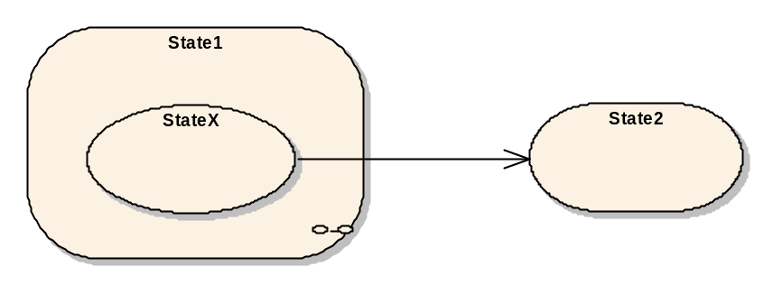
Figure 16 – Example of a state machine with transitions from sub-states
In Figure 17, the representation of this example as StateMachineType in the AddressSpace is given. The “Transition1”, part of the definition of “MyStateMachineType”, points to the “StateX” of the StateMachineType “AnotherStateMachineType”. The Reference is only exposed as forward Reference and the inverse Reference is omitted. Thus, there is no Reference from the “StateX” of “AnotherStateMachineType” to any part of “MyStateMachineType” and “AnotherStateMachineType” can be used in other places as well.

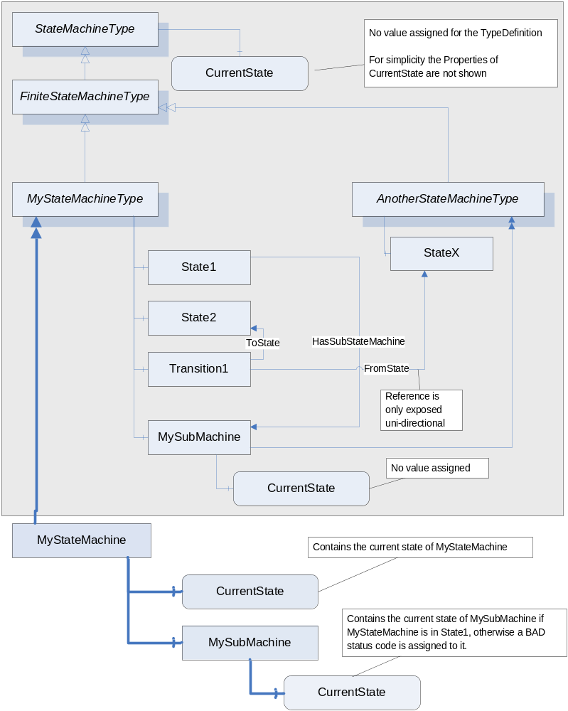
Figure 17 – Example of a StateMachineType having Transitions to SubStateMachines

The URI of the ServerArray with Index 0 must be identical to the URI of the NamespaceArray with Index 1, since both represent the local server.

